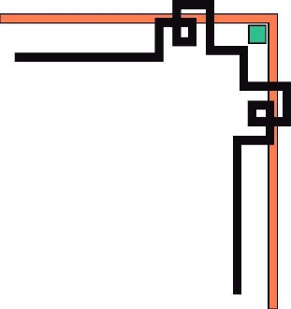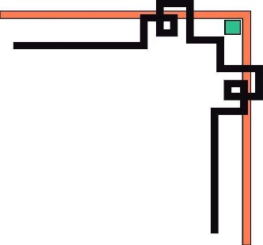

**HO CHI MINH UNIVERSITY OF TECHNOLOGY AND EDUCATION**

**FACULTY FOR HIGH QUALITY TRAINING**

**🕯✡🕮🕮✡🕯**



**GRADUATE THESIS**

**BUILD A MOVIE REVIEWS AND TICKETS BOOKING WEBSITE WITH ANGULAR AND ASP .NET CORE**

**STUDENT NAME: STUDENT ID**

**TON NU NHU QUYNH 17110214**

**NGUYEN NGOC TU DUYEN 17110116**

**School Year: 2017-2021**

**Major: Information Technology**

**Advisor: PhD. LE VAN VINH**

Tp. Ho Chi Minh, July 2021



**HO CHI MINH UNIVERSITY OF TECHNOLOGY AND EDUCATION**

**FACULTY FOR HIGH QUALITY TRAINING**

**🕯✡🕮🕮✡🕯**



GRADUATE THESIS

**BUILD A MOVIE REVIEWS AND TICKETS BOOKING WEBSITE WITH ANGULAR AND ASP .NET CORE**

**STUDENT NAME: STUDENT ID**

**TON NU NHU QUYNH 17110214**

**NGUYEN NGOC TU DUYEN 17110116**

**School Year: 2017-2021**

**Major: Information Technology**

**Advisor: PhD. LE VAN VINH**

Tp. Ho Chi Minh, July 2021

|  |  |
| --- | --- |
|  | **SOCIALIST REPUBLIC OF VIETNAM**  **Independence – Freedom - Happiness**  ----***----  Tp. Ho Chi Minh, July 2021 |

MISSION OF GRADUATE THESIS

Name of student: Tôn Nữ Như Quỳnh Student ID: 17110214

Name of student: Nguyễn Ngọc Tú Duyên Student ID: 17110116

Major: Software Engineer.

Topic name: Build a movie reviews and tickets booking website with Angular and ASP .NET Core

Mentor: PhD. Lê Văn Vinh.

**Content:**

*Theory:*

* Analysis, design, contruction of Movie Reviews And Tickets system.
* Survey the current state of demand.
* Research to expand website functionality as well as improve user experience by surveying websites in the same topic
* Find out and install support services for website features: SendGrid email, Firebase storage, Realtime notification, Paypal checkout, Third party authentication
* Research about Machine Learning to train model.

*Practice:* Apply to contruction of Movie Reviews And Tickets system.

**Execution time** from 15/03/2021 to 20/07/2021

|  |  |
| --- | --- |
|  | Ho Chi Minh, July 20th 2021 |
| HEAD OF INFORMATION TECHNOLOGY | MENTOR |
| (Name and signature) | (Name and signature) |

|  |  |
| --- | --- |
|  |  |

|  |  |
| --- | --- |
|  | **SOCIALIST REPUBLIC OF VIETNAM**  **Independence – Freedom - Happiness**  ----***---- |

COMMENTARY OF MENTOR

Student name: Tôn Nữ Như Quỳnh Student ID: 17110214

Nguyễn Ngọc Tú Duyên 17110116

Major: Software Engineer.

Topic name: Analysis, design, contruction of Movie Reviews And Tickets system.

Name of supervisor: Ph.D Lê Văn Vinh.

**COMMENTARY**

1. On content of topic & workload done:

1. Advantage:

1. Disadvantage:

4. Recommend for defense or not?

5.Rating type:

6. Mark: (By word: )

*Ho Chi Minh, ……………………………….* 2021

MENTOR

(Name and signature)

|  |  |
| --- | --- |
|  | **SOCIALIST REPUBLIC OF VIETNAM**  **Independence – Freedom - Happiness**  ----***---- |

|  |  |
| --- | --- |
|  | **SOCIALIST REPUBLIC OF VIETNAM**  **Independence – Freedom - Happiness**  ----***---- |

COMMENTARY OF REVIEWER

Student name: Tôn Nữ Như Quỳnh Student ID: 17110214

Nguyễn Ngọc Tú Duyên 17110116

Major: Software Engineer.

Topic name: Analysis, design, contruction of Movie Reviews And Tickets system.

Name of reviewer:

**COMMENTARY**

1. On content of topic & workload done:

1. Advantage:

1. Disadvantage:

1. Recommend for defense or not?
2. Rating type:
3. Mark: (By word: )

*Ho Chi Minh, ……………………………….* 2021

REVIEWER

(Name and signature)

ASSURANCE

We assure that this project is our own implementation. We do not copy, use any material or source code of others without specifying the source. We assume responsibility for violations.

*Ho Chi Minh,* July 20th 2020

Tôn Nữ Như Quỳnh Nguyễn Ngọc Tú Duyên

MANY THANKS

In this fact, there are no successes that are not associated with support or assistance, whether more or less, directly or indirectly by others. Now I would like to send this sincere thanks to PhD. Lê Văn Vinh, who directly guided us to complete this project, has supported and transmitted motivation to us in the process of choosing topics, instructions and comments. Although we do not ask much, but when asking the teacher for help, it is the motivation for us to complete the course, without the instructions and practical experiences of the teacher, I think the article This report will be difficult to complete and completed on time. Once again, I would like to thank the teacher.

I also would like to thank the teachers of the Faculty of Information Technology, Ho Chi Minh City University of Technical Education for teaching the student group to report, help and support answers so that the our report can complete the project implementation process.

Due to limited time, with limited knowledge and many other worries, there is an inevitable problem, so I look forward to receiving your valuable suggestions for my knowledge. more complete later. We sincerely thank you.

Ho Chi Minh, June 20th 2021

Tôn Nữ Như Quỳnh Nguyễn Ngọc Tú Duyên

SUMMARY INFORMATION BY ENGLISH

1. **Research issues**

* Learn about similar systems, analyze to find the strengths and suitability to apply.
* Learn about Single Page Application (Angular), ASP. Net Core to solve the problem of service providers using APIs for movie rating and tickets booking website.
* Learn about Recommendation System to suggest some suitable movies for user.

1. **Issues arising**

* Security is an important requirement for a real website.
* Stripe payment method is not applied in Viet Nam yet.

1. **Problem solving**

* Use JWT to improve security requirements.
* Replace with Paypal payment method.

1. **Results**

* Movie Review and Tickets Booking include: website for end – user side and website for admin side.
* Easy to use, user-friendly interface.
* Personalization of users through suggesting movies that may be suitable.
* Easy to manage, repair and expand.

SUMMARY INFORMATION BY VIETNAMESE

1. **Các vấn đề nghiên cứu**

* Tìm hiểu về các hệ thống tương tự, phân tích để tìm ra điểm mạnh và phù hợp để áp dụng.
* Tìm hiểu về Single Page Application (Angular), ASP. Net Core để giải quyết vấn đề cung cấp dịch vụ API cho hệ thống đánh giá phim và đặt vé.
* Tìm hiểu về Recommendation System (Hệ thống gợi ý) để gợi ý một số bộ phim phù hợp với user.

1. **Các vấn đề phát sinh**

* Bảo mật là một trong những yêu cầu quan trọng cho website thực tế.
* Phương thức thanh toán Stripe chưa được hỗ trợ tại Việt Nam.

1. **Các phương pháp giải quyết vấn đề**

* Sử dụng JWT để cải thiện yêu cầu bảo mật cho webiste.
* Thay thế bằng phương thức thanh toán Paypal.

1. **Kết quả đạt được**

* Hệ thống Movie Review and Tickets Booking bao gồm: website cho phía người dùng cuối và website cho phía admin.
* Giao diện dễ sử dụng, thân thiện với người dùng.
* Tính cá nhân hóa cho user thông qua việc gợi ý các bộ phim có thể phù hợp.
* Dễ dàng quản lý, sửa chữa và mở rộng.

**Table of Contents**

MANY THANKS i

SUMMARY INFORMATION BY ENGLISH ii

SUMMARY INFORMATION BY VIETNAMESE iii

ABBREVIATION LIST viii

TABLE LIST ix

FIGURE LIST xiii

Chapter 1. INTRODUCTION 1

1.1. Urgency and objectives of project 1

1.1.1. The urgency of project 1

1.1.2. Project objectives 1

1.2. Objects, scope and methods of research 2

1.2.1. Research objects 2

1.2.2. Research scope 2

1.3. Expected results 2

Chapter 2. SURVEY AND USER REQUIREMENT 3

2.1. Current systems 3

2.1.1. IMDb.com 3

2.1.2. Moveek 4

2.2. User requirement 7

2.2.1. Actor of system 7

2.2.2. Document Management System 12

2.2.3. Usecase Diagram 14

2.2.4. Usecase Description 16

2.2.5. Non-functional Requirement 104

Chapter 3. FUNDAMENTALS 105

3.1. Overview of ASP.NET Core 105

3.1.1. Introduction to ASP.NET Core 105

3.1.2. Features 105

3.1.3. Introduction to Web APIs in ASP.NET Core 105

3.1.4. Advantages of ASP.NET Core 106

3.1.5. ASP.NET Core in Project 106

3.2. Angular Framework 106

3.2.1. Introduction to Angular 106

3.2.2. Angular concepts 106

3.2.3. Angular in Project 107

3.3. Recommendation System 107

3.3.1. Introduce to Recommendation System 107

3.3.2. Matrix Factorization Algorithm 108

3.3.3. Advantages of Matrix Factorization 109

3.3.4. Recommendation System with MF in Project 109

3.4. Json Web Token 109

3.4.1. Introduce to Json Web Token 109

3.4.2. Json Web Token in Project 110

Chapter 4. SYSTEM DESIGN 111

4.1. Class Diagram 111

4.1.1. Class diagram description of “CinemaChain_API” 113

4.1.2. Class digram description of “MovieReviewsAndTickets” 119

4.2. Sequence Diagram 129

4.2.1. Login 129

4.2.2. Add Movie 130

4.2.3. Write Review and Rate 131

4.2.4. Book tickets 131

4.2.5. Search Movies and Post 133

4.2.6. Change Passwod 134

4.2.7. Update Movie’s Details 136

4.2.8. Share Post to Facebook 138

4.2.9. Block Admin 139

4.2.10. Send Post 140

4.2.11. Register 142

4.2.12. Add Admin 145

4.2.13. Create Post 147

4.2.14. Create Task 148

4.2.15. Accept Task 149

4.3. Database Design 150

4.3.1. Database Diagram 150

4.3.2. Intergrity Constraints 153

4.4. Activity Diagram 156

4.4.1. Add Movie 156

4.4.2. Write Review and Rate 157

4.5. State Machine Diagram 158

4.5.1. Login (End – user website) 158

4.5.2. Book Tickets 159

4.6. Component Diagram 160

4.6.1. CinemaChain API 160

4.6.2. Movie Reviews & Tickets API 162

4.7. Interface Design 164

4.7.1. End-user Website 164

4.7.2. Admin Website 173

Chapter 5. IMPLEMENTATION AND TESTING 183

5.1. System Architecture 183

5.2. Tools in Project 184

5.3. Technologies in Project 184

5.4. Test Plan 185

5.4.1. Test Scenarios 186

5.4.2. Test Result 187

Chapter 6. CONCLUSION 197

6.1. Results 197

6.2. Strengths 197

6.3. Drawbacks 197

6.4. Future works 197

REFERENCES 198

ABBREVIATION LIST

UC: Use case

MRATB-US: Movie Rating And Ticket Booking – User Side

MRATB-AS: Movie Rating And Ticket Booking – Admin Side

API: Application Programming Interface

JWT: Json Web Token

RS: Recommender Systems

CF: Collaborative Filtering

MF: Matrix Factorization

EF Core: Entity Framework Core

SCU: Screen User

SCA: Screen Admin

MLModels: Machine Learning Models

SEO: Search Engine Optimization

TABLE LIST

**Table 2.1.** Super Admin’s functions 8

**Table 2.2.** Admin functions 9

**Table 2.3.** Guest functions 10

**Table 2.4.** Authorized User functions 10

**Table 2.5.** Writer functions 11

**Table 2.6.** Description for MRATB_US Login 16

**Table 2.7.** Description for MRATB_US Reset password 18

**Table 2.8.** Description for MRATB_US Like movie 20

**Table 2.9.** Description for MRATB_US Write a review and rate 22

**Table 2.10.** Description for MRATB_US Like or Dislike a review 24

**Table 2.11.** Description for MRATB_US Logout 26

**Table 2.12.** Description for MRATB_US Update profile 27

**Table 2.13.** Description for MRATB_US Change password 29

**Table 2.14.** Description for MRATB_US View watchlist 30

**Table 2.15.** Description for MRATB_US View order history 32

**Table 2.16.** Description for MRATB_US Edit review 33

**Table 2.17.** Description for MRATB_US Delete review 35

**Table 2.18.** Description for MRATB_US Register 37

**Table 2.19.** Description for MRATB_US View upcoming movies 39

**Table 2.20.** Description for MRATB_US View movies in theaters 40

**Table 2.21.** Description for MRATB_US View movie's details 42

**Table 2.22.** Description for MRATB_US View movie's showtimes 43

**Table 2.23.** Description for MRATB_US Book tickets 45

**Table 2.24.** Description for MRATB_US Search movies 47

**Table 2.25.** Description for MRATB_US View cinemas 49

**Table 2.26.** Description for MRATB_US View cinema's details 50

**Table 2.27.** Description for MRATB_US View cinema chain 51

**Table 2.28.** Description for MRATB_US View post 53

**Table 2.29.** Description for MRATB_AS Add movie 54

**Table 2.30.** Description for MRATB_AS Update movie's details 56

**Table 2.31.** Description for MRATB_AS Update movie's casts 58

**Table 2.32.** Description for MRATB_AS Delete movie 61

**Table 2.33.** Description for MRATB_AS Block user 63

**Table 2.34.** Description for MRATB_AS Unblock user 64

**Table 2.35.** Description for MRATB_AS Delete user 66

**Table 2.36.** Description for MRATB_AS Create task 68

**Table 2.37.** Description for MRATB_AS Edit task 70

**Table 2.38.** Description for MRATB_AS View post 72

**Table 2.39.** Description for MRATB_AS Approve post 74

**Table 2.40.** Description for MRATB_AS Add cinema chain 75

**Table 2.41.** Description for MRATB_AS Update cinema's information 77

**Table 2.42.** Description for MRATB_AS Delete cinema chains 78

**Table 2.43.** Description for MRATB_AS Add admin 80

**Table 2.44.** Description for MRATB_AS Delete admin 81

**Table 2.45.** Description for MRATB_AS Block admin 83

**Table 2.46.** Description for MRATB_AS Unblock admin 85

**Table 2.47.** Description for MRATB_AS Add cinemas 87

**Table 2.48.** Description for MRATB_AS Delete cinema 88

**Table 2.49.** Description for MRATB_AS Add category 90

**Table 2.50.** Description for MRATB_AS Create post 92

**Table 2.51.** Description for MRATB_AS Delete post 94

**Table 2.52.** Description for MRATB_US Edit post 96

**Table 2.53.** Description for MRATB_AS Review post 98

**Table 2.54.** Description for MRATB_US Send post 100

**Table 2.55.** Description for MRATB_US Accept task 102

**Table 4.1.** Description for class Cinema 113

**Table 4.2.** Description for class CinemaChain 113

**Table 4.3.** Description for class City 114

**Table 4.4.** Description for class MoviesInCinemaChain 114

**Table 4.5.** Description for class Order 114

**Table 4.6.** Description for class Room 115

**Table 4.7.** Description for class RoomType 115

**Table 4.8.** Description for class ScreenFormat 116

**Table 4.9.** Description for class Seat 116

**Table 4.10.** Description for class SeatInOrder 117

**Table 4.11.** Description for class SeatType 117

**Table 4.12.** Description for class SeatTypeInChain 117

**Table 4.13.** Description for class Showtime 118

**Table 4.14.** Description for class CheckoutInfo 118

**Table 4.15.** Description for class User 119

**Table 4.16.** Description for class Account 119

**Table 4.17.** Description for class Cast 119

**Table 4.18.** Description for class Cinema 120

**Table 4.19.** Description for class CinemaChain 120

**Table 4.20.** Description for class Genre 121

**Table 4.21.** Description for class Language 121

**Table 4.22.** Description for class Movie 121

**Table 4.23.** Description for class MovieLike 122

**Table 4.24.** Description for class MovieStatus 122

**Table 4.25.** Description for class Order 123

**Table 4.26.** Description for class Review 123

**Table 4.27.** Description for class ReviewLike 124

**Table 4.28.** Description for class Role 124

**Table 4.29.** Description for class SeatsInOrder 125

**Table 4.30.** Description for class Notification 125

**Table 4.31.** Description for class Post 126

**Table 4.32.** Description for class Task 127

**Table 4.33.** Description for class PostType 127

**Table 4.34.** Description for class PostTheme 128

**Table 4.35.** Influence of Constraint on User uniqueness 153

**Table 4.36.** Influence of Constraint on Posting a review 153

**Table 4.37.** Influence of Constraint on Creating Admin/ Writer account 154

**Table 4.38**. Influence of Constraint on Managing accounts 154

**Table 4.39.** Influence of Constraint on Accepting task 154

**Table 4.40.** Influence of Constraint on Accepting task 155

**Table 4.41.** Influence of Constraint on Editing task 155

**Table 4.42.** Component of CinemaChainAPI description 161

**Table 4.43.** Component of MainBackEndAPI description 163

**Table 4.44.** List of screens in user website 165

**Table 4.45.** End user’s navbar objects 167

**Table 4.46.** Movies In Theater Screen’s objects 170

**Table 4.47.** Seats Screen’s objects 172

**Table 4.48.** List of screens in admin website 173

**Table 4.49.** Admin’s navbar objects 174

**Table 4.50.** Manage Accounts Screen’s objects 178

**Table 4.51.** Manage Movies Screen’s objects 181

**Table 5.1.** Tools using for project 184

**Table 5.2.** Technologies using for project 184

**Table 5.3.** Test scenarios 186

**Table 5.4.** Test results of Login function 187

**Table 5.5.** Test results of Book tickets function 191

**Table 5.6.** Test results of Add a movie function 194

FIGURE LIST

Figure 2.1. Movie's Informations 3

**Figure 2.2.** User reviews 4

**Figure 2.3.** Overview website functionality 5

**Figure 2.4.** Review screen 6

**Figure 2.5.** Book tickets function 7

**Figure 2.6.** Usecase diagram for Admin's system 14

**Figure 2.7.** Usecase diagram for End – user’s system 15

**Figure 3.1.** Json web token structure 110

**Figure 4.1.** Class diagram of CinemaChainAPI 111

**Figure 4.2.** Class diagram of MovieReviews&TicketsAPI 112

**Figure 4.3.** Sequence diagram Login function 129

**Figure 4.4.** Sequence diagram Add movie function 130

**Figure 4.5.** Sequence diagram Write review and rate function 131

**Figure 4.6.** Sequence diagram Book tickets function 133

**Figure 4.7.** Sequence diagram Search Movies and Posts fucntion 133

**Figure 4.8.** Sequence diagram Change Password function 135

**Figure 4.9.** Sequence diagram Update Movie’s Details function 137

**Figure 4.10.** Sequence diagram Share Post to Facebook function 138

**Figure 4.11.** Sequence diagram Block Admin function 139

**Figure 4.12.** Sequence diagram Send Post function 141

**Figure 4.13.** Sequence diagram Register function 144

**Figure 4.14**. Sequence diagram Add Admin function 147

**Figure 4.15.** Sequence diagram Create Post fucntion 147

**Figure 4.16.** Sequence diagram Create Task function 148

**Figure 4.17.** Sequence diagram Accept Task function 149

**Figure 4.18.** Database diagram of CinemaChainAPI 151

**Figure 4.19.** Database diagram of MainBackendA 153

**Figure 4.20.** Activity diagram Add movie function 156

**Figure 4.21.** Activity diagram Write review and rate function 157

**Figure 4.22.** State machine diagram Login function 158

**Figure 4.23.** State machine diagram Book tickets function 159

**Figure 4.24.** Component diagram of CinemaChainAPI 160

**Figure 4.25.** Component diagram of MainbackendAPI 162

**Figure 4.26.** Screen flow for Guest in End user website 164

**Figure 4.27.** Screen flow for Authorized user in End user website 164

**Figure 4.28.** Screen flow for Writer in End user website 165

**Figure 4.29.** Navbar of Guest 167

**Figure 4.30.** Navbar of Authorized user 167

**Figure 4.31.** SCU002 - Movies In Theater Screen 169

**Figure 4.32.** Login Dialog 169

**Figure 4.33.** SCU005a - Seats Screen 172

**Figure 4.34.** Screen flow for Admin in Admin website 173

**Figure 4.35.** Screen flow for Super Admin in Admin website 173

**Figure 4.36.** Navbar of Admin 174

**Figure 4.37.** Navbar of Super Admin 174

**Figure 4.38.** SCA004 - Manage Accounts Screen 177

**Figure 4.39.** Dialog Add Admin/Writer of SCA004 178

**Figure 4.40.** SCA005 - Manage Movies Screen’s objects 180

**Figure 5.1.** Overview of architectural design for system 183

**Figure 5.2.** Expected & Actual result of TC_LI_01 189

**Figure 5.3.** Expected & Actual result of TC_LI_02 189

**Figure 5.4.** Expected & Actual result of TC_LI_03 190

**Figure 5.5.** Expected & Actual result of TC_BT_01 193

**Figure 5.6.** Expected & Actual result of TC_BT_02 193

**Figure 5.7.** Expected & Actual result of TC_AM_01 196

**Figure 5.8.** Expected & Actual result of TC_AM_02 196

# INTRODUCTION

## Urgency and objectives of project

### The urgency of project

Sometimes you see a movie coming out and find it interesting, but don't know if its content is right for you? You want reviews from people who have seen it? Or you simply want to know what the movie is about before taking the time to watch. So you go to the internet and find movie review websites to know more about the movie. Therefore, the idea of a community sharing reviews, dicussions on film and art as appropriate to social needs.

Moreover, while you are reading about the movie, you happen to know that the movie is playing at the theaters. Isn’t it convenient that you can buy tickets through the website? It will save you time buying tickets at theaters and give you the opportunity to buy tickets with satisfactory showtimes and seats. Consequently, expanding functions like booking tickets are necessary for a movie reviews website, especially when we’re in the era of E-commerce.

### Project objectives

Topic “BUILD A MOVIE REVIEWS AND TICKETS BOOKING WEBSITE WITH ANGULAR AND ASP .NET CORE” is solve the issues include:

- The group of students working on the project should have results research expertise and understand the generalization and applicability of Asp.net Core and Angular js. Using technologies, techniques, libraries applied to the software development process to develop website.

- Building the system for the movie reviews and ticket with the features to help users can use the website to see or write reviews about movies, book tickets online at home.

- In addition to completing the functions of the system must also satisfy the requirements of security factors such as authentication form between the user and the server, the algorithm of encryption of private information, the corresponding mechanism of authorization system functions.

- The product is a website should require a user-friendly interface that is suitable for the subject that is intended.

## Objects, scope and methods of research

### Research objects

The project was conducted around two focus objects, including: the technologies and the practical knowledge about the management and operation of a movie reviews and tickets booking system.

In which the object of technologies includes compulsory research objects: micro services architecture, open source ASP.NET Core, RESTful APIs, Angular framework, MS SQL Server database. Technologies used to deploy and operate the system include Somee, Firebase.

The objects of research subjects on practical knowledge about the management and operation of movie reviews and book tickets, including movie review, online booking ticket process, user and admin management, statistics and analysis of website activities.

### Research scope

The scope of the research is set at a general level, understands the general knowledge of the research content and applies each knowledge content to the actual product, without putting heavy theories and non-application.

## Expected results

- Understand the knowledge about ASP.NET Core, RESTful APIs, Angular framework.

- Build a movie reviews and tickets booking website with that knowledge.

# SURVEY AND USER REQUIREMENT

## Current systems

### IMDb.com

#### Introduction

Surely anyone, if you've ever visited famous online movie-watching websites in the country such as: phimmoi.net, xemtvhd.com, banhtv.com, vuviphim.com, hdonline.vn, etc, then surely you has seen IMDb Score. So have you ever wondered how the role of IMDb Score influences movie community?

IMDb is the world's most popular and authoritative source for movie, TV and celebrity content, designed to help fans explore the world of movies and shows and decide what to watch [1].

#### Browse information about movie

Overview:

You can quickly search and view trailers, ratings, actors, and storylines. In addition, you can read reviews by reviewers and users. Now, you can decide if you want to watch that movie or search for another movie to watch instead.

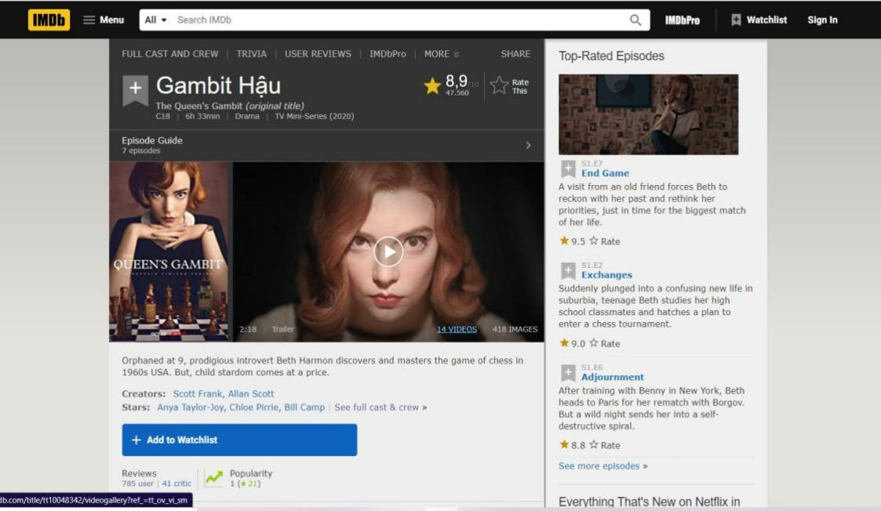

Figure 2.1. Movie's Informations

#### User Reviews

Overview:

You can see everyone's review of the movie as well as the rate score. When posting a review, if the review contains spoilers, we can choose whether or not this review will reveal content. In addition, upon successful registration of a member account of the site, we can leave a comment.

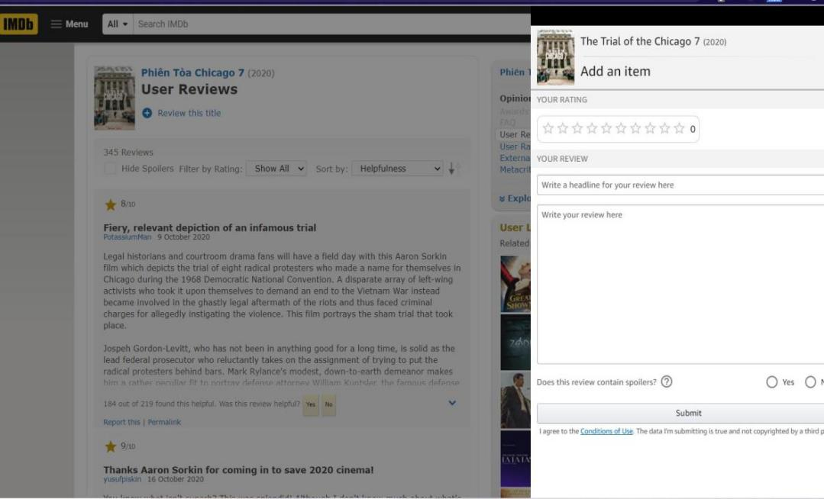

**Figure 2.2.** User reviews

### Moveek

#### Introduction

Moveek.com is an information site providing articles introducing and evaluating films shown in theaters across the country. In addition, Moveek also collaborates with cinema chains in the coutry to sell movie tickets [2].

Services are understood to include: movie tickets at co-operative theaters; corn - water or other foods provided by cooperative theaters; and items related to film promotion provided by the affiliated cinemas.

#### Website functionality

Overview:

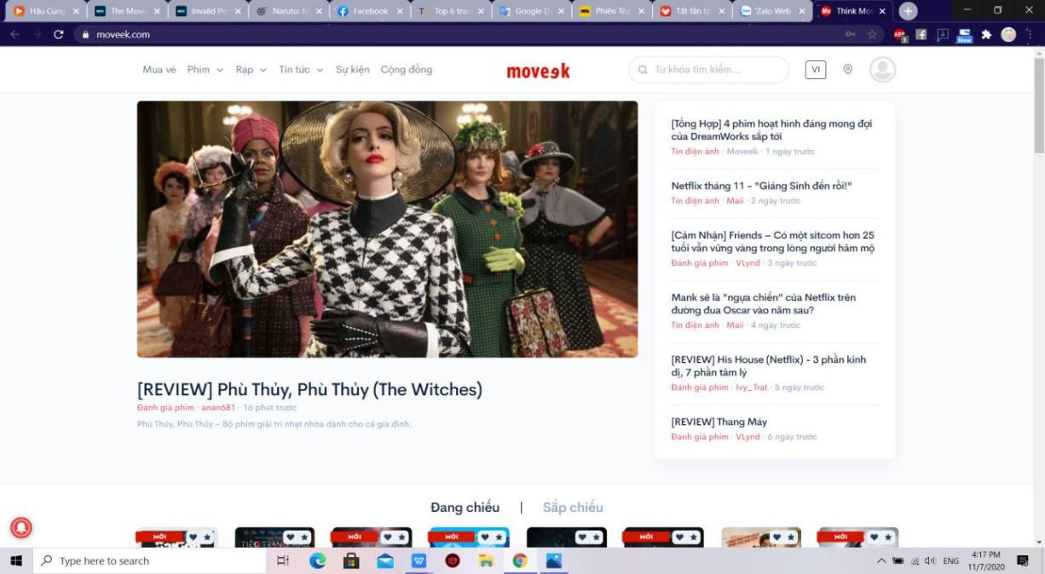

**Figure 2.3.** Overview website functionality

Home interface and functions:

* Book ticket: are movie tickets at movie theaters that Moveek cooperates. Customers can only purchase tickets online for theaters where Moveek has announced its Online Booking Partnership.
* Movie: see movie showtimes, list of movies is filtered by current, upcoming show..
* Cinema: list of theaters by region in cluster theaters working with moveek
* Information: Synthesize articles about movies, audience reviews, and related videos..

#### Review function

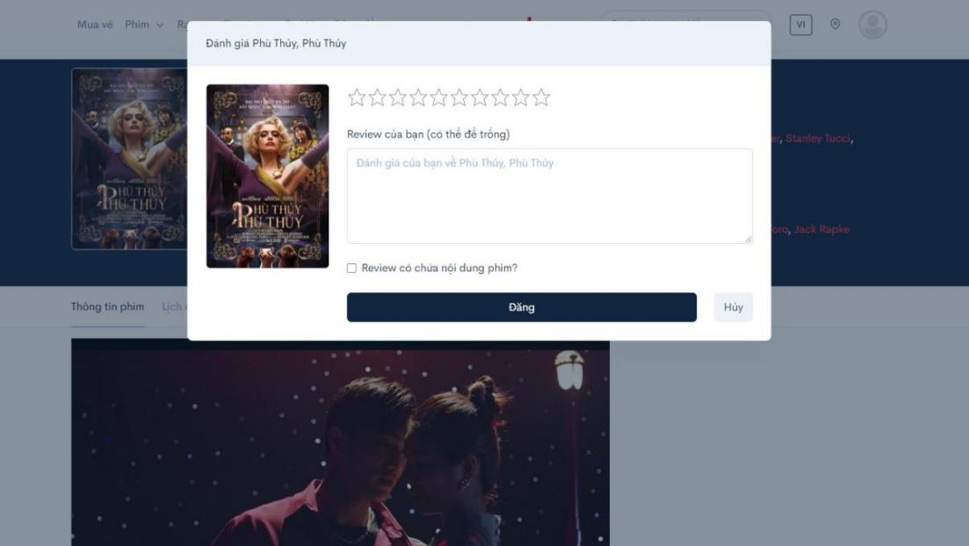

**Figure 2.4.** Review screen

You can see everyone's rating of the movie as well as the rate score. In addition, upon successful registration of a member account of the site, we can leave a comment. We can choose whether or not this review will reveal content.

#### Book tickets

Customers can only purchase tickets online for theaters where Moveek has announced its Online Booking Partnership.

Customers can buy tickets and choose seats just like when buying tickets at the theater.

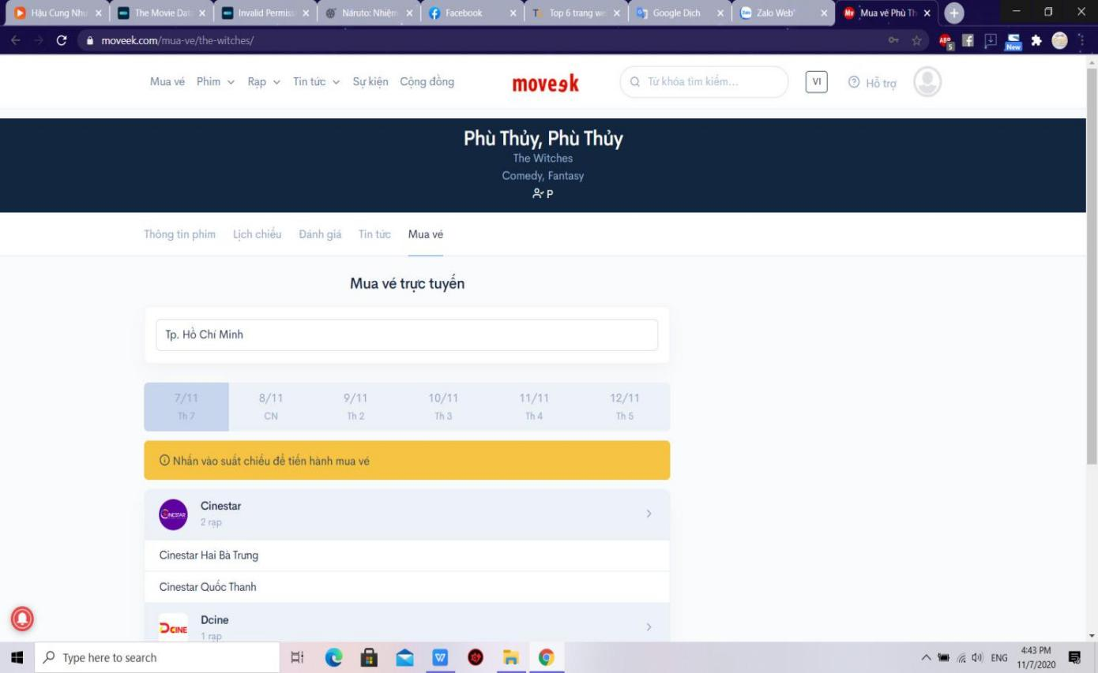

**Figure 2.5.** Book tickets function

## User requirement

With the results of collecting and examining the current systems, we will build an easy-to-use website that is decentralized to admin and users.

### Actor of system

Based on the description of the problem, we can identify the main actors of the system statistics are as follows:

- Super Admin: Use the system with the highest privileges. People who perform the functions of system administration, which is managing accounts, movies, posts, tasks, cinema chains. Super Administration functions in this system must be logged.

- Admin: Under Super Admin's control. Admin has movie management and user management rights, view statistic. Administration functions in this system must be logged.

- Authorized User: Inheriting all functions of Unauthorized user. Need to login to manage account, write reviews, like / unlike movies, view booking history.

- Guest: Can view showtimes, view reviews, view cinemas and book tickets also sign up for an account.

- Writer : Inherit all functions of Unauthorized user and can also accept/ deny assigned tasks, manage posts.

**Main functions:**

* **Super Admin’s functions:**

**Table 2.1.** Super Admin’s functions

|  |  |  |
| --- | --- | --- |
|  | Function name | Description |
| 1 | Add Admin | Register Admin account for employees. |
| 2 | Delete Admin | Delete Admin account from website. |
| 3 | Block Admin | Block Admin account when suspended or disciplined. |
| 4 | UnBlock Admin | Unblock Admin account to continue operating the site. |
| 5 | Add cinema chain | Add cinema chain to website. |
| 6 | Delete cinema chain | Delete cinema chain from website. |
| 7 | Add cinemas | Add cinemas in cinema chain to website |
| 8 | Delete a cinema | Delete a cinema from website |
| 9 | Update cinema’s information | Update detailed information about the chain of cinemas such as location, quantity.. |
| 10 | Add category | Add new category to website |

* **Admin’s functions**

**Table 2.2.** Admin functions

|  |  |  |
| --- | --- | --- |
|  | Function name | Description |
| 1 | Login | Enter username and password. Validation matches data. If available, the system will allow login to perform functions in the system. |
| 2 | Add Movie | Add movie and and classification to website. |
| 3 | Delete Movie | Delete movie from website. |
| 4 | Update movie’s cast | Update movie’s cast information |
| 5 | Update movie’s detail | Update detailed information about the movie such as datetime, trailers… |
| 6 | Block user | Block user account when suspended or disciplined. |
| 7 | Unblock user | Unblock Admin account to continue operating the site. |
| 8 | Update cinema’s information | Update detailed information about the chain of cinemas such as location, quantity.. |
| 9 | View statistics | See website analytics such as visits, interactions, ticket purchases.. |
| 10 | Create task | Create new task in task list |
| 11 | Edit task | Allow admin edit task that created |
| 12 | View post | Review a post that writer sent |
| 13 | Approve post | Publist a post |

* **Guest functions**

**Table 2.3.** Guest functions

|  |  |  |
| --- | --- | --- |
|  | Function name | Description |
| 1 | View movies in theaters | See information about movies being shown in cinemas. |
| 2 | View upcoming movies | See information about upcoming movies in cinemas. |
| 3 | View movie’s detail | View detailed movie information such as genre, actor, and screen time. |
| 4 | Search movies | Search for movies by keywords. |
| 5 | Search cinemas | Search for cinemas by keywords. |
| 6 | View cinema | The website navigates to the cinemas screen and displays a list of cinemas located in user’s city. |
| 7 | View cinema chain | Information about theaters is divided by regions for users to find easily |
| 8 | View cinema’s detail | Cinema information such as address, ticket price... |
| 9 | Register | Create an account as role “User”. |
| 10 | View post | View a post from webiste |

* **Authorized User’s functions**

**Table 2.4.** Authorized User functions

|  |  |  |
| --- | --- | --- |
|  | Function name | Description |
| 1 | Login | Enter username and password. Validation matches data. If available, the system will allow login to perform functions in the system. |
| 2 | Logout | Log out of the website |
| 3 | View movie’s detail | View detailed movie information such as genre, actor, and screen time. |
| 4 | Search movies | Search for movies by keywords. |
| 5 | View cinema | The website navigates to the cinemas screen and displays a list of cinemas located in user’s city. |
| 6 | View cinema chain | Information about theaters is divided by regions for users to find easily |
| 7 | View cinema’s detail | Cinema information such as address, ticket price... |

* **Writer’s functions**

**Table 2.5.** Writer functions

|  |  |  |
| --- | --- | --- |
|  | Function name | Description |
| 1 | Create post | Create a new post |
| 2 | Delete post | Delete an unsent post |
| 3 | Edit post | Modify a post user created and save |
| 4 | Review post | Review a post content |
| 5 | Send post | Send a post for the task he/she has been assigned to the the task’s owner |
| 6 | Accept task | Accept the assigned task |

### Document Management System

This system will manage all documents, drawings, detailed description of the entire system, helping newcomers in construction and development can read and understand the system quickly and easily. In addition, this system will make maintenance and upgrades a breeze, or for transferring technology to a new team more easily and quickly.

***Super Admin functions:***

* + - Add/Delete/Block/Unblock admin.
    - Add/Delete cinema chain.
    - Update cinema’s information.
    - Implementing the functions of Admin and User.
    - Add cinemas.
    - Delete a cinema.
    - Add category

***Admin functions:***

* + - Delete/Block/Unblock User
    - Add/Delete movie.
    - Update movie’s cast
    - Update movie’s details
    - View Statistics
    - Create/Edit task
    - Approve post
    - Write feedback

***Guest functions:***

* + - Register
    - View movies in theaters
    - View upcoming movies
    - View movie’s detail
    - Search movies.
    - View cinema
    - View cinema chain
    - View cinema’s detail
    - View posts

***Authorized User functions:***

* + - Login
    - Logout
    - Reset password
    - Update profile
    - Change password
    - Like/Unlike a movie
    - Write review and rate
    - View watchlist
    - Edit review
    - Delete review
    - Like or dislike a review
    - View order history

***Writer functions:***

* + - Create/ Delete/ Edit/ Review post
    - Send post
    - Accept task

### Usecase Diagram

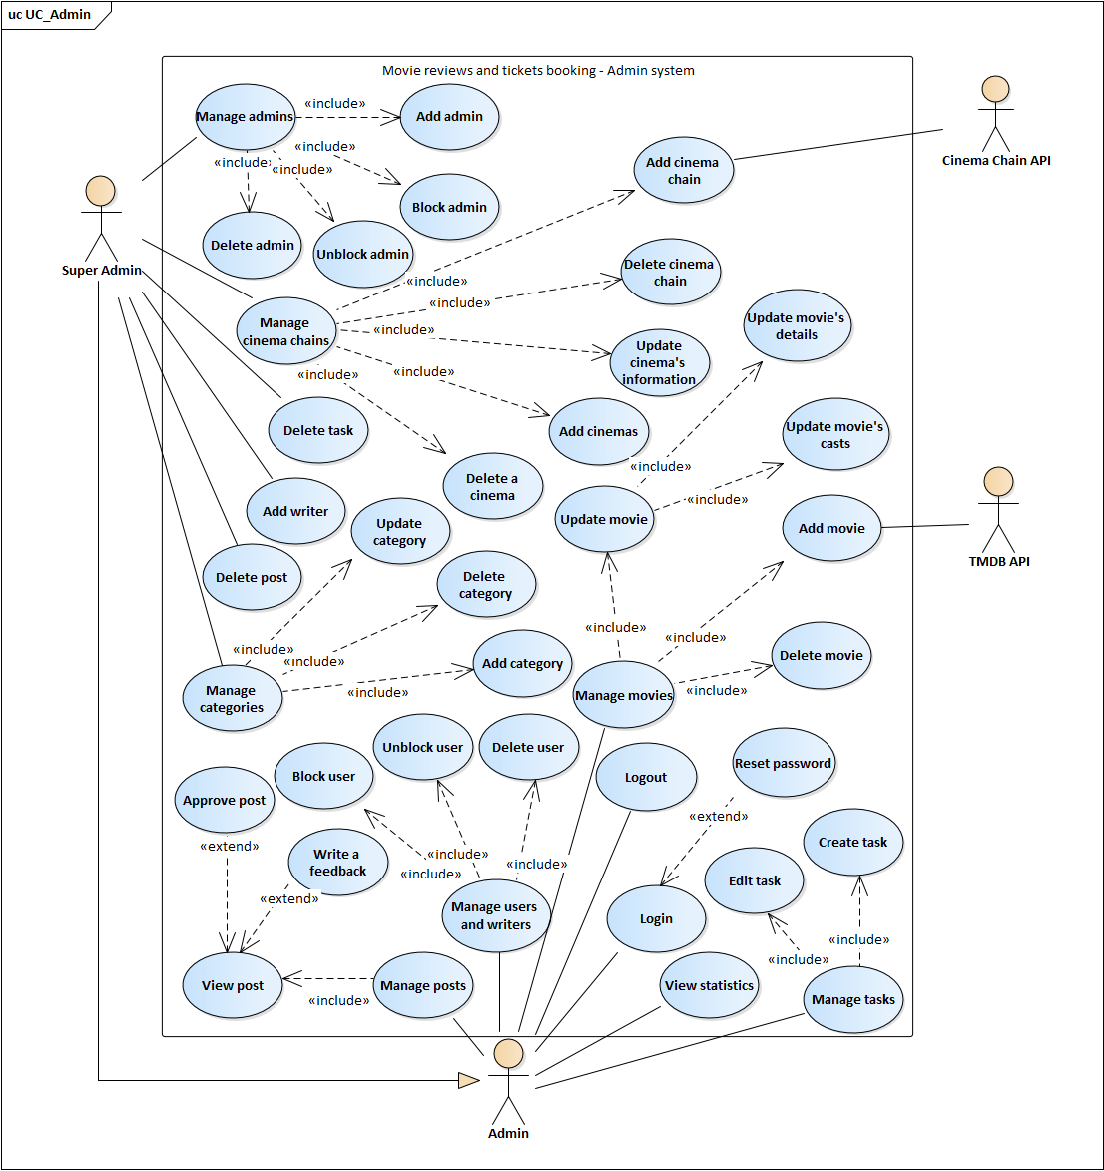

**Figure 2.6.** Usecase diagram for Admin's system



**Figure 2.7.** Usecase diagram for End – user’s system

### Usecase Description

#### Functional requirements of “Authorized user”

##### Use case “Login”



**Table 2.6.** Description for MRATB_US Login

|  |  |  |  |
| --- | --- | --- | --- |
| **USE CASE – MRATB-US_UC_01** | | | |
| **Use Case No.** | MRATB-US_UC_01 | **Use case version** | 1.0 |
| **Use case name** | Login | | |
| **Author** | Tôn Nữ Như Quỳnh | | |
| **Date** | 14/09/2020 | **Priority** | High |
| **Actor:**   * Authorized user   **Summary:**   * Allows Authorized user to login to the website.   **Goal:**   * User with authorization is logged in to the website with specific role.   **Triggers:**   * Users need to log in the website for some specific functions. * User click “Login” on the navigation bar.   **Preconditions:**   * User haven’t logged in to the website.   **Post conditions:**   * Succeeded: User is logged in to the website with specific role. * Failed: Error “Invalid user”.   **Main Success Scenario:**   |  |  |  | | --- | --- | --- | | **Step** | **Actor Action** | **System Response** | | 1 | Authorized user clicks “Login” on the right side of the navigation bar | The website shows the popup “Login” in the middle of the screen | | 2 | Authorized user types his/her name and password on the login form | [Exception 1]  [Exception 2]  [Exception 3] | | 3 | Authorized user clicks “Login”  [Alternative 1] | The popup disappears. On the right side of the navigation bar there will be the username of user  [Exception 4] |   **Alternative Scenario:**   |  |  |  | | --- | --- | --- | | **Step** | **Actor Action** | **System Response** | | 1 | Authorized user types “Enter” | The login form will be submitted and the website will validate the username and password |   **Exceptions:**   |  |  |  | | --- | --- | --- | | **No** | **Actor Action** | **System Response** | | 1 | Authorized user leaves username or password or both fields empty | Errors appear under the username or password input “Không được để trống trường này!” | | 2 | Username is not from 6 to 15 characters length, has special character or blank space | Errors appear under the username or password input “Tên đăng nhập không hợp lệ!” | | 3 | Password is not from 6 to 15 characters length | Errors appear under the username or password input “ Mật khẩu phải từ 6 - 15 kí tự!” | | 4 | Invalid username and password | Error appears on the top of login form “Tài khoản không tồn tại!” |   **Relationships:**  **Business Rules:**   * Username: must be 6 – 15 characters length with no special character and cannot be left empty. * Password: must be 6 – 15 characters length and cannot be left empty. | | | |

##### Use case “Reset password”



**Table 2.7.** Description for MRATB_US Reset password

|  |  |  |  |
| --- | --- | --- | --- |
| **USE CASE – MRATB-US_UC_02** | | | |
| **Use Case No.** | MRATB-US_UC_02 | **Use case version** | 1.0 |
| **Use case name** | Reset password | | |
| **Author** | Tôn Nữ Như Quỳnh | | |
| **Date** | 14/09/2020 | **Priority** | Low |
| **Actor:**   * Authorized user   **Summary:**   * Allows authorized user who forgot password to make a new password for his/her account.   **Goal:**   * Authorized user logins to the website with the new password.   **Triggers:**   * Authorized user forgot his/her password and clicks “Forgot password?” in the Login popup.   **Preconditions:**   * Authorized user haven’t logged in to the website.   **Post conditions:**   * Succeeded: User can login to the website with the new password. * Failed: User cannot login to the website with the new password.   **Main Success Scenario:**   |  |  |  | | --- | --- | --- | | **Step** | **Actor Action** | **System Response** | | 1 | Authorized user clicks “Login” on the right side of the navigation bar. | The Login popup appears at the center of the screen. | | 2 | Authorized user clicks “Forgot password?” at the right corner above the password input in the login form | The website navigate to reset password page. | | 3 | Authorized user types his/her registered email and clicks “Quên mật khẩu" | [Exception 1]  [Exception 2]  [Exception 3] | | 4 | Authorized user checks email and goes to the reset password link the website has sent. |  | | 5 | Authorized user types new password and confirm password. | [Exception 4] | | 6 | Authorized user clicks “Đặt lại” | Notification appears above the form “Đặt lại mật khẩu thành công” and the button “Về trang chủ” appears. |   **Alternative Scenario:**  **Exceptions:**   |  |  |  | | --- | --- | --- | | **No** | **Actor Action** | **System Response** | | 1 | User leaves email empty. | Error appears under the empty input “Không được bỏ trống trường này”, button “Gửi email” disables. | | 2 | User types invalid email | Error appears under the input “Email không hợp lệ!”, button “Gửi email” disables. | | 3 | User types email that does not exist | Error appears at the top right of the screen “Email chưa được đăng ký!”, button “Gửi email” disables. | | 4 | Password and confirm password don’t match | Error appears under the Confirm password input “Mật khẩu không trùng khớp!”. |   **Relationships:** MRATB-US_UC_01(Login)  **Business Rules:**   * Email: cannot be left empty and need existing. * Password and Confirm password: cannot be left empty and must match with each other. | | | |

##### Use case “Like a movie”



**Table 2.8.** Description for MRATB_US Like movie

|  |  |  |  |
| --- | --- | --- | --- |
| **USE CASE – MRATB-US_UC_03** | | | |
| **Use Case No.** | MRATB-US_UC_03 | **Use case version** | 1.0 |
| **Use case name** | Like a movie | | |
| **Author** | Tôn Nữ Như Quỳnh | | |
| **Date** | 15/09/2020 | **Priority** | Normal |
| **Actor:**   * Authorized user.   **Summary:**   * Allows user to like a movie and add this movie to his/her watchlist.   **Goal:**   * The heart symbol of the movie from gray turns to red and the movie will be added to the watchlist of user.   **Triggers:**   * User clicks the heart symbol of a movie in the movie list.   **Preconditions:**   * There’s no precondition for this usecase.   **Post conditions:**   * Succeeded: The heart symbol of the movie from gray turns to red. A green message appears at the top right corner of the screen “Like phim thành công!”. * Failed: The heart symbol of the movie doesn’t turns to red, no movie added to watchlist. A red message appears at the top right corner of the screen “Like phim không thành công!”.   **Main Success Scenario:**   |  |  |  | | --- | --- | --- | | **STEP** | **Actor Action** | **System Response** | | 1 | User clicks the heart symbol of a movie in the movie list screen  [Alternative 1]  [Alternative 2] | The heart symbol of the movie from gray turns to red. A green message appears at the top right corner of the screen “Like phim thành công!”.  [Exception 1] |   **Alternative Scenario:**   |  |  |  | | --- | --- | --- | | **No** | **Actor Action** | **System Response** | | 1 | User clicks the heart symbol of the movie in movie’s details screen |  | | 2 | User hasn’t logged in to the website | Popup login appears |   **Exceptions:**   |  |  |  | | --- | --- | --- | | **No** | **Actor Action** | **System Response** | | 1 |  | The heart symbol of the movie doesn’t turns to red, no movie added to watchlist. A red message appears at the top right corner of the screen “Like phim không thành công!”. |   **Relationships:**  **Business Rules:**   * Unauthorized user will need authorization to like a movie. | | | |

##### Use case “Write a review and rate”



**Table 2.9.** Description for MRATB_US Write a review and rate

|  |  |  |  |
| --- | --- | --- | --- |
| **USE CASE – MRATB-US_UC_04** | | | |
| **Use Case No.** | MRATB-US_UC_04 | **Use case version** | 1.0 |
| **Use case name** | Write a review and rate | | |
| **Author** | Tôn Nữ Như Quỳnh | | |
| **Date** | 15/09/2020 | **Priority** | Normal |
| **Actor:**   * Authorized user.   **Summary:**   * Allows user to rate and write view for a movie.   **Goal:**   * User’s review and rating for a movie will be displayed in the review list of that movie.   **Triggers:**   * User clicks “Đánh giá” in the movie’s details screen.   **Preconditions:**   * The website is in the movie details screen.   **Post conditions:**   * Succeeded: Page reloads, user’s review for the movie will be displayed in the review list of that movie. * Failed: Shows error.   **Main Success Scenario:**   |  |  |  | | --- | --- | --- | | **STEP** | **Actor Action** | **System Response** | | 1 | User clicks “Đánh giá” in the movie details screen. | Popup Review will be displayed at the center of movie detail screen. | | 2 | User rates and types review and ticks “Review có tiết lộ nội dung?” if the review contains spoilers |  | | 3 | User clicks “Đăng” | Page reloads, user’s review and rating for a movie will be displayed in the review list of that movie.  [Exception 1]  [Exception 2]  [Alternative 1] |   **Alternative Scenario:**   |  |  |  | | --- | --- | --- | | **No** | **Actor Action** | **System Response** | | 1 | User hasn’t logged in to the website | Popup Login will be displayed |   **Exceptions:**   |  |  |  | | --- | --- | --- | | **No** | **Actor Action** | **System Response** | | 1 | User writes a review but leaves the rating empty | Error in the Review form “Không được bỏ trống trường này!” | | 2 |  | Review form closes. A red message appears at the top right corner of the screen “Post đánh giá không thành công!”. |   **Relationships:** MRABTW_UC_16 (View movie’s details)  **Business Rules:**   * Rating: must be rated. * Review: can be left empty if user already rates the movie. * User needs authorization to post a review. | | | |

##### Use case “Like or Dislike a review”



**Table 2.10.** Description for MRATB_US Like or Dislike a review

|  |  |  |  |
| --- | --- | --- | --- |
| **USE CASE – MRATB-US_UC_05** | | | |
| **Use Case No.** | MRATB-US_UC_05 | **Use case version** | 1.0 |
| **Use case name** | Like or Dislike a review | | |
| **Author** | Tôn Nữ Như Quỳnh | | |
| **Date** | 15/09/2020 | **Priority** | Normal |
| **Actor:**   * Authorized user.   **Summary:**   * Allows user to like or dislike a review.   **Goal:**   * The like (dislike) button below the review will be displayed in green (red for dislike).   **Triggers:**   * User clicks like or dislike button below the review.   **Preconditions:**   * The website is in the movie details screen.   **Post conditions:**   * Succeeded: The like (dislike) button below the review will be displayed in green (red for dislike).   **Main Success Scenario:**   |  |  |  | | --- | --- | --- | | **STEP** | **Actor Action** | **System Response** | | 1 | User clicks on the like (dislike) button below the review. | The like (dislike) button below the review will be displayed in green (red for dislike). The number counting likes or dislikes next to the button will be updated.  [Alternative 1] |   **Alternative Scenario:**   |  |  |  | | --- | --- | --- | | **No** | **Actor Action** | **System Response** | | 1 | User hasn’t logged in to the website | Popup Login will be displayed |   **Exceptions:**  **Relationships:**  **Business Rules:**   * User cannot like and dislike a review at the same time. * Unauthorized user when clicks on like/dislike button will need authorization to like or dislike a review. | | | |

##### Use case “Log out”



**Table 2.11.** Description for MRATB_US Logout

|  |  |  |  |
| --- | --- | --- | --- |
| **USE CASE – MRATB-US_UC_05** | | | |
| **Use Case No.** | MRATB-US_UC_06 | **Use case version** | 1.0 |
| **Use case name** | Log out | | |
| **Author** | Tôn Nữ Như Quỳnh | | |
| **Date** | 16/09/2020 | **Priority** | Normal |
| **Actor:**   * Authorized user   **Summary:**   * Allows user to log out of the website.   **Goal:**   * User logs out of the website becoming unauthorized user.   **Triggers:**   * User clicks “Logout” in the menu on the right side of the website’s navigation bar.   **Preconditions:**   * User has already logged in to the website.   **Post conditions:**   * Succeeded: User log out of the website becoming unauthorized user.   **Main Success Scenario:**   |  |  |  | | --- | --- | --- | | **STEP** | **Actor Action** | **System Response** | | 1 | User clicks “Logout” in the menu on the right side of the website’s navigation bar | The website navigates to the home page, username at the right side of the navigation bar disappears |   **Alternative Scenario:**  **Exceptions:**  **Relationships:**  **Business Rules:** | | | |

##### Use case “Update profile”



**Table 2.12.** Description for MRATB_US Update profile

|  |  |  |  |
| --- | --- | --- | --- |
| **USE CASE – MRATB-US_UC_07** | | | |
| **Use Case No.** | MRATB-US_UC_07 | **Use case version** | 1.0 |
| **Use case name** | Update profile | | |
| **Author** | Tôn Nữ Như Quỳnh | | |
| **Date** | 16/09/2020 | **Priority** | Normal |
| **Actor:**   * Authorized user.   **Summary:**   * Allows user to change their profile’s information.   **Goal:**   * The changes user make in their profile will be saved.   **Triggers:**   * User clicks “Quản lý tài khoản” in the menu on the right side of the navigation’s bar.   **Preconditions:**   * User has logged in to the website.   **Post conditions:**   * Succeeded: The website notifies “Cập nhật thành công”. * Failed: The website shows error.   **Main Success Scenario:**   |  |  |  | | --- | --- | --- | | **STEP** | **Actor Action** | **System Response** | | 1 | User clicks “Quản lý tài khoản” in the menu on the right side of the navigation’s bar | The website navigates to the user’s profile screen to display user’s information. | | 2 | User types into those inputs which user want to change | [Exception 1] | | 3 | User clicks “Cập nhật” | The website saves changes into the database and shows message “Cập nhật thành công” |   **Alternative Scenario:**  **Exceptions:**   |  |  |  | | --- | --- | --- | | **No** | **Actor Action** | **System Response** | | 1 | User doesn’t type correct phone number format | Displays error above phone number input “Invalid phone number format” |   **Relationships:**  **Business Rules:**   * User cannot change username and email input. * Fullname, Region, Phone number could be left empty. * The profile image input cannot browse other file format except .png, .jpg, .jpeg. | | | |

##### Use case “Change password”



**Table 2.13.** Description for MRATB_US Change password

|  |  |  |  |
| --- | --- | --- | --- |
| **USE CASE – MRATB-US_UC_08** | | | |
| **Use Case No.** | MRATB-US_UC_08 | **Use case version** | 1.0 |
| **Use case name** | Change password | | |
| **Author** | Tôn Nữ Như Quỳnh | | |
| **Date** | 16/09/2020 | **Priority** | Normal |
| **Actor:**   * Authorized user.   **Summary:**   * Allows user to changes his/her account’s password.   **Goal:**   * User’s new password will be saved into database and user can log in to the website by the new password.   **Triggers:**   * User clicks “Quản lý tài khoản” in the menu on the right side of the navigation’s bar, open the tab “Đổi mật khẩu” in profile screen.   **Preconditions:**   * User has logged in to the website.   **Post conditions:**   * Succeeded: The website shows message “Đổi mật khẩu thành công”. * Failed: The website shows error.   **Main Success Scenario:**   |  |  |  | | --- | --- | --- | | **STEP** | **Actor Action** | **System Response** | | 1 | User clicks “Quản lý tài khoản” in the menu on the right side of the navigation’s bar, open the tab “Đổi mật khẩu” in profile screen | The website navigates to the user’s profile screen then open tab “Đổi mật khẩu” | | 2 | User types the required inputs: Current password, New password, Confirm password | [Exception 1]  [Exception 2]  [Exception 3] | | 3 | User clicks “Đổi mật khẩu” | The website saves changes into the database and shows message “Đổi mật khẩu thành công”  [Exception 4] |   **Alternative Scenario:**  **Exceptions:**   |  |  |  | | --- | --- | --- | | **No** | **Actor Action** | **System Response** | | 1 | User leaves required inputs empty | Errors appear above those input “Không được bỏ trống trường này” | | 2 | User enter new password with incorrect format | Errors appear above those input “Mật khẩu phải từ 6 - 15 kí tự!” | | 3 | New password and confirm password don’t match | Error appears above Confirm password input “Mật khẩu không trùng khớp” | | 4 | Current password isn’t correct | Shows message “Mật khẩu hiện tại không đúng”. |   **Relationships:**  **Business Rules:**   * New password and Confirm password must match. * New password must be 6 to 15 characters length. * The required inputs: Current password, New password, Confirm password must be filled for user to be able to submit form. | | | |

##### Use case “View Watchlist”



**Table 2.14.** Description for MRATB_US View watchlist

|  |  |  |  |
| --- | --- | --- | --- |
| **USE CASE – MRATB-US_UC_09** | | | |
| **Use Case No.** | MRATB-US_UC_09 | **Use case version** | 1.0 |
| **Use case name** | View Watchlist | | |
| **Author** | Tôn Nữ Như Quỳnh | | |
| **Date** | 16/09/2020 | **Priority** | Normal |
| **Actor:**   * Authorized user.   **Summary:**   * Allows user to view the list of movies he/she has rated and liked.   **Goal:**   * The website navigates to the watchlist screen and displays a list of movies he/she has rated and liked.   **Triggers:**   * User clicks “Tủ phim” in the menu on the right side of the navigation’s bar.   **Preconditions:**   * User has logged in to the website.   **Post conditions:**   * Succeeded: The website navigates to the watchlist screen and displays a list of movies he/she has rated and liked.   **Main Success Scenario:**   |  |  |  | | --- | --- | --- | | **STEP** | **Actor Action** | **System Response** | | 1 | User clicks “Tủ phim” in the menu on the right side of the navigation’s bar. | The website navigates to the watchlist screen and displays a list of movies he/she has rated and liked. |   **Alternative Scenario:**  **Exceptions:**  **Relationships:**  **Business Rules:** | | | |

##### Use case “View order history”

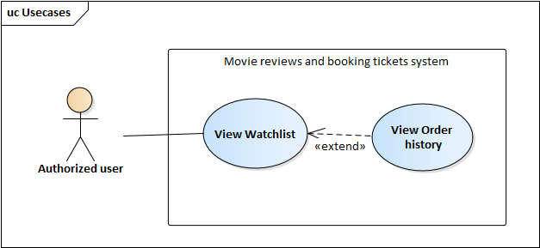

**Table 2.15.** Description for MRATB_US View order history

|  |  |  |  |
| --- | --- | --- | --- |
| **USE CASE – MRATB-US_UC_10** | | | |
| **Use Case No.** | MRATB-US_UC_10 | **Use case version** | 1.0 |
| **Use case name** | View Order history | | |
| **Author** | Tôn Nữ Như Quỳnh | | |
| **Date** | 16/09/2020 | **Priority** | Normal |
| **Actor:**   * Authorized user.   **Summary:**   * Allows user to view the list of orders he/she has made.   **Goal:**   * The website switches to tab “Vé đã mua” in Watchlist screen and displays a list of orders user has made.   **Triggers:**   * User clicks “Vé đã mua” tab in the watchlist screen.   **Preconditions:**   * User has logged in to the website.   **Post conditions:**   * Succeeded: The website switches to tab “Vé đã mua” in Watchlist screen and displays a list of orders user has made.   **Main Success Scenario:**   |  |  |  | | --- | --- | --- | | **STEP** | **Actor Action** | **System Response** | | 1 | User clicks “Vé đã mua” tab in the watchlist screen. | The website switches to tab “Vé đã mua” in Watchlist screen and displays a list of orders user has made. |   **Alternative Scenario:**  **Exceptions:**  **Relationships:** MRABTW_UC_09  **Business Rules:** | | | |

##### Use case “Edit Review”



**Table 2.16.** Description for MRATB_US Edit review

|  |  |  |  |
| --- | --- | --- | --- |
| **USE CASE – MRATB-US_UC_11** | | | |
| **Use Case No.** | MRATB-US_UC_11 | **Use case version** | 1.0 |
| **Use case name** | Edit Review | | |
| **Author** | Tôn Nữ Như Quỳnh | | |
| **Date** | 17/09/2020 | **Priority** | Normal |
| **Actor:**   * Authorized user.   **Summary:**   * Allows user to edit the review he/she wrote.   **Goal:**   * The changes will be saved to database and the review will be updated according to changes.   **Triggers:**   * User clicks “Đánh giá” in the movie details screen.   **Preconditions:**   * User has logged in to the website. * User is in the movie details screen of the movie for which user rated and wrote a review.   **Post conditions:**   * Succeeded: The changes user make will be saved to database and the review will be updated according to changes. * Failed: The review won’t be updated according to changes user make.   **Main Success Scenario:**   |  |  |  | | --- | --- | --- | | **STEP** | **Actor Action** | **System Response** | | 1 | User clicks “Đánh giá” in the movie details screen.  [Alternative 1] | Popup Review will be displayed at the center of movie detail screen and shows user’s review and rating of the movie | | 2 | User changes the rating, review or checkbox “Review có tiết lộ nội dung?” | [Exception 1] | | 3 | User clicks “Đăng” | User’s review for the movie will be updated in the review list of that movie. |   **Alternative Scenario:**   |  |  |  | | --- | --- | --- | | **No** | **Actor Action** | **System Response** | | 1 | User clicks the yellow star icon list in movie list screen |  |   **Exceptions:**   |  |  |  | | --- | --- | --- | | **No** | **Actor Action** | **System Response** | | 1 | User writes a review but leaves the rating empty | Error in the Review form “Không được để trống” |   **Relationships:**  **Business Rules:**   * User can only edit his/her review. * Rating: cannot be left empty. * Review: can be left empty if user already rates the movie. | | | |

##### Use case “Delete Review”



**Table 2.17.** Description for MRATB_US Delete review

|  |  |  |  |
| --- | --- | --- | --- |
| **USE CASE – MRATB-US_UC_12** | | | |
| **Use Case No.** | MRATB-US_UC_12 | **Use case version** | 1.0 |
| **Use case name** | Delete review | | |
| **Author** | Tôn Nữ Như Quỳnh | | |
| **Date** | 17/09/2020 | **Priority** | Normal |
| **Actor:**   * Authorized user.   **Summary:**   * Allows user to delete his/her review for a movie.   **Goal:**   * The review will be disappear from the review list in movie’s details screen.   **Triggers:**   * User clicks “Đánh giá” in the movie details screen. * User clicks “Xóa review” button in the Review popup.   **Preconditions:**   * User has logged in to the website. * User is in the movie details screen of the movie for which user rated and wrote a review.   **Post conditions:**   * Succeeded: The website shows green message “Xóa đánh giá thành công” and the review will disappear from the review list in movie’s details screen. * Failed: The website show red message.   **Main Success Scenario:**   |  |  |  | | --- | --- | --- | | **STEP** | **Actor Action** | **System Response** | | 1 | User clicks “Đánh giá” in the movie details screen.  [Alternative 1] | Popup Review will be displayed at the center of movie detail screen and shows user’s review and rating of the movie | | 2 | User clicks “Xóa review” button in the Review popup. | Confirm dialog appears “Bạn có chắc muốn xóa bài đánh giá này?” | | 3 | User clicks “Yes”  [Alternative 2] | The website shows green message “Xóa thành đánh giá công”, page reloads & the review will disappear from the review list in movie’s details screen.  [Exception 1] |   **Alternative Scenario:**   |  |  |  | | --- | --- | --- | | **No** | **Actor Action** | **System Response** | | 1 | User clicks the yellow star icon list in movie list screen |  | | 2 | User clicks “No” | The Confirm dialog disappears. |   **Exceptions:**   |  |  |  | | --- | --- | --- | | **No** | **Actor Action** | **System Response** | | 1 |  | The website show red message “Xóa đánh giá không thành công!” |   **Relationships:** MRATB-US_UC_11  **Business Rules:**   * User can only delete his/her review. | | | |

#### Functional requirements of “Guest”

##### Use case “Register”



**Table 2.18.** Description for MRATB_US Register

|  |  |  |  |
| --- | --- | --- | --- |
| **USE CASE – MRATB-US_UC_13** | | | |
| **Use Case No.** | MRATB-US_UC_13 | **Use case version** | 1.0 |
| **Use case name** | Register | | |
| **Author** | Tôn Nữ Như Quỳnh | | |
| **Date** | 14/09/2020 | **Priority** | High |
| **Actor:**   * Guest.   **Summary:**   * Allows guest to create an account as role “User”.   **Goal:**   * Guest becomes authorized user of the website with role as “User”.   **Triggers:**   * Guest who haven’t registered an account to the website. * Guest click on “Register” in the Login popup   **Preconditions:**   * Guest who doesn’t have an account.   **Post conditions:**   * Succeeded: Guest is logged in to the website as role “User” * Failed: Cannot create account.   **Main Success Scenario:**   |  |  |  | | --- | --- | --- | | **Step** | **Actor Action** | **System Response** | | 1 | Guest clicks “Register” on the right side of the navigation bar.  [Alternative 1] | The website navigate to the register screen. | | 2 | Guest types his/her email, username, passwords | [Exception 1], [Exception 2] | | 3 | Guest clicks “Tạo tài khoản”  [Alternative 2] | Notification appears above the register form “Tạo tài khoản thành công” and the website navigates back to home page.  [Exception 3] |   **Alternative Scenario:**   |  |  |  | | --- | --- | --- | | **Step** | **Actor Action** | **System Response** | | 1 | Guest clicks “Register” at the bottom of Login popup |  | | 2 | Guest types “Enter” | The register form will be submitted and the website will validate the input fields. |   **Exceptions:**   |  |  |  | | --- | --- | --- | | **No** | **Actor Action** | **System Response** | | 1 | Guest leaves username, passwords or empty. | Errors appear under the empty inputs “Không được bỏ trống trường này”. | | 2 | Password and confirm password don’t match | Error appears under the Confirm password input “Các mật khẩu không trùng khớp”. | | 3 | Reused email or username | Errors on the top of email or username input “Đã được sử dụng”. |   **Relationships:**  **Business Rules:**   * Username: cannot be left empty and cannot be reused. * Email: cannot be left empty and cannot be reused. * Password and Confirm password: cannot be left empty and must match with each other. | | | |

##### Use case “View upcoming movies”



**Table 2.19.** Description for MRATB_US View upcoming movies

|  |  |  |  |
| --- | --- | --- | --- |
| **USE CASE – MRATB-US_UC_14** | | | |
| **Use Case No.** | MRATB-US_UC_14 | **Use case version** | 1.0 |
| **Use case name** | View upcoming movies | | |
| **Author** | Tôn Nữ Như Quỳnh | | |
| **Date** | 15/09/2020 | **Priority** | High |
| **Actor:**   * Guest.   **Summary:**   * Allows user to view upcoming movies.   **Goal:**   * The website displays a list of upcoming movies.   **Triggers:**   * User clicks “Sắp chiếu” option in the menu “Phim” of navigation bar.   **Preconditions:**   * There’s no precondition for this use case.   **Post conditions:**   * Succeeded: The website directs to the movie list screen.   **Main Success Scenario:**   |  |  |  | | --- | --- | --- | | **STEP** | **Actor Action** | **System Response** | | 1 | User clicks “Sắp chiếu” option in the menu “Phim” of navigation bar | The website directs to the movie list screen displaying upcoming movies.  [Exception 1] |   **Alternative Scenario:**  **Exceptions:**   |  |  |  | | --- | --- | --- | | **No** | **Actor Action** | **System Response** | | 1 |  | The website displays “Không có phim sắp chiếu” |   **Relationships:**  **Business Rules:** | | | |

##### Use case “View movies in theaters”



**Table 2.20.** Description for MRATB_US View movies in theaters

|  |  |  |  |
| --- | --- | --- | --- |
| **USE CASE – MRATB-US_UC_15** | | | |
| **Use Case No.** | MRATB-US_UC_15 | **Use case version** | 1.0 |
| **Use case name** | View movies in theaters | | |
| **Author** | Tôn Nữ Như Quỳnh | | |
| **Date** | 15/09/2020 | **Priority** | Normal |
| **Actor:**   * Guest.   **Summary:**   * Allows user to view movies now playing in theaters.   **Goal:**   * The website displays a list of movies on theaters.   **Triggers:**   * User clicks “Đang chiếu” option in the menu “Phim” of navigation bar.   **Preconditions:**   * There’s no precondition for this use case.   **Post conditions:**   * Succeeded: The website directs to the movie list screen.   **Main Success Scenario:**   |  |  |  | | --- | --- | --- | | **STEP** | **Actor Action** | **System Response** | | 1 | User clicks “Đang chiếu” option in the menu “Phim” of navigation bar | The website directs to the movie list screen displaying movies that are playing at the theaters.  [Exception 1] |   **Alternative Scenario:**  **Exceptions:**   |  |  |  | | --- | --- | --- | | **No** | **Actor Action** | **System Response** | | 1 |  | The website displays “Không có phim đang chiếu” |   **Relationships:**  **Business Rules:** | | | |

##### Use case “View movie’s details”



**Table 2.21.** Description for MRATB_US View movie's details

|  |  |  |  |
| --- | --- | --- | --- |
| **USE CASE – MRATB-US_UC_16** | | | |
| **Use Case No.** | MRATB-US_UC_16 | **Use case version** | 1.0 |
| **Use case name** | View movie’s details | | |
| **Author** | Tôn Nữ Như Quỳnh | | |
| **Date** | 15/09/2020 | **Priority** | Normal |
| **Actor:**   * Guest.   **Summary:**   * Allows user to view details of a movie.   **Goal:**   * The website displays movie’s details.   **Triggers:**   * User clicks on a movie in the movie list screen.   **Preconditions:**   * There’s no precondition for this use case.   **Post conditions:**   * Succeeded: The website directs to the movie’s details screen. * Failed: The website directs to the Not Found screen.   **Main Success Scenario:**   |  |  |  | | --- | --- | --- | | **STEP** | **Actor Action** | **System Response** | | 1 | User clicks on a movie in the movie list screen | The website directs to the movie’s details screen displaying movie’s information, showtimes, reviews.  [Exception 1] |   **Alternative Scenario:**   |  |  |  | | --- | --- | --- | | **No** | **Actor Action** | **System Response** | | 1 | User clicks on a movie in the movie list in home page |  |   **Exceptions:**   |  |  |  | | --- | --- | --- | | **No** | **Actor Action** | **System Response** | | 1 |  | The website directs to the Not Found screen. |   **Relationships:**  **Business Rules:** | | | |

##### Use case “View movie’s showtimes”



**Table 2.22.** Description for MRATB_US View movie's showtimes

|  |  |  |  |
| --- | --- | --- | --- |
| **USE CASE – MRATB-US_UC_17** | | | |
| **Use Case No.** | MRATB-US_UC_17 | **Use case version** | 1.0 |
| **Use case name** | View movie’s showtimes | | |
| **Author** | Tôn Nữ Như Quỳnh | | |
| **Date** | 15/09/2020 | **Priority** | Normal |
| **Actor:**   * Guest.   **Summary:**   * Allows user to view the movie’s showtimes at theaters that are located in the user’s city.   **Goal:**   * The website displays the movie’s showtimes in specific cinemas.   **Triggers:**   * User clicks “Lịch chiếu” tab in the movie details screen.   **Preconditions:**   * The website is in the movie details screen.   **Post conditions:**   * Succeeded: The website displays the movie’s showtimes in every cinema located at user’s city.   **Main Success Scenario:**   |  |  |  | | --- | --- | --- | | **STEP** | **Actor Action** | **System Response** | | 1 | User clicks the tab “Lịch chiếu” in the movie details screen.  [Alternative 1] | Displays a list of cinema chains which has showtimes of the movie on that day, in located city. | | 2 | User clicks on a cinema chain | Display a list of cinemas located in user’s city | | 3 | User clicks on a cinema in the list | Displays a list of showtimes of the movie in that cinema |   **Alternative Scenario:**   |  |  |  | | --- | --- | --- | | **No** | **Actor Action** | **System Response** | | 1 | User clicks “Mua vé” button in the movie details screen |  |   **Exceptions:**  **Relationships:** MRATB-US_UC_16  **Business Rules:**   * The showtime which is already passed will has color gray. | | | |

##### Use case “Book tickets”



**Table 2.23.** Description for MRATB_US Book tickets

|  |  |  |  |
| --- | --- | --- | --- |
| **USE CASE – MRATB-US_UC_18** | | | |
| **Use Case No.** | MRATB-US_UC_18 | **Use case version** | 1.0 |
| **Use case name** | Book tickets | | |
| **Author** | Nguyễn Ngọc Tú Duyên | | |
| **Date** | 21/10/2020 | **Priority** | Normal |
| **Actor:**   * Guest.   **Summary:**   * Allows user to book the movie’s tickets from cinemas that are cooperate with “Movie Review and Tickets ”.   **Goal:**   * User can book the movie’s tickets valid as tickets purchased at cinema.   **Triggers:**   * User picks a showtimes in the movie’ showtime list.   **Preconditions:**  **Post conditions:**   * Succeeded: User get an email and a SMS which user fills in the checkout page to inform the tickets info. * Failed: Website show errors.   **Main Success Scenario:**   |  |  |  | | --- | --- | --- | | **STEP** | **Actor Action** | **System Response** | | 1 | User go to Movie details page | Display movies’s details | | 2 | User clicks the tab “Lịch chiếu” | Display a list showtimes in that day and in located city. | | 3 | User clicks on an available showtime | The website navigates to Booking page displaying seats of the showtime. | | 4 | User clicks on a showtime in list | Display a list of rows and countdown booking seat time. | | 5 | User chooses seat number in list then clicks “Tiếp tục”.  [Alternative 1] | Display the Checkout page | | 6 | User fills in information form then clicks on “Thanh toán”.  [Exception 1]  [Alternative 1] | Display Stripe payment form | | 7 | User fills in the card’s info in Stripe payment form and clicks “Pay ...”  [Alternative 1] | The page displays loading circle and navigates to the Ticket details page displaying Tickets’s information. User also receives email and SMS informing tickets are booked sucessfully.  [Exception 2]  [Exception 3] |   **Alternative Scenario:**   |  |  |  | | --- | --- | --- | | **No** | **Actor Action** | **System Response** | | 1 | User hasn’t finished the order after 5 minutes | A dialog appears “Hết thời gian giữ ghế. Hãy thực hiện lại đơn hàng của bạn” |   **Exceptions:**   |  |  |  | | --- | --- | --- | | **No** | **Actor Action** | **System Response** | | 1 | User leaves required inputs empty | Errors appear beneath inputs, button “Thanh toán” disables. | | 2 | One or more of the seats user picked were picked by someone else before the order was posted to the system | A dialog appears “Đã xảy ra lỗi, hãy thực hiện lại đơn hàng của bạn” | | 3 | User’s Card is unable to be charged | A red message appears at the top right corner of the screen “Thông tin thẻ không hợp lệ!” |   **Relationships:** MRATB-US_UC_17 (View movie’s showtimes), MRATB-US_UC_23 (View cinema’s details)  **Business Rules:**   * The seat reservation time is 5 minutes, after that if user hasn’t finished order, user will be asked to come back previous page. * The email in Checkout form is the email user wants website to send tickets’ information, the email in Stripe payment is the email of the card’s owner. | | | |

##### Use case “Search movie”



**Table 2.24.** Description for MRATB_US Search movies

|  |  |  |  |
| --- | --- | --- | --- |
| **USE CASE – MRATB-US_UC_19** | | | |
| **Use Case No.** | MRATB-US_UC_19 | **Use case version** | 1.0 |
| **Use case name** | Search movies | | |
| **Author** | Tôn Nữ Như Quỳnh | | |
| **Date** | 15/09/2020 | **Priority** | Normal |
| **Actor:**   * Guest.   **Summary:**   * Allows user to search movies matching the keyword.   **Goal:**   * The website navigates to the search screen and displays list of movies matching the search keyword.   **Triggers:**   * User types “Enter” after typing a search string or clicks the search symbol next to the search input.   **Preconditions:**   * User is in the home page of the website where the search bar is.   **Post conditions:**   * Succeeded: The website navigates to the search screen and displays list of movies matching the search keyword.   **Main Success Scenario:**   |  |  |  | | --- | --- | --- | | **STEP** | **Actor Action** | **System Response** | | 1 | User types the search keyword into the search input in home page and clicks the search symbol on the right side of the input  [Alternative 1] | The website navigates to the search screen and displays list of movies matching the search keyword.  [Alternative 2] |   **Alternative Scenario:**   |  |  |  | | --- | --- | --- | | **No** | **Actor Action** | **System Response** | | 1 | User types “Enter” after typing the search string |  | | 2 |  | Displays “Không có kết quả tìm kiếm cho ...” |   **Exceptions:**  **Relationships:**  **Business Rules:** | | | |

##### Use case “View Cinemas”



**Table 2.25.** Description for MRATB_US View cinemas

|  |  |  |  |
| --- | --- | --- | --- |
| **USE CASE – MRATB-US_UC_20** | | | |
| **Use Case No.** | MRATB-US_UC_20 | **Use case version** | 1.0 |
| **Use case name** | View Cinemas | | |
| **Author** | Tôn Nữ Như Quỳnh | | |
| **Date** | 15/09/2020 | **Priority** | Normal |
| **Actor:**   * Unauthorized user.   **Summary:**   * Allows user to view cinemas located in user’s city.   **Goal:**   * The website navigates to the cinemas screen and displays a list of cinemas located in user’s city.   **Triggers:**   * User clicks “Rạp phim” button on the left side of the navigation bar.   **Preconditions:**   * There’s no precondition for this usecase.   **Post conditions:**   * Succeeded: A dialog shows up displaying a list of cinemas in user’s located city.   **Main Success Scenario:**   |  |  |  | | --- | --- | --- | | **STEP** | **Actor Action** | **System Response** | | 1 | User clicks “Rạp phim” button on the left side of the navigation bar | A dialog shows up displaying a list of cinemas in user’s located city. |   **Alternative Scenario:**  **Exceptions:**  **Relationships:**  **Business Rules:** | | | |

##### Use case “View cinema details”



**Table 2.26.** Description for MRATB_US View cinema's details

|  |  |  |  |
| --- | --- | --- | --- |
| **USE CASE – MRATB-US_UC_21** | | | |
| **Use Case No.** | MRATB-US_UC_21 | **Use case version** | 1.0 |
| **Use case name** | View cinema’s details | | |
| **Author** | Tôn Nữ Như Quỳnh | | |
| **Date** | 16/09/2020 | **Priority** | Normal |
| **Actor:**   * Unauthorized user.   **Summary:**   * Allows user to view cinema’s details.   **Goal:**   * The website navigates to the cinema’s detail screen and displays cinema’s information.   **Triggers:**   * User clicks on a cinema in the cinema list screen.   **Preconditions:**   * The website is in the cinema list screen.   **Post conditions:**   * Succeeded: The website navigates to the cinema’s detail screen and displays cinema’s information. * Failed: The website navigates to Not Found page.   **Main Success Scenario:**   |  |  |  | | --- | --- | --- | | **STEP** | **Actor Action** | **System Response** | | 1 | User clicks on a cinema in the cinema list screen | The website navigates to the cinema’s detail screen and displays cinema’s information includes: details, map, showtimes.  [Exception 1] |   **Alternative Scenario:**  **Exceptions:**   |  |  |  | | --- | --- | --- | | **No** | **Actor Action** | **System Response** | | 1 | The cinema user wants to see is deleted. | The website navigates to Not Found page. |   **Relationships:** View Cinemas (MRATB-US_UC_20), Book tickets (MRATB-US_UC_18), View cinema chain (MRATB-US_UC_22)  **Business Rules:** | | | |

##### Use case “View cinema chain”



**Table 2.27.** Description for MRATB_US View cinema chain

|  |  |  |  |
| --- | --- | --- | --- |
| **USE CASE – MRATB-US_UC_22** | | | |
| **Use Case No.** | MRATB-US_UC_22 | **Use case version** | 1.0 |
| **Use case name** | View cinema chain | | |
| **Author** | Tôn Nữ Như Quỳnh | | |
| **Date** | 16/09/2020 | **Priority** | Normal |
| **Actor:**   * Guest.   **Summary:**   * Allows user to view the cinema chain that the cinema belongs to.   **Goal:**   * The website navigates to the cinema chain screen and displays cinemas in that cinema chain.   **Triggers:**   * User clicks the cinema chain’s name below the name of the cinema in the cinema’s details screen   **Preconditions:**   * The website is in the cinema’s details screen.   **Post conditions:**   * Succeeded: The website navigates to the cinema chain screen and displays cinemas in that cinema chain.   **Main Success Scenario:**   |  |  |  | | --- | --- | --- | | **STEP** | **Actor Action** | **System Response** | | 1 | User clicks the cinema chain’s name below the cinema’s name in the cinema details screen | The website navigates to the cinema chain screen and displays cinemas in that cinema chain  [Exception 1] |   **Alternative Scenario:**  **Exceptions:**   |  |  |  | | --- | --- | --- | | **No** | **Actor Action** | **System Response** | | 1 | The cinema chain user wants to see is deleted. | The website navigates to Not Found page. |   **Relationships:** View cinema details (MRATB-US_UC_21)  **Business Rules:** | | | |

##### Use case “View post”



**Table 2.28.** Description for MRATB_US View post

|  |  |  |  |
| --- | --- | --- | --- |
| **USE CASE – MRABT-US_UC_23** | | | |
| **Use Case No.** | MRABT-US_UC_23 | **Use case version** | 1.0 |
| **Use case name** | View post | | |
| **Author** | Tôn Nữ Như Quỳnh | | |
| **Date** | 04/04/2021 | **Priority** | Medium |
| **Actor:**   * Guest   **Summary:**   * Allows unauthorized or authorized user to view a post.   **Goal:**   * Website displays the desired post.   **Triggers:**   * User clicks at a post in the post list.   **Preconditions:**   * There’s no precondition for this use case.   **Post conditions:**   * Succeeded: Website displays the desired post and its content. * Failed: Website navigates to Not Found page.   **Main Success Scenario:**   |  |  |  | | --- | --- | --- | | **Step** | **Actor Action** | **System Response** | | 1 | User clicks at a post in the post list page.  [Alternative 1]  [Alternative 2]  [Alternative 3] | Website navigates to post’s content page.  [Exception 1] |   **Alternative Scenario:**   |  |  |  | | --- | --- | --- | | **Step** | **Actor Action** | **System Response** | | 1 | User clicks at a post in the “Tin mới nhất” section in Home page |  | | 2 | User clicks at a post in the Search page |  | | 3 | User clicks at a post in the Movie’s details page |  |   **Exceptions:**   |  |  |  | | --- | --- | --- | | **No** | **Actor Action** | **System Response** | | 1 |  | Website navigates to Not Found page |   **Relationships:**  **Business Rules:** | | | |

#### Functional requirements of “Admin”

##### Use case “Add movie”



**Table 2.29.** Description for MRATB_AS Add movie

|  |  |  |  |
| --- | --- | --- | --- |
| **USE CASE – MRATB-AS_UC_01** | | | |
| **Use Case No.** | MRATB-AS_UC_01 | **Use case version** | 1.0 |
| **Use case name** | Add movie | | |
| **Author** | Nguyễn Ngọc Tú Duyên | | |
| **Date** | 12/10/2020 | **Priority** | Normal |
| **Actor:**   * Admin   **Summary:**   * Allows Admin to add a new movie for the website.   **Goal:**   * New movie being added to the database.   **Triggers:**   * Admin enters the “Quản lý phim” page. * Admin clicks “Thêm phim”.   **Preconditions:**   * Admin has logged in to website as Admin or Super Admin.   **Post conditions:**   * Success: website shows message “Thêm phim thành công”. * Failed: website shows message “Thêm phim không thành công”.   **Main Success Scenario:**   |  |  |  | | --- | --- | --- | | **STEP** | **Actor Action** | **System Response** | | 1 | Admin clicks “Thêm phim” button at the left side of the movie list table in the “Quản lý phim” page | The website directs to the “Thêm phim” page, displays a list of upcoming movies. | | 2 | Admin clicks at the plus button of a movie | Dialog “Thêm phim” appears to show user the movie’s details | | 3 | Admin enters the empty fields and modifies some movie’s details | [Exception 1]  [Exception 2] | | 4 | Admin clicks “Lưu” | Dialog “Thêm phim” disappears, a green message appears on the top right corner of the screen “Thêm phim thành công”  [Exception 3] |   **Alternative Scenario:**  **Exceptions:**   |  |  |  | | --- | --- | --- | | **No** | **Actor Action** | **System Response** | | 1 | Admin leaves required fields empty | Error appears under the empty input “Không được bỏ trống trường này”. The “Lưu” button stays disabled. | | 2 | Admin enters wrong format for the “Poster”, “Backdrop” or “Trailer” input | Error appears under the input “Url không hợp lệ!” | | 3 | The movie already exists in the database | Dialog “Thêm phim” disappears, a red message appears on the top right corner of the screen “Phim đã được thêm rồi!” |   **Relationships:**  **Business Rules:**   * “Tựa gốc”, “Tựa việt”, “Ngôn ngữ”, “Thể loại”, “Trạng thái”, “Thời gian”, “Ngày chiếu” inputs: cannot be left empty. * “Thời gian” input’s value must be integer from 0 to 9999. * “Poster”, “Backdrop” inputs: have to be url. * “Trailer” input must be url and must start with “https://youtube.com/embed”. | | | |

##### Use case “Update movie’s details”



**Table 2.30.** Description for MRATB_AS Update movie's details

|  |  |  |  |
| --- | --- | --- | --- |
| **USE CASE – MRATB-AS_UC_02** | | | |
| **Use Case No.** | MRATB-AS_UC_02 | **Use case version** | 1.0 |
| **Use case name** | Update movie’s details | | |
| **Author** | Nguyễn Ngọc Tú Duyên | | |
| **Date** | 13/10/2020 | **Priority** | Normal |
| **Actor:**   * Admin   **Summary:**   * Allows Admin to update the movie’s details.   **Goal:**   * Changes Admin has made will be saved into the database.   **Triggers:**   * Admin enters the “Quản lý phim” page. * Admin clicks the edit icon of a movie and picks the “Chi tiết phim”option.   **Preconditions:**   * Admin has logged in to website as an Admin or Super Admin.   **Post conditions:**   * Success: website shows message “Cập nhật phim thành công”. * Failed: website shows message “Cập nhật phim không thành công”.   **Main Success Scenario:**   |  |  |  | | --- | --- | --- | | **STEP** | **Actor Action** | **System Response** | | 1 | Admin clicks the edit icon of a movie | A dropdown menu with two options: “Chi tiết phim” và “Diễn viên” is displayed | | 2 | Admin clicks “Chi tiết phim” | Dialog “Cập nhật phim” appears to show user the movie’s details | | 3 | Admin modifies the desired fields | [Exception 1]  [Exception 2] | | 4 | Admin clicks “Lưu” | Dialog “Cập nhật phim” disappears, a green message appears on the top right corner of the screen “Cập nhật phim thành công”  [Exception 3] |   **Alternative Scenario:**  **Exceptions:**   |  |  |  | | --- | --- | --- | | **No** | **Actor Action** | **System Response** | | 1 | Admin leaves required fields empty | Error appears under the empty input “Không được bỏ trống trường này”. The “Lưu” button stays disabled. | | 2 | Admin enters wrong format for the “Poster”, “Backdrop” or “Trailer” input | Error appears under the input “Url không hợp lệ!” | | 3 |  | Dialog “Thêm phim” disappears, a red message appears on the top right corner of the screen “Cập nhật phim không thành công!” |   **Relationships:**  **Business Rules:**   * “Tựa gốc”, “Tựa việt”, “Ngôn ngữ”, “Thể loại”, “Trạng thái”, “Thời gian”, “Ngày chiếu” inputs: cannot be left empty. * “Thời gian” input’s value must be integer from 0 to 9999. * “Poster”, “Backdrop” inputs: have to be url. * “Trailer” input must be url and must start with “https://youtube.com/embed”. | | | |

##### Use case “Update movie’s casts”



**Table 2.31.** Description for MRATB_AS Update movie's casts

|  |  |  |  |
| --- | --- | --- | --- |
| **USE CASE – MRATB-AS_UC_03** | | | |
| **Use Case No.** | MRATB-AS_UC_03 | **Use case version** | 1.0 |
| **Use case name** | Update movie’s casts | | |
| **Author** | Nguyễn Ngọc Tú Duyên | | |
| **Date** | 13/10/2020 | **Priority** | Normal |
| **Actor:**   * Admin   **Summary:**   * Allows Admin to update the movie’s details.   **Goal:**   * Changes Admin has made for the movie’s casts will be saved into the database.   **Triggers:**   * Admin enters the “Quản lý phim” page. * Admin clicks the edit icon of a movie and picks the “Diễn viên”option.   **Preconditions:**   * Admin has logged in to website as an Admin or Super Admin.   **Post conditions:**   * Success: website shows message “Cập nhật phim thành công”. * Failed: website shows message “Cập nhật phim không thành công”.   **Main Success Scenario:**   |  |  |  | | --- | --- | --- | | **STEP** | **Actor Action** | **System Response** | | 1 | Admin clicks the edit icon of a movie | A dropdown menu with two options: “Chi tiết phim” và “Diễn viên” is displayed | | 2 | Admin clicks “Diễn viên” option | Dialog “Diễn viên của phim” appears to show user the movie’s details | | 3 | Admin picks a cast in the list to edit  [Alternative 1]  [Alternative 2] | Name and character of the picked actor will be displayed in the input. Button “Thêm diễn viên” will be changed to “Cập nhật” | | 4 | Admin modifies the required input | [Exception 1]  [Exception 2] | | 5 | Admin clicks “Cập nhật”  [Alternative 3]  [Alternative 4] | The cast is updated in the cast list. A green message appears above the cast list “Đã cập nhật thay đổi” | | 6 | Admin clicks “Lưu” button | Dialog “Cập nhật phim” disappears, a green message appears on the top right corner of the screen “Cập nhật phim thành công”.  [Exception 3] |   **Alternative Scenario:**   |  |  |  | | --- | --- | --- | | **No** | **Actor Action** | **System Response** | | 1 | Admin doesn’t pick a cast to edit but instead, Admin types the input to add a new cast. |  | | 2 | Admin clicks the X icon to delete a cast off the list. | The picked cast is deleted from the cast list. | | 3 | Admin clicks “Thêm diễn viên” | The new cast appears in the cast list. A green message appears above the cast list “Đã thêm diễn viên”  [Exception 5] |   **Exceptions:**   |  |  |  | | --- | --- | --- | | **No** | **Actor Action** | **System Response** | | 1 | Admin leaves required fields empty | Error appears under the empty input “Không được bỏ trống trường này”. The “Cập nhật” button stays disabled. | | 2 | Admin enters wrong format for the “Poster”, “Backdrop” or “Trailer” input | Error appears under the input “Url không hợp lệ!” | | 3 |  | Dialog “Diễn viên của phim” disappears, a red message appears on the top right corner of the screen “Cập nhật phim không thành công!” | | 4 | Admin add an existed actor to the list | A red text appears above the “Tên diễn viên” input: “Diễn viên đã có rồi” |   **Relationships:**  **Business Rules:**   * “Tên diễn viên”, “Nhân vật” inputs: cannot be left empty. | | | |

##### Use case “Delete movie”



**Table 2.32.** Description for MRATB_AS Delete movie

|  |  |  |  |
| --- | --- | --- | --- |
| **USE CASE – MRATB-AS_UC_04** | | | |
| **Use Case No.** | MRATB-AS_UC_04 | **Use case version** | 1.0 |
| **Use case name** | Delete movie | | |
| **Author** | Nguyễn Ngọc Tú Duyên | | |
| **Date** | 13/10/2020 | **Priority** | Normal |
| **Actor:**   * Admin   **Summary:**   * Allows Admin to delete a movie.   **Goal:**   * The movie and its reference data will be deleted from the website   **Triggers:**   * Admin enters the “Quản lý phim” page. * Admin clicks the delete icon of a movie.   **Preconditions:**   * Admin has logged in to website as an Admin or Super Admin.   **Post conditions:**   * Success: website shows message “Xóa phim thành công”. * Failed: website shows message “Xóa phim không thành công”.   **Main Success Scenario:**   |  |  |  | | --- | --- | --- | | **STEP** | **Actor Action** | **System Response** | | 1 | Admin clicks the delete icon of a movie | A confirm box in the top middle corner of the screen will be displayed: “Bạn có chắc muốn xóa phim này không?” | | 2 | Admin clicks “Yes” option  [Alternative 1] | A green message appears on the top right corner of the screen “Xóa phim thành công”. The movie is disappeared from the movie list  [Exception 1] |   **Alternative Scenario:**   |  |  |  | | --- | --- | --- | | **No** | **Actor Action** | **System Response** | | 1 | Admin picks “No” option | The confirm dialog disappeared |   **Exceptions:**   |  |  |  | | --- | --- | --- | | **No** | **Actor Action** | **System Response** | | 1 |  | A red message appears on the top right corner of the screen “Cập nhật phim không thành công!” |   **Relationships:**  **Business Rules:**   * When Admin deletes a movie, the movie’s information and its reference data: casts, reviews will be deleted. The deleted movie will also disappear from watchlists of the website’s users | | | |

##### Use case “Block user”



**Table 2.33.** Description for MRATB_AS Block user

|  |  |  |  |
| --- | --- | --- | --- |
| **USE CASE –** MRATB-AS_UC_05 | | | |
| **Use Case No.** | MRATB-AS_UC_05 | **Use case version** | 1.0 |
| **Use case name** | Block user | | |
| **Author** | Nguyễn Ngọc Tú Duyên | | |
| **Date** | 13/10/2020 | **Priority** | Normal |
| **Actor:**   * Admin   **Summary:**   * Allows Admin to block a user.   **Goal:**   * The blocked user will not be able to log in to the website.   **Triggers:**   * Admin enters the “Quản lý người dùng” page. * Admin clicks the block icon of a user in the user list.   **Preconditions:**   * User has logged in to website as an Admin or Super Admin.   **Post conditions:**   * Success: website shows message “Block tài khoản thành công”. * Failed: website shows message “Block tài khoản không thành công”.   **Main Success Scenario:**   |  |  |  | | --- | --- | --- | | **STEP** | **Actor Action** | **System Response** | | 1 | Admin clicks the block icon of a user | A confirm box in the top middle corner of the screen will be displayed: “Bạn có chắc muốn khóa tài khoản (username) này không?” | | 2 | Admin clicks “Yes” option  [Alternative 1] | A green message appears on the top right corner of the screen “Block tài khoản thành công”. The user status from the tick icon changed to the ban icon  [Exception 1] |   **Alternative Scenario:**   |  |  |  | | --- | --- | --- | | **No** | **Actor Action** | **System Response** | | 1 | Admin picks “No” option | The confirm dialog disappeared |   **Exceptions:**   |  |  |  | | --- | --- | --- | | **No** | **Actor Action** | **System Response** | | 1 |  | A red message appears on the top right corner of the screen “Block tài khoản không thành công” |   **Relationships:**  **Business Rules:**   * An admin can only block an account with role user. Super admin can block both user and admin role. | | | |

##### Use case “Unblock user”



**Table 2.34.** Description for MRATB_AS Unblock user

|  |  |  |  |
| --- | --- | --- | --- |
| **USE CASE –** MRATB-AS_UC_06 | | | |
| **Use Case No.** | MRATB-AS_UC_06 | **Use case version** | 1.0 |
| **Use case name** | Unblock user | | |
| **Author** | Nguyễn Ngọc Tú Duyên | | |
| **Date** | 13/10/2020 | **Priority** | Normal |
| **Actor:**   * Admin   **Summary:**   * Allows Admin to unblock an account.   **Goal:**   * The blocked user will be unblocked and be able to login the website.   **Triggers:**   * Admin enters the “Quản lý người dùng” page. * Admin clicks the unblock icon of an account in the user list.   **Preconditions:**   * Admin has logged in to website as an Admin or Super Admin.   **Post conditions:**   * Success: website shows message “Block tài khoản thành công”. * Failed: website shows message “Block tài khoản không thành công”.   **Main Success Scenario:**   |  |  |  | | --- | --- | --- | | **STEP** | **Actor Action** | **System Response** | | 1 | Admin clicks the block icon of a user | A confirm box in the top middle corner of the screen will be displayed: “Bạn có chắc muốn kích hoạt tài khoản (username) này không?” | | 2 | Admin clicks “Yes” option  [Alternative 1] | A green message appears on the top right corner of the screen “Kích hoạt tài khoản thành công”. The user status from the ban icon changes to the tick icon.  [Exception 1] |   **Alternative Scenario:**   |  |  |  | | --- | --- | --- | | **No** | **Actor Action** | **System Response** | | 1 | Admin picks “No” option | The confirm dialog disappeared |   **Exceptions:**   |  |  |  | | --- | --- | --- | | **No** | **Actor Action** | **System Response** | | 1 |  | A red message appears on the top right corner of the screen “Kích hoạt tài khoản không thành công” |   **Relationships:**  **Business Rules:**   * An admin can only unblock an account with role user. Super admin can unblock both user and admin role. | | | |

##### Use case “Delete user”



**Table 2.35.** Description for MRATB_AS Delete user

|  |  |  |  |
| --- | --- | --- | --- |
| **USE CASE – MRATB-AS_UC_07** | | | |
| **Use Case No.** | MRATB-AS_UC_07 | **Use case version** | 1.0 |
| **Use case name** | Delete user | | |
| **Author** | Nguyễn Ngọc Tú Duyên | | |
| **Date** | 13/10/2020 | **Priority** | Normal |
| **Actor:**   * Admin   **Summary:**   * Allows Admin to delete an account.   **Goal:**   * The accounts and its reference data will be deleted from the website   **Triggers:**   * Admin enters the “Quản lý tài khoản” page. * Admin clicks the delete icon of an account.   **Preconditions:**   * User has logged in to website as an Admin or Super Admin.   **Post conditions:**   * Success: website shows message “Xóa tài khoản thành công”. * Failed: website shows message “Xóa tài khoản không thành công”.   **Main Success Scenario:**   |  |  |  | | --- | --- | --- | | **STEP** | **Actor Action** | **System Response** | | 1 | Admin clicks the delete icon of an account | A confirm box in the top middle corner of the screen will be displayed: “Bạn có chắc muốn xóa người dùng này? Dữ liệu hoạt động của tài khoản này sẽ mất hết” | | 2 | Admin clicks “Yes” option  [Alternative 1] | A green message appears on the top right corner of the screen “Xóa tài khoản thành công”. The account is disappeared from the account list  [Exception 1] |   **Alternative Scenario:**   |  |  |  | | --- | --- | --- | | **No** | **Actor Action** | **System Response** | | 1 | Admin picks “No” option | The confirm dialog disappeared |   **Exceptions:**   |  |  |  | | --- | --- | --- | | **No** | **Actor Action** | **System Response** | | 1 |  | A red message appears on the top right corner of the screen “Xóa tài khoản không thành công” |   **Relationships:**  **Business Rules:**   * An admin can only delete the account with role user. Super admin can delete both user and admin role. * When an account is deleted, its reference data: reviews it has posted, movie it has liked and rated will also be deleted. | | | |

##### Use case “Create task”



**Table 2.36.** Description for MRATB_AS Create task

|  |  |  |  |
| --- | --- | --- | --- |
| **USE CASE – MRATB-AS_UC_08** | | | |
| **Use Case No.** | MRATB-AS_UC_08 | **Use case version** | 1.0 |
| **Use case name** | Create task | | |
| **Author** | Nguyễn Ngọc Tú Duyên | | |
| **Date** | 04/04/2021 | **Priority** | High |
| **Actor:**   * Admin   **Summary:**   * Allows admin to create a new task.   **Goal:**   * A new task is added to the Task list.   **Triggers:**   * Admin clicks “Tạo task mới” button in the Task list page.   **Preconditions:**   * Admin is in the Task list page.   **Post conditions:**   * Succeeded: website shows green message “Tạo task thành công”. * Failed: website shows error message “Tạo task không thành công”.   **Main Success Scenario:**   |  |  |  | | --- | --- | --- | | **Step** | **Actor Action** | **System Response** | | 1 | Admin clicks “Tạo task mới” button in the Task list page. | Website displays “Tạo task” dialog | | 2 | User enters the required fields | [Exception 1]  [Exception 2] | | 3 | User clicks “Lưu” button | The “Lưu” button disables. Seconds later, the dialog disappears and a green message appears at the top right corner of the screen “Tạo task thành công”.  [Exception 3] |   **Alternative Scenario:**  **Exceptions:**   |  |  |  | | --- | --- | --- | | **No** | **Actor Action** | **System Response** | | 1 | User leaves required fields empty | Error appears under the empty input “Không được bỏ trống trường này”. “Lưu” button disables. | | 2 | User enters wrong format for the deadline field | Error appears under the empty input “Giá trị không hợp lệ”. “Lưu” button disables. | | 3 |  | The “Lưu” button disables. Seconds later, error message “Tạo task không thành công” appears above the “Lưu” button. |   **Relationships:**  **Business Rules:**   * “Tên task”, “Nội dung task”, “Deadline”: cannot be left empty. * “Tên task” input: can only have less than 150 characters. * “Giao task cho” input is the dropdown list for Admin to select a writer and assign this task for that writer. If admin assigns task for writer, which means the input is not empty, an email and a notification will be sent to the assigned writer. | | | |

##### Use case “Edit task”



**Table 2.37.** Description for MRATB_AS Edit task

|  |  |  |  |
| --- | --- | --- | --- |
| **USE CASE – MRATB-AS_UC_09** | | | |
| **Use Case No.** | MRATB-AS_UC_09 | **Use case version** | 1.0 |
| **Use case name** | Edit task | | |
| **Author** | Tôn Nữ Như Quỳnh | | |
| **Date** | 05/04/2021 | **Priority** | High |
| **Actor:**   * Admin   **Summary:**   * Allows admin to edit his/her task.   **Goal:**   * Changes admin makes on the task will be saved.   **Triggers:**   * Admin clicks the button with Eye icon of the desired task.   **Preconditions:**   * Admin is in the Task list page.   **Post conditions:**   * Succeeded: website shows green message “Cập nhật task thành công”. * Failed: website shows error message “Cập nhật task không thành công”.   **Main Success Scenario:**   |  |  |  | | --- | --- | --- | | **Step** | **Actor Action** | **System Response** | | 1 | Admin clicks the button with Eye icon of the desired task. | Website displays “Chi tiết task” dialog | | 2 | User enters the required fields | [Exception 1]  [Exception 2] | | 3 | User clicks “Lưu” button | The “Lưu” button disables. Seconds later, the dialog disappears and a green message appears at the top right corner of the screen “Cập nhật task thành công”.  [Exception 3] |   **Alternative Scenario:**  **Exceptions:**   |  |  |  | | --- | --- | --- | | **No** | **Actor Action** | **System Response** | | 1 | User leaves required fields empty | Error appears under the empty input “Không được bỏ trống trường này”. “Lưu” button disables. | | 2 | User enters wrong format for the deadline field | Error appears under the empty input “Giá trị không hợp lệ”. “Lưu” button disables. | | 3 |  | The “Lưu” button disables. Seconds later, error message “Cập nhật task không thành công” appears above the “Lưu” button. |   **Relationships:**  **Business Rules:**   * “Tên task”, “Nội dung task”, “Deadline”: cannot be left empty. * “Tên task” input: can only have less than 150 characters. * “Giao task cho” input is the dropdown list for Admin to select a writer and assign this task for that writer. If admin assigns task for writer, which means the input is not empty, an email and a notification will be sent to the assigned writer. If the task is already assigned and admin just changes other fields, a notification will be sent to the writer to inform about the changes. * Admin can only edit tasks that his/her owns, but not under these conditions: * Task is waiting for approvement from Admin (Writer already sent post for this task and he/she is waiting for Admin to approve the post/task). * Task which is complete (Admin already approved (published) the post writer had sent for this task). * Task was accepted by writer and is being executed while the deadline is still available. * Within 2 hours since the task was assigned for writer, admin cannot edit that task. | | | |

##### Use case “View post”



**Table 2.38.** Description for MRATB_AS View post

|  |  |  |  |
| --- | --- | --- | --- |
| **USE CASE – MRATB-AS_UC_10** | | | |
| **Use Case No.** | MRATB-AS_UC_10 | **Use case version** | 1.0 |
| **Use case name** | View post | | |
| **Author** | Nguyễn Ngọc Tú Duyên | | |
| **Date** | 05/04/2021 | **Priority** | High |
| **Actor:**   * Admin   **Summary:**   * Allows admin to review a post that writer sent.   **Goal:**   * Website displays the post’s content.   **Triggers:**   * User clicks at a post in the Post list page.   **Preconditions:**   * User is at the Post list page.   **Post conditions:**   * Succeeded: website navigates to the post’s content page. * Failed: website navigates to Not Found page.   **Main Success Scenario:**   |  |  |  | | --- | --- | --- | | **Step** | **Actor Action** | **System Response** | | 1 | User clicks at a post in the Post list page.  [Alternative 1] | Website navigates to the post’s content page.  [Exception 1] |   **Alternative Scenario:**   |  |  |  | | --- | --- | --- | | **No** | **Actor Action** | **System Response** | | 1 | Admin opens the unread notifications on the navbar and clicks the notification informing that writer had sent admin a post |  |   **Exceptions:**   |  |  |  | | --- | --- | --- | | **No** | **Actor Action** | **System Response** | | 1 |  | Website navigates to Not Found page. |   **Relationships:**  **Business Rules:** | | | |

##### Use case “Approve post”



**Table 2.39.** Description for MRATB_AS Approve post

|  |  |  |  |
| --- | --- | --- | --- |
| **USE CASE – MRATB-AS_UC_11** | | | |
| **Use Case No.** | MRATB-AS_UC_11 | **Use case version** | 1.0 |
| **Use case name** | Approve post | | |
| **Author** | Tôn Nữ Như Quỳnh | | |
| **Date** | 05/04/2021 | **Priority** | High |
| **Actor:**   * Admin   **Summary:**   * Allows admin to publish a post.   **Goal:**   * The post will be displayed in post list for users to read.   **Triggers:**   * Admin clicks at the “Xuất bản bài viết” button.   **Preconditions:**   * Admin is at the post’s content page.   **Post conditions:**   * Succeeded: website shows success message. * Failed: website shows error message.   **Main Success Scenario:**   |  |  |  | | --- | --- | --- | | **Step** | **Actor Action** | **System Response** | | 1 | Admin clicks at the “Xuất bản bài viết” button. | Website displays a green message “Xuất bản bài viết thành công” at the top right corner of the screen. The publish button disappears  [Exception 1] |   **Alternative Scenario:**  **Exceptions:**   |  |  |  | | --- | --- | --- | | **No** | **Actor Action** | **System Response** | | 1 |  | Website displays a red message “Xuất bản bài viết không thành công” at the top right corner of the screen.  [Exception 1] |   **Relationships:** MRATB-AS_UC_10  **Business Rules:**   * When the post is successfully published, the task which writer sent the post for will be complete. | | | |

#### Functional requirements of “Super Admin”

##### Use case “Add cinema chain”



**Table 2.40.** Description for MRATB_AS Add cinema chain

|  |  |  |  |
| --- | --- | --- | --- |
| **USE CASE – MRATB-AS_UC_12** | | | |
| **Use Case No.** | MRATB-AS_UC_12 | **Use case version** | 1.0 |
| **Use case name** | Add cinema chain | | |
| **Author** | Nguyễn Ngọc Tú Duyên | | |
| **Date** | 13/10/2020 | **Priority** | Normal |
| **Actor:**   * Super admin   **Summary:**   * Allows Super admin to add a cinema chain to the website.   **Goal:**   * The cinema chain and its cinemas will be added to the database.   **Triggers:**   * Super admin enters the “Quản lý chuỗi rạp” page. * Super admin picks a cinema chain and then clicks “Thêm chuỗi rạp”.   **Preconditions:**   * User has logged in to website as a Super Admin.   **Post conditions:**   * Success: website shows message “Thêm chuỗi rạp thành công”. * Failed: website shows message “Chuỗi rạp đã có trong hệ thống”.   **Main Success Scenario:**   |  |  |  | | --- | --- | --- | | **STEP** | **Actor Action** | **System Response** | | 1 | Super admin picks a cinema chain in the dropdown menu. Then, user clicks “Thêm chuỗi rạp” button | A green message appears on the top right corner of the screen “Thêm chuỗi rạp thành công”. The new cinema chain appears in the list  [Exception 1] |   **Alternative Scenario:**  **Exceptions:**   |  |  |  | | --- | --- | --- | | **No** | **Actor Action** | **System Response** | | 1 | Super admin add an already existed cinema chain | A red message appears on the top right corner of the screen “Chuỗi rạp đã có trong hệ thống” |   **Relationships:**  **Business Rules:**   * When a cinema chain is added, the cinema chain’s information and its cinemas in the chain will be added to the database. | | | |

##### Use case “Update cinema’s information”



**Table 2.41.** Description for MRATB_AS Update cinema's information

|  |  |  |  |
| --- | --- | --- | --- |
| **USE CASE – MRATB-AS_UC_13** | | | |
| **Use Case No.** | MRATB-AS_UC_13 | **Use case version** | 1.0 |
| **Use case name** | Update cinema’s information | | |
| **Author** | Nguyễn Ngọc Tú Duyên | | |
| **Date** | 13/10/2020 | **Priority** | Normal |
| **Actor:**   * Super admin   **Summary:**   * Allows Super admin to update cinema’s information.   **Goal:**   * The changes Super admin has made will be saved into the database.   **Triggers:**   * Super admin enters the “Quản lý chuỗi rạp” page. * Super admin picks a cinema chain, and then clicks the edit icon of a cinema from that chain.   **Preconditions:**   * User has logged in to website as a Super Admin.   **Post conditions:**   * Success: website shows message “Cập nhật thông tin rạp thành công!”. * Failed: website shows message “Cập nhật thông tin rạp không thành công!”.   **Main Success Scenario:**   |  |  |  | | --- | --- | --- | | **STEP** | **Actor Action** | **System Response** | | 1 | Super admin picks a cinema chain in the cinema chain list | A list of cinemas from that chain appears | | 2 | Super admin clicks the edit icon of a cinema | A dialog “Cập nhật thông tin rạp” appears at the middle of the screen. | | 3 | Super admin modifies the desired inputs | [Exception 1] | | 4 | Super admin clicks “Lưu” button | Dialog disappears, a green message appears on the top right corner of the screen “Cập nhật thông tin rạp thành công!”.  [Exception 2] |   **Alternative Scenario:**  **Exceptions:**   |  |  |  | | --- | --- | --- | | **No** | **Actor Action** | **System Response** | | 1 | Super admin leaves the required inputs empty | Message appears beneath the empty input “Không được bỏ trống trường này” | | 2 |  | Dialog disappears, a red message appears on the top right corner of the screen “Cập nhật thông tin rạp không thành công!”. |   **Relationships:**  **Business Rules:**   * All the inputs in the “Cập nhật thông tin rạp” cannot be left empty. | | | |

##### Use case “Delete cinema chain”



**Table 2.42.** Description for MRATB_AS Delete cinema chains

|  |  |  |  |
| --- | --- | --- | --- |
| **USE CASE – MRATB-AS_UC_14** | | | |
| **Use Case No.** | MRATB-AS_UC_14 | **Use case version** | 1.0 |
| **Use case name** | Delete cinema chain | | |
| **Author** | Nguyễn Ngọc Tú Duyên | | |
| **Date** | 13/10/2020 | **Priority** | Normal |
| **Actor:**   * Super admin   **Summary:**   * Allows Super admin to delete the cinema chain.   **Goal:**   * The deleted cinema chain will be disappeared from the cinema chain list.   **Triggers:**   * Super admin enters the “Quản lý chuỗi rạp” page. * Super admin clicks the garbage icon in a cinema chain.   **Preconditions:**   * User has logged in to website as a Super Admin.   **Post conditions:**   * Success: website shows message “Xóa cụm rạp thành công!”. * Failed: website shows message “Xóa cụm rạp không thành công!”.   **Main Success Scenario:**   |  |  |  | | --- | --- | --- | | **STEP** | **Actor Action** | **System Response** | | 1 | Super admin clicks the delete icon of an account | A confirm box in the top middle corner of the screen will be displayed: “Bạn có chắc muốn xóa cụm rạp này không?” | | 2 | Super admin clicks “Yes” option  [Alternative 1] | A green message appears on the top right corner of the screen “Xóa cụm rạp thành công”. The cinema chain is disappeared from the cinema chain list  [Exception 1] |   **Alternative Scenario:**   |  |  |  | | --- | --- | --- | | **No** | **Actor Action** | **System Response** | | 1 | Super admin picks “No” option | The confirm dialog disappeared |   **Exceptions:**   |  |  |  | | --- | --- | --- | | **No** | **Actor Action** | **System Response** | | 1 |  | A red message appears on the top right corner of the screen “Xóa cụm rạp không thành công” |   **Relationships:**  **Business Rules:**   * When a cinema chain is deleted, all the cinema data of the chain will also be deleted. | | | |

##### Usecase “Add Admin”



**Table 2.43.** Description for MRATB_AS Add admin

|  |  |  |  |
| --- | --- | --- | --- |
| **USE CASE – MRATB-AS_UC_15** | | | |
| **Use Case No.** | MRATB-AS_UC_15 | **Use case version** | 1.0 |
| **Use case name** | Add Admin | | |
| **Author** | Nguyễn Ngọc Tú Duyên | | |
| **Date** | 13/10/2020 | **Priority** | Normal |
| **Actor:**   * Super admin   **Summary:**   * Allows Super admin to add a Admin to the website.   **Goal:**   * The Admin will be added to the database.   **Triggers:**   * Super admin enters the “Quản lý Users” page. * Super admin clicks “Thêm Admin”.   **Preconditions:**   * User has logged in to website as a Super Admin.   **Post conditions:**   * Success: Admin account shows up in the list of users. * Failed: Admin account does not show up in the list of users .   **Main Success Scenario:**   |  |  |  | | --- | --- | --- | | **STEP** | **Actor Action** | **System Response** | | 1 | Super admin clicks “Thêm Admin” button | A form Add Admin is displayed | | 2 | Super admin fill in the information | A green message appears on the top right corner of the screen “Thêmtài khoản Admin thành công”. The new Admin account appears in the list  [Exception 1] |   **Alternative Scenario:**  **Exceptions:**   |  |  |  | | --- | --- | --- | | **No** | **Actor Action** | **System Response** | | 1 | Super admin add an already existed Admin | A red message appears on the top of form “Email đã được sử dụng” |   **Relationships:**  **Business Rules:**   * When a Admin account is added, the admin account’s information will be added to the database. | | | |

##### Use case “Delete Admin”



**Table 2.44.** Description for MRATB_AS Delete admin

|  |  |  |  |
| --- | --- | --- | --- |
| **USE CASE –** **MRATB-AS_UC_16** | | | |
| **Use Case No.** | MRATB-AS_UC_16 | **Use case version** | 1.0 |
| **Use case name** | Delete admin | | |
| **Author** | Nguyễn Ngọc Tú Duyên | | |
| **Date** | 13/10/2020 | **Priority** | Normal |
| **Actor:**   * Super admin   **Summary:**   * Allows Super admin to delete the admin.   **Goal:**   * The deleted admin will be disappeared from the user list.   **Triggers:**   * Super admin enters the “Quản lý Users” page. * Super admin clicks the garbage icon in a admin account.   **Preconditions:**   * User has logged in to website as a Super Admin.   **Post conditions:**   * Success: website shows message “Xóa tài khoản rạp thành công!”. * Failed: website shows message “Xóa tài khoản không thành công!”.   **Main Success Scenario:**   |  |  |  | | --- | --- | --- | | **STEP** | **Actor Action** | **System Response** | | 1 | Super admin clicks the delete icon of an account | A confirm box in the top middle corner of the screen will be displayed: “Bạn có chắc muốn xóa tài khoản (username) không? Dữ liệu hoạt động của tài khoản này sẽ mất hết” | | 2 | Super admin clicks “Yes” option  [Alternative 1] | A green message appears on the top right corner of the screen “Xóa tài khoản thành công”. The admin account is disappeared from the users list  [Exception 1] |   **Alternative Scenario:**   |  |  |  | | --- | --- | --- | | **No** | **Actor Action** | **System Response** | | 1 | Super admin picks “No” option | The confirm dialog disappeared |   **Exceptions:**   |  |  |  | | --- | --- | --- | | **No** | **Actor Action** | **System Response** | | 1 |  | A red message appears on the top right corner of the screen “Xóa tài khoản không thành công” |   **Relationships:**  **Business Rules:**   * When a admin account is deleted, all the data of the account will also be deleted. | | | |

##### Use case “Block admin”



**Table 2.45.** Description for MRATB_AS Block admin

|  |  |  |  |
| --- | --- | --- | --- |
| **USE CASE – MRATB-AS_UC_17** | | | |
| **Use Case No.** | MRATB-AS_UC_17 | **Use case version** | 1.0 |
| **Use case name** | Block admin | | |
| **Author** | Nguyễn Ngọc Tú Duyên | | |
| **Date** | 13/10/2020 | **Priority** | Normal |
| **Actor:**   * Super Admin   **Summary:**   * Allows Super Admin to block a user.   **Goal:**   * The blocked admin will not be able to log in to the website.   **Triggers:**   * Super Admin enters the “Quản lý người dùng” page. * Super Admin clicks the block icon of a Admin in the user list.   **Preconditions:**   * User has logged in to website as an Super Admin.   **Post conditions:**   * Success: website shows message “Block tài khoản thành công”. * Failed: website shows message “Block tài khoản không thành công”.   **Main Success Scenario:**   |  |  |  | | --- | --- | --- | | **STEP** | **Actor Action** | **System Response** | | 1 | Super Admin clicks the block icon of a Admin | A confirm box in the top middle corner of the screen will be displayed: “Bạn có chắc muốn khóa tài khoản (username) này không?” | | 2 | Super Admin clicks “Yes” option  [Alternative 1] | A green message appears on the top right corner of the screen “Block tài khoản thành công”. The user status from the tick icon changed to the ban icon  [Exception 1] |   **Alternative Scenario:**   |  |  |  | | --- | --- | --- | | **No** | **Actor Action** | **System Response** | | 1 | Admin picks “No” option | The confirm dialog disappeared |   **Exceptions:**   |  |  |  | | --- | --- | --- | | **No** | **Actor Action** | **System Response** | | 1 |  | A red message appears on the top right corner of the screen “Block tài khoản không thành công” |   **Relationships:**  **Business Rules:**   * Super admin can block both user and admin role. | | | |

##### Use case “Unblock Admin”



**Table 2.46.** Description for MRATB_AS Unblock admin

|  |  |  |  |
| --- | --- | --- | --- |
| **USE CASE – MRATB-AS_UC_18** | | | |
| **Use Case No.** | MRATB-AS_UC_18 | **Use case version** | 1.0 |
| **Use case name** | Unblock Admin | | |
| **Author** | Nguyễn Ngọc Tú Duyên | | |
| **Date** | 13/10/2020 | **Priority** | Normal |
| **Actor:**   * Super Admin   **Summary:**   * Allows Super Admin to unblock an Admin account.   **Goal:**   * The blocked admin will be unblocked and be able to login the website.   **Triggers:**   * Super admin enters the “Quản lý người dùng” page. * Super admin clicks the unblock icon of an account in the user list.   **Preconditions:**   * User has logged in to website as an Super Admin.   **Post conditions:**   * Success: website shows message “Block tài khoản thành công”. * Failed: website shows message “Block tài khoản không thành công”.   **Main Success Scenario:**   |  |  |  | | --- | --- | --- | | **STEP** | **Actor Action** | **System Response** | | 1 | Super Admin clicks the block icon of a admin | A confirm box in the top middle corner of the screen will be displayed: “Bạn có chắc muốn kích hoạt tài khoản (username) này không?” | | 2 | Super Admin clicks “Yes” option  [Alternative 1] | A green message appears on the top right corner of the screen “Kích hoạt tài khoản thành công”. The user status from the ban icon changes to the tick icon.  [Exception 1] |   **Alternative Scenario:**   |  |  |  | | --- | --- | --- | | **No** | **Actor Action** | **System Response** | | 1 | Admin picks “No” option | The confirm dialog disappeared |   **Exceptions:**   |  |  |  | | --- | --- | --- | | **No** | **Actor Action** | **System Response** | | 1 |  | A red message appears on the top right corner of the screen “Kích hoạt tài khoản không thành công” |   **Relationships:**  **Business Rules:**   * Super admin can unblock both user and admin role. | | | |

##### Usecase “Add Cinemas”



**Table 2.47.** Description for MRATB_AS Add cinemas

|  |  |  |  |
| --- | --- | --- | --- |
| **USE CASE – MRATB-AS_UC_19** | | | |
| **Use Case No.** | MRATB-AS_UC_19 | **Use case version** | 1.0 |
| **Use case name** | Add cinemas | | |
| **Author** | Nguyễn Ngọc Tú Duyên | | |
| **Date** | 16/12/2020 | **Priority** | Normal |
| **Actor:**   * Super admin   **Summary:**   * Allows Super admin to add cinemas to the website .   **Goal:**   * The cinemas will be added to the database successfully.   **Triggers:**   * Super admin enters the “Quản lý chuỗi rạp” page.   **Preconditions:**   * User has logged in to website as a Super Admin. * Cinema Chain that includes cinemas was added earlier.   **Post conditions:**   * Success: website shows message “Thêm các rạp thành công”. * Failed: website shows message “Thêm các rạp không thành công”.   **Main Success Scenario:**   |  |  |  | | --- | --- | --- | | **STEP** | **Actor Action** | **System Response** | | 1 | Super admin enters the “Quản lý chuỗi rạp” page | The system automatically searches for cinemas in the cinema chain that have not been added yet and displays them in a dialog if any exists | | 2 | Super admin click “Lưu” button | A green message appears on the top right corner of the screen “Thêm các rạp thành công”  [Exception 1] |   **Alternative Scenario:**  **Exceptions:**   |  |  |  | | --- | --- | --- | | **No** | **Actor Action** | **System Response** | | 1 | Super admin click “Lưu” button | A red message appears on the top right corner of the screen “Thêm các rạp không thành công” |   **Relationships:**  **Business Rules:** | | | |

##### Usecase “Delete Cinema”



**Table 2.48.** Description for MRATB_AS Delete cinema

|  |  |  |  |
| --- | --- | --- | --- |
| **USE CASE – MRATB-AS_UC_20** | | | |
| **Use Case No.** | MRATB-AS_UC_20 | **Use case version** | 1.0 |
| **Use case name** | Delete Cinema | | |
| **Author** | Nguyễn Ngọc Tú Duyên | | |
| **Date** | 16/12/2020 | **Priority** | Normal |
| **Actor:**   * Super admin   **Summary:**   * Allows Super admin to delete a cinema in cinema chain.   **Goal:**   * The deleted cinema will be disappeared from the cinema list in cinema chain.   **Triggers:**   * Super admin enters the “Quản lý Chuỗi Rạp” page.   **Preconditions:**   * User has logged in to website as a Super Admin.   **Post conditions:**   * Success: website shows message “Xóa rạp thành công!”. * Failed: website shows message “Xóa rạp không thành công!”.   **Main Success Scenario:**   |  |  |  | | --- | --- | --- | | **STEP** | **Actor Action** | **System Response** | | 1 | Super admin clicks the delete icon in a cinema. | A confirm box in the top middle corner of the screen will be displayed: “Bạn có chắc muốn xóa rạp này?”. | | 2 | Super admin clicks “Yes” option | A green message appears on the top right corner of the screen “Xóa rạp thành công”. The cinema is disappeared from the cinema chain  [Exception 1] |   **Alternative Scenario:**   |  |  |  | | --- | --- | --- | | **No** | **Actor Action** | **System Response** | | 1 | Super admin picks “No” option | The confirm dialog disappeared |   **Exceptions:**   |  |  |  | | --- | --- | --- | | **No** | **Actor Action** | **System Response** | | 1 |  | A red message appears on the top right corner of the screen “Xóa rạp không thành công” |   **Relationships:**  **Business Rules:** | | | |

##### Usecase “Add category”



**Table 2.49.** Description for MRATB_AS Add category

|  |  |  |  |
| --- | --- | --- | --- |
| **USE CASE – MRATB-AS_UC_21** | | | |
| **Use Case No.** | MRATB-AS_UC_21 | **Use case version** | 1.0 |
| **Use case name** | Add category | | |
| **Author** | Nguyễn Ngọc Tú Duyên | | |
| **Date** | 05/04/2021 | **Priority** | Medium |
| **Actor:**   * Super Admin   **Summary:**   * Allows super admin to add a new category.   **Goal:**   * A new item is added to the list of selected category.   **Triggers:**   * Super Admin clicks “Thêm” button in the Manage Categories page.   **Preconditions:**   * Super Admin is in the Manage Categories page.   **Post conditions:**   * Succeeded: website shows success message. * Failed: website shows error message.   **Main Success Scenario:**   |  |  |  | | --- | --- | --- | | **Step** | **Actor Action** | **System Response** | | 1 | User picks a type of category to add at the dropdown list “Loại danh mục” on the left. | Table displays items of the selected category. | | 2 | User enters the required fields | [Exception 1] | | 3 | User clicks “Thêm” button | The “Thêm” button disables, seconds later, a green message appears at the top right corner of the screen “Thêm (category type) thành công”. “Thêm” button enables again.  [Exception 5] |   **Alternative Scenario:**  **Exceptions:**   |  |  |  | | --- | --- | --- | | **No** | **Actor Action** | **System Response** | | 1 | User leaves required fields empty | Error appears under the empty input “Không được bỏ trống trường này”. “Thêm” button disables. | | 5 |  | The “Thêm” button disables, seconds later, a red message appears at the top right corner of the screen “Thêm (category type) không thành công”. “Thêm” button enables again. |   **Relationships:**  **Business Rules:** | | | |

#### Functional requirements of “Writer”

##### Use case “Create post”



**Table 2.50.** Description for MRATB_AS Create post

|  |  |  |  |
| --- | --- | --- | --- |
| **USE CASE – MRATB-US_UC_24** | | | |
| **Use Case No.** | MRATB-US_UC_24 | **Use case version** | 1.0 |
| **Use case name** | Create post | | |
| **Author** | Tôn Nữ Như Quỳnh | | |
| **Date** | 04/04/2021 | **Priority** | High |
| **Actor:**   * Writer   **Summary:**   * Allows writer to create a new post.   **Goal:**   * A new post is added to user’s post list.   **Triggers:**   * User clicks “Tạo bài viết” button in the Post list page.   **Preconditions:**   * User is in the Writer section – Moviefy Editor.   **Post conditions:**   * Succeeded: website shows green message “Tạo bài viết thành công”. * Failed: website shows red message “ Lưu bài viết không thành công! Hãy F5 lại trang”.   **Main Success Scenario:**   |  |  |  | | --- | --- | --- | | **Step** | **Actor Action** | **System Response** | | 1 | User clicks “Tạo bài viết” button in the Post list page. | Website navigates to Post’s details page. | | 2 | User enters the required fields | [Exception 1]  [Exception 2]  [Exception 3]  [Exception 4] | | 3 | User clicks “Lưu” button | The “Lưu” button disables, seconds later, a green message appears at the top right corner of the screen “Tạo bài viết thành công”. “Lưu” button enables again, “Xem trước” and “Gửi bài” button appears  [Exception 5] |   **Alternative Scenario:**  **Exceptions:**   |  |  |  | | --- | --- | --- | | **No** | **Actor Action** | **System Response** | | 1 | User leaves required fields empty | Error appears under the empty input “Không được bỏ trống trường này”. “Lưu” button disables. | | 2 | User enters wrong format for the “Tên bài viết” field | Error appears under the empty input “ Tựa bài viết trong khoảng từ 5 - 60 từ”. “Lưu” button disables. | | 3 | User enters wrong format for the “Lời mở đầu bài viết” field | Error appears under the empty input “Lời mở đầu trong khoảng từ 5 - 70 từ”. “Lưu” button disables. | | 4 | User uploads file with wrong format for the “Ảnh bìa” input | Error appears under the empty input “ Upload file với định dạng .jpg, .png, .jpeg”. “Lưu” button disables. | | 5 |  | A red message appears at the top right corner of the screen “Lưu bài viết không thành công”. “Lưu” button enables again. |   **Relationships:**  **Business Rules:**   * “Tên bài viết”, “Lời mở đầu bài viết”, “Nội dung bài viết”, “Loại bài viết”, “Ảnh bìa” inputs: cannot be left empty. * “Tên bài viết” input: must have from 5 to 60 words. * “Lời mở đầu bài viết” input: must have from 5 to 70 words. * “Ảnh bìa” input: cannot browse other file format except .png, .jpg, .jpeg. | | | |

##### Use case “Delete post”



**Table 2.51.** Description for MRATB_AS Delete post

|  |  |  |  |
| --- | --- | --- | --- |
| **USE CASE – MRATB-US_UC_25** | | | |
| **Use Case No.** | MRATB-US_UC_25 | **Use case version** | 1.0 |
| **Use case name** | Delete post | | |
| **Author** | Nguyễn Ngọc Tú Duyên | | |
| **Date** | 04/04/2021 | **Priority** | Low |
| **Actor:**   * Writer   **Summary:**   * Allows writer to delete an unsent post.   **Goal:**   * The post is removed from the user’s Post list.   **Triggers:**   * User clicks the red button with X icon of the post.   **Preconditions:**   * User is in the Post list page in the Moviefy Editor section. * The post user wants to delete must be an unsent post.   **Post conditions:**   * Success: website shows message “Xóa bài viết thành công”. * Failed: website shows message “Xóa bài viết không thành công”.   **Main Success Scenario:**   |  |  |  | | --- | --- | --- | | **STEP** | **Actor Action** | **System Response** | | 1 | User clicks the delete icon of a post | A confirm box in the top middle corner of the screen will be displayed: “Bạn có chắc muốn xóa bài viết này không?” | | 2 | User clicks “Yes” option  [Alternative 1] | A green message appears on the top right corner of the screen “Xóa bài viết thành công”. The post is disappeared from the movie list  [Exception 1] |   **Alternative Scenario:**   |  |  |  | | --- | --- | --- | | **No** | **Actor Action** | **System Response** | | 1 | User picks “No” option | The confirm dialog disappeared |   **Exceptions:**   |  |  |  | | --- | --- | --- | | **No** | **Actor Action** | **System Response** | | 1 |  | A red message appears on the top right corner of the screen “Xóa bài viết không thành công!” |   **Relationships:**  **Business Rules:**   * Writer can only delete the post which hasn’t been sent to Admin for feedback. | | | |

##### Use case “Edit post”



**Table 2.52.** Description for MRATB_US Edit post

|  |  |  |  |
| --- | --- | --- | --- |
| **USE CASE – MRATB-US_UC_26** | | | |
| **Use Case No.** | MRATB-US_UC_26 | **Use case version** | 1.0 |
| **Use case name** | Edit post | | |
| **Author** | Tôn Nữ Như Quỳnh | | |
| **Date** | 04/04/2021 | **Priority** | High |
| **Actor:**   * Writer   **Summary:**   * Allows writer modify the post user created and save.   **Goal:**   * The changes user made with the post is saved.   **Triggers:**   * User clicks the button with Eye icon of a post in Post list.   **Preconditions:**   * User is in the Post list page in the Moviefy Editor section.   **Post conditions:**   * Success: website shows message “Lưu bài viết thành công”. * Failed: website shows message “Lưu bài viết không thành công”.  |  |  |  | | --- | --- | --- | | **Step** | **Actor Action** | **System Response** | | 1 | User clicks the button with Eye icon of a post in Post list.  [Alternative 1] | Website navigates to Post’s details page. | | 2 | User modifies fields | [Exception 1]  [Exception 2]  [Exception 3]  [Exception 4] | | 3 | User clicks “Lưu” button | The “Lưu” button disables, seconds later, a green message appears at the top right corner of the screen “Lưu bài viết thành công”. “Lưu” button enables again, “Xem trước” and “Gửi bài” button appears  [Exception 5] |   **Alternative Scenario:**   |  |  |  | | --- | --- | --- | | **No** | **Actor Action** | **System Response** | | 1 | After create a post, user can continue to modify the post |  |   **Exceptions:**   |  |  |  | | --- | --- | --- | | **No** | **Actor Action** | **System Response** | | 1 | User leaves required fields empty | Error appears under the empty input “Không được bỏ trống trường này”. “Lưu” button disables. | | 2 | User enters wrong format for the “Tên bài viết” field | Error appears under the empty input “Tựa bài viết trong khoảng từ 5 - 60 từ”. “Lưu” button disables. | | 3 | User enters wrong format for the “Lời mở đầu bài viết” field | Error appears under the empty input “Lời mở đầu trong khoảng từ 5 - 70 từ”. “Lưu” button disables. | | 4 | User uploads file with wrong format for the “Ảnh bìa” input | Error appears under the empty input “ Upload file với định dạng .jpg, .png, .jpeg”. “Lưu” button disables. | | 5 |  | A red message appears at the top right corner of the screen “Lưu bài viết không thành công”. “Lưu” button enables again. |   **Relationships:**  **Business Rules:**   * “Tên bài viết”, “Lời mở đầu bài viết”, “Nội dung bài viết”, “Loại bài viết”, “Ảnh bìa” inputs: cannot be left empty. * “Tên bài viết” input: must have from 5 to 60 words. * “Lời mở đầu bài viết” input: must have from 5 to 70 words. * “Ảnh bìa” input: cannot browse other file format except .png, .jpg, .jpeg. * When the post is sent to the task’s owner (Admins) and is waiting for approvement or feedbacks, every changes user makes will be informed to the task’s owner. * When the post is approved, user can no longer edit it. | | | |

##### Use case “Review post”



**Table 2.53.** Description for MRATB_AS Review post

|  |  |  |  |
| --- | --- | --- | --- |
| **USE CASE – MRATB-US_UC_27** | | | |
| **Use Case No.** | MRATB-US_UC_27 | **Use case version** | 1.0 |
| **Use case name** | Review post | | |
| **Author** | Nguyễn Ngọc Tú Duyên | | |
| **Date** | 04/04/2021 | **Priority** | High |
| **Actor:**   * Writer   **Summary:**   * Allows writer to review a post.   **Goal:**   * Website displays the post’s content.   **Triggers:**   * User clicks at the “Xem trước” button in the Post’s details page.   **Preconditions:**   * User is at the Post’s details page.   **Post conditions:**   * Succeeded: A new tab is opened, the tab displays the desired post and its content. * Failed: A new tab is opened, the tab navigates to Not Found page.   **Main Success Scenario:**   |  |  |  | | --- | --- | --- | | **Step** | **Actor Action** | **System Response** | | 1 | User clicks the “Xem trước” in the Post’s details page | A new tab is opened, the tab displays the desired post and its content. [Exception 1] |   **Alternative Scenario:**  **Exceptions:**   |  |  |  | | --- | --- | --- | | **No** | **Actor Action** | **System Response** | | 1 |  | A new tab is opened, the tab navigates to Not Found page |   **Relationships:** MRATB-US_UC_ 26 (Edit post)  **Business Rules:** | | | |

##### Use case “Send post”



**Table 2.54.** Description for MRATB_US Send post

|  |  |  |  |
| --- | --- | --- | --- |
| **USE CASE – MRATB-US_UC_28** | | | |
| **Use Case No.** | MRATB-US_UC_28 | **Use case version** | 1.0 |
| **Use case name** | Send post | | |
| **Author** | Tôn Nữ Như Quỳnh | | |
| **Date** | 04/04/2021 | **Priority** | High |
| **Actor:**   * Writer   **Summary:**   * Allows writer to send a post for the task he/she has been assigned to the the task’s owner.   **Goal:**   * The post is sent to task’s owner so that he/she could reviews and gives feedbacks or publishes it.   **Triggers:**   * User clicks the button “Gửi bài” in the Post’s details page.   **Preconditions:**   * User is in the Post’s details page of the Moviefy Editor section.   **Post conditions:**   * Success: website shows success message “Gửi bài viết thành công”. * Failed: website shows error message “Gửi bài viết không thành công”.  |  |  |  | | --- | --- | --- | | **Step** | **Actor Action** | **System Response** | | 1 | User clicks the button “Gửi bài” in the Post’s details page. | All the button disable, | | 2 | Dialog “Chọn task để gửi” displays a list of available tasks of user. User picks a task | A confirm box in the top middle corner of the screen will be displayed: “Bạn có chắc muốn nộp bài viết cho task ... không?” | | 3 | User chooses “Yes” | The dialog displays a spinner. Seconds later, the dialog disappears and a green message “Gửi bài viết thành công” appears at the top right corner of the screen. “Lưu” and “Xem trước” button enable again, “Gửi bài” button disappears  [Exception 1] |   **Alternative Scenario:**   |  |  |  | | --- | --- | --- | | **Step** | **Actor Action** | **System Response** | | 1 | User chooses “No” | The confirm box disappears |   **Exceptions:**   |  |  |  | | --- | --- | --- | | **Step** | **Actor Action** | **System Response** | | 1 |  | The dialog displays a spinner. Seconds later, the dialog disappears and a red message “Gửi bài viết không thành công” appears at the top right corner of the screen. |   **Relationships:** MRATB-US_UC_ 26 (Edit post)  **Business Rules:**   * Every changes user makes after the post is sent will be notified to the task’s owner. * When user sends a post for a task, the task will be moved to Unapproved state, which means the task will be waiting for admin to review, give feedbacks or approve the post goes with it. * User can only sends post for tasks which were accepted by he/she and have unexpired deadline. | | | |

##### Use case “Accept task”



**Table 2.55.** Description for MRATB_US Accept task

|  |  |  |  |
| --- | --- | --- | --- |
| **USE CASE – MRATB-US_UC_29** | | | |
| **Use Case No.** | MRATB-US_UC_29 | **Use case version** | 1.0 |
| **Use case name** | Accept task | | |
| **Author** | Tôn Nữ Như Quỳnh | | |
| **Date** | 04/04/2021 | **Priority** | High |
| **Actor:**   * Writer   **Summary:**   * Allows writer to accept the assigned task.   **Goal:**   * The accepted task will be moved to Processing state in user’s task list, the task owner (Admin) will also be informed that the task is accepted   **Triggers:**   * User goes to the Task’s details page.   **Preconditions:**   * User is at the Task’s details page in Moviefy Editor section.   **Post conditions:**   * Succeeded: website shows message “Chấp nhận task thành công”. * Failed: website shows error message.   **Main Success Scenario:**   |  |  |  | | --- | --- | --- | | **Step** | **Actor Action** | **System Response** | | 1 | User clicks the button with the Eye icon of a task in the Task list page  [Alternative 1]  [Alternative 2] | Website navigates to the Task’s details page | | 2 | User clicks the “Chấp nhận” button in the Task’s details page | “Chấp nhận” and “Từ chối” button disappears, a green message appears at the top right corner of the screen “Chấp nhận task thành công”  [Exception 1] |   **Alternative Scenario:**   |  |  |  | | --- | --- | --- | | **No** | **Actor Action** | **System Response** | | 1 | User clicks the link in the email informing admin has assigned user a new task | Website navigates to the Task’s details page (authorization is required) | | 2 | User clicks at the notification informing admin has assigned user a new task | Website navigates to the Task’s details page |   **Exceptions:**   |  |  |  | | --- | --- | --- | | **No** | **Actor Action** | **System Response** | | 1 |  | Task’s details disappear, a message display “Không tìm thấy task. Có thể task đã bị xóa hoặc được chuyển cho người khác” |   **Relationships:**  **Business Rules:** | | | |

### Non-functional Requirement

#### Usability of website

Attractive interface, convenient and easy for users

#### Reliability of website

- User’s data is saved permanently in database

- Password is hashed in database

#### Availability of website

When users need to use the website, they are always ready.

#### Security of website

On average, only admins are allowed to add product information to the system and access employee information and manage personnel.

#### Durability of website

Easy to manage and maintain

#### Ability of website

Currently only developed on website platforms

# FUNDAMENTALS



## Overview of ASP.NET Core

### Introduction to ASP.NET Core

ASP.NET Core is a cross-platform, high-performance, free and open-source web framework and successor to ASP.NET, developed by Microsoft and the community [3].

### Features

- No need for compile experience from developer (i.e. compilation is continuous, so that the developer does not have to invoke the compilation command).

- Can produce or comsume code through NuGet packages.

- A unified story for building web UI and web APIs (i.e. both the same).

- A light-weight and modular HTTP request pipeline.

- Can be built and run cross-platform on Windows, Mac, and Linux.

- Open-source and community-focused.

- Inbuilt support for dependency injection.

### Introduction to Web APIs in ASP.NET Core

ASP.NET makes it easy to build services that reach a broad range of clients, including browsers and mobile devices. With ASP.NET you use the same framework and patterns to build both web pages and services, side-by-side in the same project.

ASP.NET was designed for modern web experiences. Endpoints automatically serialize your classes to properly formatted JSON out of the box. No special configuration is required. Of course, serialization can be customized for endpoints that have unique requirements.

ASP.NET lets you define routes and verbs inline with your code, using attributes. Data from the request path, query string, and request body are automatically bound to method parameters.

.NET provides first class support for HTTPS out of the box. Automatically generate a test certificate and easily import it to enable local HTTPS so you run, and debug, your apps the way they are intended to be secured [4].

### Advantages of ASP.NET Core

- Fast - It is a lightweight, high-performance web framework.

- Easy integration for Modern UI Framework - ASP.NET Core support modern, client - side frameworks like AngularJS, ReactJS and React with Redux etc. ASP.NET framework supports client-side framework templates like AngularJS, ReactJS and React with Redux etc.

- Hosting - It has the ability to host on IIS, Apache, Docker or Self Hosting.

- Cross Platform app - ASP.NET Core web application can be run on Windows, Mac, Linux.

- Support Built-In Dependency Injection - It supports built-in Dependency Injection.

- Supports Modular - It support modular HTTP request.

- Open-Source - It is an open-source and community-focused web framework.

### ASP.NET Core in Project

Use to build Web API CinemaChain and Web API MovieReviewsAndTickets.

## Angular Framework

### Introduction to Angular

Angular is a platform and framework for building single-page client applications using HTML and TypeScript. Angular is written in TypeScript. It implements core and optional functionality as a set of TypeScript libraries that you import into your apps [5].

### Angular concepts

The concepts of Angular includes the following [6]:

- Module: Angular’s NgModules differ from and complement JavaScript (ES2015) modules. An NgModule declares a compilation context for a set of components that is dedicated to an application domain, a workflow, or a closely related set of capabilities. An NgModule can associate its components with related code, such as services, to form functional units.

- Component: Every Angular application has at least one component, the root component that connects a component hierarchy with the page document object model (DOM). Each component defines a class that contains application data and logic, and is associated with an HTML template that defines a view to be displayed in a target environment.

- Templates, directives, and data binding: A template combines HTML with Angular markup that can modify HTML elements before they are displayed. Template directives provide program logic, and binding markup connects your application data and the DOM.

- Services and dependency injection: A service class definition is immediately preceded by the @Injectable() decorator. The decorator provides the metadata that allows other providers to be injected as dependencies into your class.

- Routing: The Angular Router NgModule provides a service that lets you define a navigation path among the different application states and view hierarchies in your app.

### Angular in Project

In the project, movie reviews and tickets website is developed base on Angular version 10.1.3.

## Recommendation System

### Introduce to Recommendation System

Recommender Systems (RS) is a form of information filtering system, it is used to predict the preferences or ratings that a user might give to a particular item which they have not considered in the past (item can be a song, movie, video clip, book, article, etc). With that prediction, the system can recommend the most likely item that the users are most likely to purchase and are of interest to.

Recommendation systems are everywhere these days. In fact, some of the biggest brands we engage with every day are built around one, including Netflix, Amazon, Google, and Goodreads.

There are two main types of recommendation systems: Collaborative Filtering and Content-based Filtering.

- Collaborative Filtering: This approach focuses on analyzing the data collected on user behavior, activities, and preferences to predict what a person will like based on their similarity to other users. Most of the algorithms in this approach don’t need to analyze the content of the item. They simply pick items to recommend based on what they know about the users.

- Content-based Filtering: This approach works on the opposite principle of CF, which is that if you like an item, you will also like this similar item. These algorithms use a profile of user’s preferences and descriptions of an item (genre, language, producer, word length, etc) to analyze the similarity of items using Cosine or Euclidean distances.

After considering the advantages and disadvantages of two groups, we saw that the Collaborative Filtering approach is what we need for this project. Therefore, we used the Matrix Factorization, which is an algorithm in this group for the project.

### Matrix Factorization Algorithm

Matrix factorization (MF) belongs to the Collaborative Filtering group in the Recommendation System. It is a technique to compute latent features of a system based on user-item interaction. For example, in the movie recommendation system, the hidden properties can be movie genres such as: criminal, political, action, comedy, etc; may also be some combination of these genres; or it could be anything we don't have to name. The user-item interactions can be represented as a matrix with users on one axis and items on the other. In which, each item will have hidden properties represented as the coefficients in its vector xx. The higher the coefficient, the more clearly the item has that property and vice versa.

Similarly, each user will also tend to prefer certain hidden properties described by the coefficients in its vector ww. The high coefficient corresponds to the user liking the movies with that hidden nature. The value of xwxw will be high if the corresponding components of xx and ww are high. This means that the item has hidden properties that the user likes, so this item should be suggested to that user.

In most movie recommendation system interactions, the interaction is primarily user ratings for the movie, but can also be various data, such as implicit feedback, transient effects, or levels of confidence. This rating matrix is usually very sparse in real-world applications because users typically only rate a fraction of all the movies in the system. MF has been shown to make very good predictions even on very sparse matrices [7].

### Advantages of Matrix Factorization

* Matrix Factorization is based on the Collaborative Filtering principle of Recommendation System, so it is based on actual user behavior, objective reality. This is the biggest advantage - observing people in their natural environment and making predictions directly on the results.
* Matrix Factorization saves computation time during training, even on a multidimensional dataset.
* Matrix Factorization helps to reduce data complexity. While different transformation techniques on multidimensional data sets can lead to data sets becoming larger and more complex, MF decomposes the original matrix into smaller matrices with latent features.
* In real world applications, users typically only rate a small amount of all the items in the system. Matrix Factorization can give good predictions even on sparse matrices.
* Easy to train and integrate into the application to give suggestions to users.

### Recommendation System with MF in Project

After creating the API, we just have to let FrontEnd_User call the API Recommend with the id of the logged in user, the model will make predictions about movies that the user is likely to love (movies that the user is likely to rate higher 7 points).

## Json Web Token

### Introduce to Json Web Token

JWT is a means of representing transfer requests between the two Client - Server parties, the information in the JWT string is formatted in JSON. In which, the Token string must have 3 parts: header, payload part and signature part separated by "."

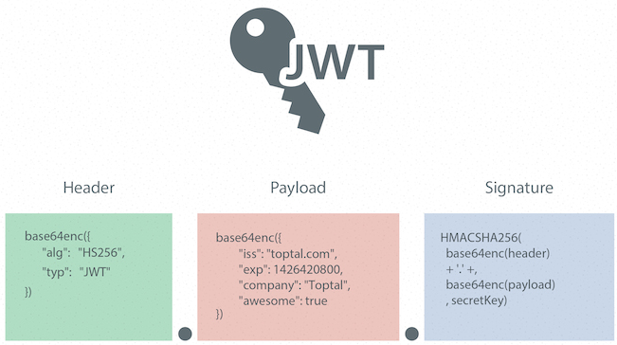

**Figure 3.1.** Json web token structure

JWT (Json Web Token) is an open standard token used to exchange information with HTTP requests. This information is verified and reliably marked based on the signature. JWT has many advantages over sessions.

* Stateless, information is not stored on the server.
* Easy to develop, expand.
* Better performance because the server reads the information in the request (if use session, the system must query information in storage or database).

### Json Web Token in Project

JWT is applied to authentication and authorization between the Backend and Frontend.

# SYSTEM DESIGN



## Class Diagram



**Figure 4.1.** Class diagram of CinemaChainAPI

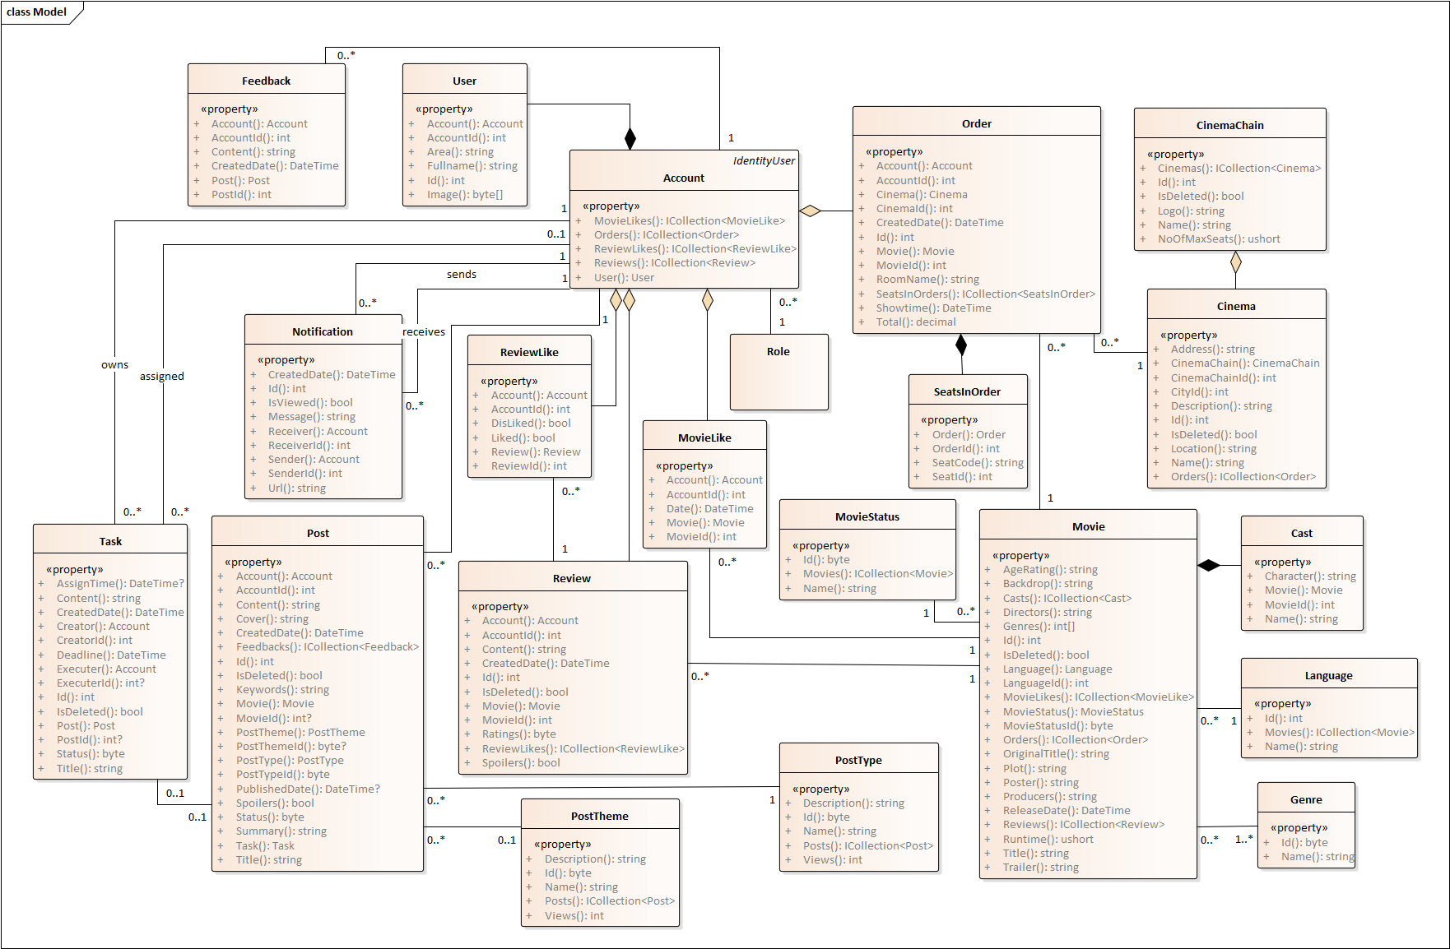

**Figure 4.2.** Class diagram of MovieReviews&TicketsAPI

### Class diagram description of “CinemaChain_API”

#### Class “Cinema”

**Table 4.1.** Description for class Cinema

|  |  |  |  |
| --- | --- | --- | --- |
| Property | Type | Access level | Description |
| Id | int | public | Cinema Id |
| Name | string | public | Cinema Name |
| Description | string | public | Description of cinema |
| Address | string | public | Address of cinema |
| Location | string | public | Location of cinema |
| CinemaChainId | CinemaChain | public | Cinema chain id that cinema belongs to |
| CityId | City | public | City id that cinema belongs to |

#### Class “CinemaChain”

**Table 4.2.** Description for class CinemaChain

|  |  |  |  |
| --- | --- | --- | --- |
| Property | Type | Access level | Description |
| Id | int | public | Cinema chain Id |
| Name | string | public | Cinema chain Name |
| CountryCode | string | public | Country code of cinema chain |
| Logo | string | public | Logo of cinema chain |
| NoOfMaxSeats | ushort | public | Number of max seats in cinema chain |

#### Class “City”

**Table 4.3.** Description for class City

|  |  |  |  |
| --- | --- | --- | --- |
| Property | Type | Access level | Description |
| Id | int | public | City Id |
| Name | string | public | City Name |

#### Class “MovieInCinemaChain”

**Table 4.4.** Description for class MoviesInCinemaChain

|  |  |  |  |
| --- | --- | --- | --- |
| Property | Type | Access level | Description |
| MovieId | Movie | public | Movie id belongs to cinema chain |
| CinemaChainId | CinemaChain | public | Cinema chain id |
| Status | byte | public | Status of movie in cinema chain: 0 is in theater, 1: in comming, 2: have no showtime schedule yet |

#### Class “Order”

**Table 4.5.** Description for class Order

|  |  |  |  |
| --- | --- | --- | --- |
| Property | Type | Access level | Description |
| Id | int | public | Order id belongs to cinema chain |
| Name | string | public | Name of customer in order |
| Email | string | public | Email of customer in order |
| Phone | string | public | Phone number of customer in order |
| ShowtimeId | Showtime | public | Showtime id in order |
| Total | decimal | public | Total order price |
| CreatedDate | DateTime | public | Create date of order |

#### Class “Room”

**Table 4.6.** Description for class Room

|  |  |  |  |
| --- | --- | --- | --- |
| Property | Type | Access level | Description |
| Id | int | public | Room id |
| Name | string | public | Room name |
| Cols | int | public | Number of columns in room |
| Rows | int | public | Number of rows in room |
| CinemaId | Cinema | public | Cinema id that room belongs to |
| RoomTypeId | int? | public | Room type id that room belongs to |

#### Class “RoomType”

**Table 4.7.** Description for class RoomType

|  |  |  |  |
| --- | --- | --- | --- |
| Property | Type | Access level | Description |
| Id | int | public | Room type id |
| Name | string | public | Room type name |
| ExtraFee | decimal | public | Extra fee of room type |
| CinemaChainId | CinemaChain | public | Cinema chain id that room type belongs to |

#### Class “ScreenFormat”

**Table 4.8.** Description for class ScreenFormat

|  |  |  |  |
| --- | --- | --- | --- |
| Property | Type | Access level | Description |
| Id | int | public | Screen format id |
| Name | string | public | Screen format name |
| ExtraFee | decimal | public | Extra fee of screen format |
| CinemaChainId | CinemaChain | public | Cinema chain id that screen format belongs to |

#### Class “Seat”

**Table 4.9.** Description for class Seat

|  |  |  |  |
| --- | --- | --- | --- |
| Property | Type | Access level | Description |
| Id | int | public | Seat id |
| Code | string | public | Seat code |
| RowIndex | int | public | Row index of seat |
| ColIndex | int | public | Col index of seat |
| RoomId | Room | public | Room id that seat belongs to |
| SeatTypeId | SeatType | public | Seat type id that seat belongs to |
| CoupleSeatA | Seat | public | Couple seat that point to seat |
| CoupleSeatId | int? | public | Couple seat id |
| CoupleSeatB | Seat | public | Couple seat that point to seat |

#### Class “SeatInOrder”

**Table 4.10.** Description for class SeatInOrder

|  |  |  |  |
| --- | --- | --- | --- |
| Property | Type | Access level | Description |
| OrderId | Order | public | Order id that seats in order belongs to |
| SeatId | Seat | public | Seat id that seat seats in order belongs to |
| Price | decimal | public | Total seat price in order |

#### Class “SeatType”

**Table 4.11.** Description for class SeatType

|  |  |  |  |
| --- | --- | --- | --- |
| Property | Type | Access level | Description |
| Id | int | public | Seat type id |
| Name | string | public | Seat type name |

#### Class “SeatTypeInChain”

**Table 4.12.** Description for class SeatTypeInChain

|  |  |  |  |
| --- | --- | --- | --- |
| Property | Type | Access level | Description |
| SeatTypeId | SeatType | public | Seat type id that seat type in chain belongs to |
| CinemaChainId | CinemaChain | public | Cinema chain id that seat type in chain belongs to |
| ExtraFee | decimal | public | Extra fee of seat in cinema chain |

#### Class “Showtime”

**Table 4.13.** Description for class Showtime

|  |  |  |  |
| --- | --- | --- | --- |
| Property | Type | Access level | Description |
| Id | int | public | Showtime id |
| MovieId | int | public | Movie id of showtime |
| CinemaId | Cinema | public | Cinema id that showtime belongs to |
| RoomId | Room | public | Room id that showtime belongs to |
| ScreenFormatId | ScreenFormat | public | Screen format id that showtime belongs to |
| StartDate | DateTime | public | Start date of showtime |
| Price | decimal | public | Price of showtime |

#### Class “CheckoutInfo”

**Table 4.14.** Description for class CheckoutInfo

|  |  |  |  |
| --- | --- | --- | --- |
| Property | Type | Access level | Description |
| CinemaChainId | CinemaChain | public | Cinema chain id that checkout info belongs to |
| PublicKey | string | public | Public key of stripe checkout |
| PrivateKey | string | public | Public key of stripe checkout |

### Class digram description of “MovieReviewsAndTickets”

#### Class “User”

**Table 4.15.** Description for class User

|  |  |  |  |
| --- | --- | --- | --- |
| Property | Type | Access level | Description |
| Id | int | public | User id |
| FullName | string | public | User full name |
| Area | string | public | User area |
| Image | string | public | User profile picture |
| AccountId | Account | public | Each user has an account id |

#### Class “Account”

**Table 4.16.** Description for class Account

|  |  |  |  |
| --- | --- | --- | --- |
| Property | Type | Access level | Description |
| User | User | public | Get user data |

#### Class “Cast”

**Table 4.17.** Description for class Cast

|  |  |  |  |
| --- | --- | --- | --- |
| Property | Type | Access level | Description |
| MovieId | Movie | public | Movie id that cast belongs to |
| Name | string | public | Name of actor |
| Character | string | public | Name of actor in movie |

#### Class “Cinema”

**Table 4.18.** Description for class Cinema

|  |  |  |  |
| --- | --- | --- | --- |
| Property | Type | Access level | Description |
| Id | int | public | Cinema id |
| Name | string | public | Cinema name |
| Description | string | public | Description of cinema |
| Address | string | public | Address of cinema |
| Location | string | public | Location of cinema |
| CinemaChainId | CinemaChain | public | Cinema chain id that cinema belongs to |
| CityId | int | public | City id of cinema |

#### Class “CinemaChain”

**Table 4.19.** Description for class CinemaChain

|  |  |  |  |
| --- | --- | --- | --- |
| Property | Type | Access level | Description |
| Id | int | public | Cinema chain id |
| Name | string | public | Cinema chain name |
| Logo | string | public | Cinema chain logo |
| NoOfMaxSeats | ushort | public | Number of max seats in cinema chain |

#### Class “Genre”

**Table 4.20.** Description for class Genre

|  |  |  |  |
| --- | --- | --- | --- |
| Property | Type | Access level | Description |
| Id | byte | public | Genre id |
| Name | string | public | Genre name |

#### Class “Language”

**Table 4.21.** Description for class Language

|  |  |  |  |
| --- | --- | --- | --- |
| Property | Type | Access level | Description |
| Id | int | public | Language id |
| Name | string | public | Language name |

#### Class “Movie”

**Table 4.22.** Description for class Movie

|  |  |  |  |
| --- | --- | --- | --- |
| Property | Type | Access level | Description |
| Id | int | public | Movie id |
| OriginalTitle | string | public | Original title of movie |
| Title | string | public | Title of movie |
| Plot | string | public | Plot of movie |
| Directors | string | public | Directors of movie |
| Producers | string | public | Producers of movie |
| ReleaseDate | DateTime | public | Release date of movie |
| Runtime | ushort | public | Movie length |
| AgeRating | string | public | Age rating of movie |
| Genres | Int[] | public | Genres of movie |
| Poster | string | public | Poster of movie |
| Backdrop | string | public | Backdrop of movie |
| Trailer | string | public | Trailer of movie |
| LanguageId | Language | public | Language id that movie belongs to |
| MovieStatusId | MovieStatus | public | Movie status id that movie belongs to |

#### Class “MovieLike”

**Table 4.23.** Description for class MovieLike

|  |  |  |  |
| --- | --- | --- | --- |
| Property | Type | Access level | Description |
| AccountId | Account | public | Account id that movie like belongs to |
| MovieId | Movie | public | Movie id that movie like belongs to |

#### Class “MovieStatus”

**Table 4.24.** Description for class MovieStatus

|  |  |  |  |
| --- | --- | --- | --- |
| Property | Type | Access level | Description |
| Id | byte | public | Movie status id |
| Name | string | public | Movie status name |

#### Class “Order”

**Table 4.25.** Description for class Order

|  |  |  |  |
| --- | --- | --- | --- |
| Property | Type | Access level | Description |
| Id | int | public | Order id |
| Total | decimal | public | Total price of order |
| Showtime | DateTime | public | Showtime in order |
| RoomName | string | public | Room name in order |
| AccountId | Account | public | Account id that order belongs to |
| CinemaId | Cinema | public | Cinema id that order belongs to |
| MovieId | Movie | public | Movie id that order belongs to |

#### Class “Review”

**Table 4.26.** Description for class Review

|  |  |  |  |
| --- | --- | --- | --- |
| Property | Type | Access level | Description |
| Id | int | public | Review id |
| Content | string | public | Content of review |
| Ratings | byte | public | Rating for movie |
| Spoilers | bool | public | Review content reveal content or not |
| CreatedDate | DateTime | public | Created date of review |
| MovieId | Movie | public | Movie id that review belongs to |
| AccountId | Account | public | Account id that review belongs to |

#### Class “ReviewLike”

**Table 4.27.** Description for class ReviewLike

|  |  |  |  |
| --- | --- | --- | --- |
| Property | Type | Access level | Description |
| ReviewId | Review | public | Review id that review like belongs to |
| AccountId | Account | public | Account id that review like belongs to |
| Liked | bool | public | Review like |
| DisLike | bool | public | Review dislike |

#### Class “Role”

**Table 4.28.** Description for class Role

|  |  |  |  |
| --- | --- | --- | --- |
| Property | Type | Access level | Description |
| Id | Review | public | Role id |
| Name | Account | public | Role name |

#### Class “SeatsInOrder”

**Table 4.29.** Description for class SeatsInOrder

|  |  |  |  |
| --- | --- | --- | --- |
| Property | Type | Access level | Description |
| OrderId | Order | public | Order id that seats in order belongs to |
| SeatId | Seat | public | Seat id that seats in order belongs to |
| SeatCode | string | public | Seat code in order |

#### Class “Notification”

**Table 4.30.** Description for class Notification

|  |  |  |  |
| --- | --- | --- | --- |
| Property | Type | Access level | Description |
| Id | int | public | Notification id |
| CreatedDate | DateTime | public | Date time of notification |
| IsViewed | bool | public | Notification is viewed or not |
| Message | string | public | Content of notification |
| ReceiverId | Account | public | Receiver id that notification sent to |
| SenderId | Account | public | Sender id that sent notification |
| Url | string | public | Link to content |

#### Class “Post”

**Table 4.31.** Description for class Post

|  |  |  |  |
| --- | --- | --- | --- |
| Property | Type | Access level | Description |
| Id | int | public | Id of post |
| AccountId | int | public | Account id that post belong to |
| Content | string | public | Content of post |
| Cover | string | public | Cover of post |
| CreatedDate | DateTime | public | Date time that post is created |
| IsDeleted | bool | public | Post is deleted or not |
| KeyWords | Account | public | Key word of post |
| MovieId | Movie | public | Movie id that post belong to |
| PostThemeId | PostTheme | public | Theme of post |
| PostTypeId | PostType | public | Type of post |
| PublishedDate | DateTime | public | Publish date of post |
| Spoilers | bool | public | Post is spoil content of movie of not |
| Status | byte | public | Status of post |
| Summary | string | public | Summary of post |
| Title | string | public | Title of post |

#### Class “Task”

**Table 4.32.** Description for class Task

|  |  |  |  |
| --- | --- | --- | --- |
| Property | Type | Access level | Description |
| Id | int | public | Id of task |
| CreatedId | Account | public | Create id that create task |
| Content | string | public | Content of task |
| CreatedDate | DateTime | public | Date time that task is created |
| IsDeleted | bool | public | Post is deleted or not |
| ExecuterId | Account | public | Executer id that execute task |
| PostId | Post | public | Post id that task belong |
| PublishedDate | DateTime | public | Publish date of post |
| Spoilers | bool | public | Post is spoil content of movie of not |
| Status | byte | public | Status of post |
| Summary | string | public | Summary of post |
| Title | string | public | Title of post |

#### Class “Post Type”

**Table 4.33.** Description for class PostType

|  |  |  |  |
| --- | --- | --- | --- |
| Property | Type | Access level | Description |
| Id | byte | public | Post type id |
| Name | string | public | Name of post type |
| Description | string | public | Description of post type |
| Views | int | public | User’s views of a post type |

#### Class “Post Theme”

**Table 4.34.** Description for class PostTheme

|  |  |  |  |
| --- | --- | --- | --- |
| Property | Type | Access level | Description |
| Id | byte | public | Post theme id |
| Name | string | public | Name of post theme |
| Description | string | public | Description of post theme |
| Views | int | public | User’s views of a post theme |

## Sequence Diagram

### Login

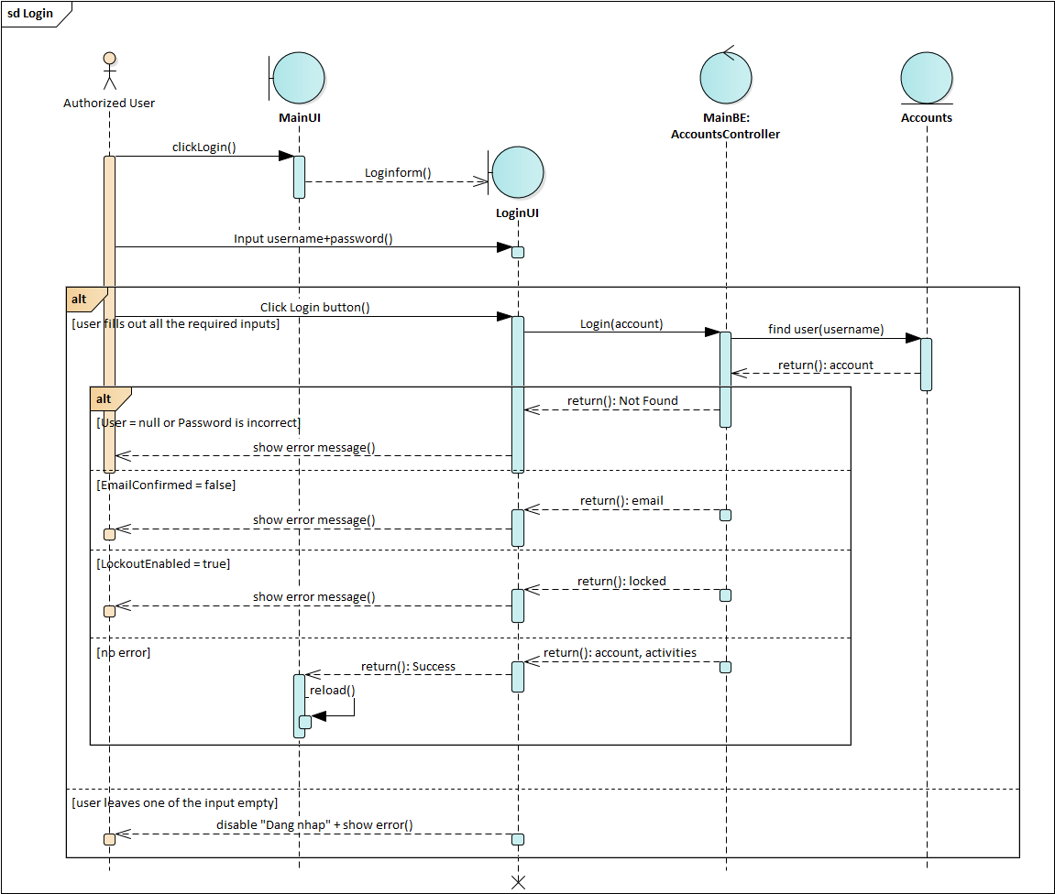

**Figure 4.3.** Sequence diagram Login function

### Add Movie

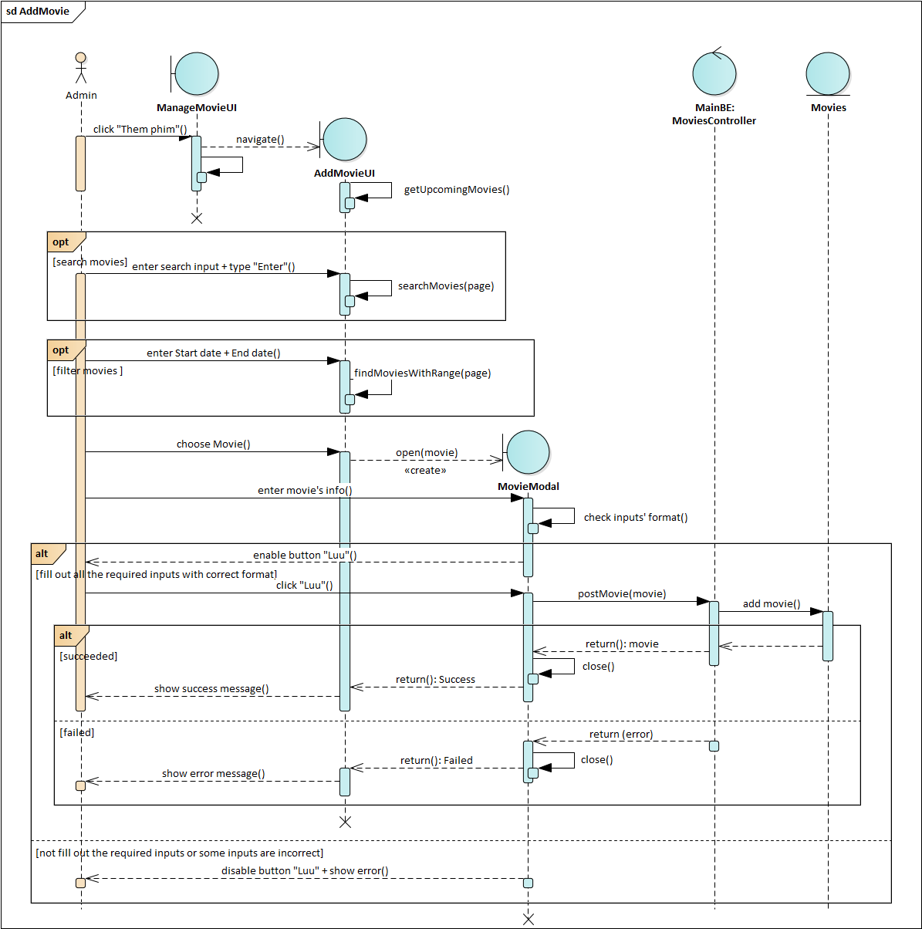

**Figure 4.4.** Sequence diagram Add movie function

### Write Review and Rate

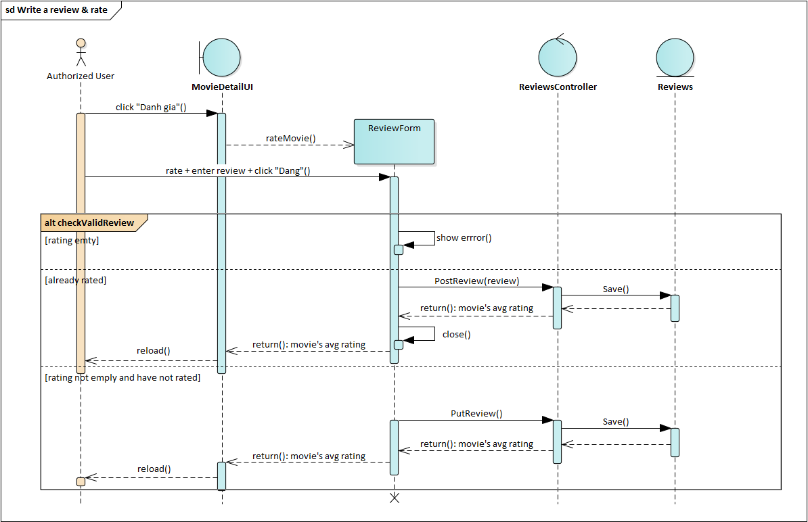

**Figure 4.5.** Sequence diagram Write review and rate function

### Book tickets

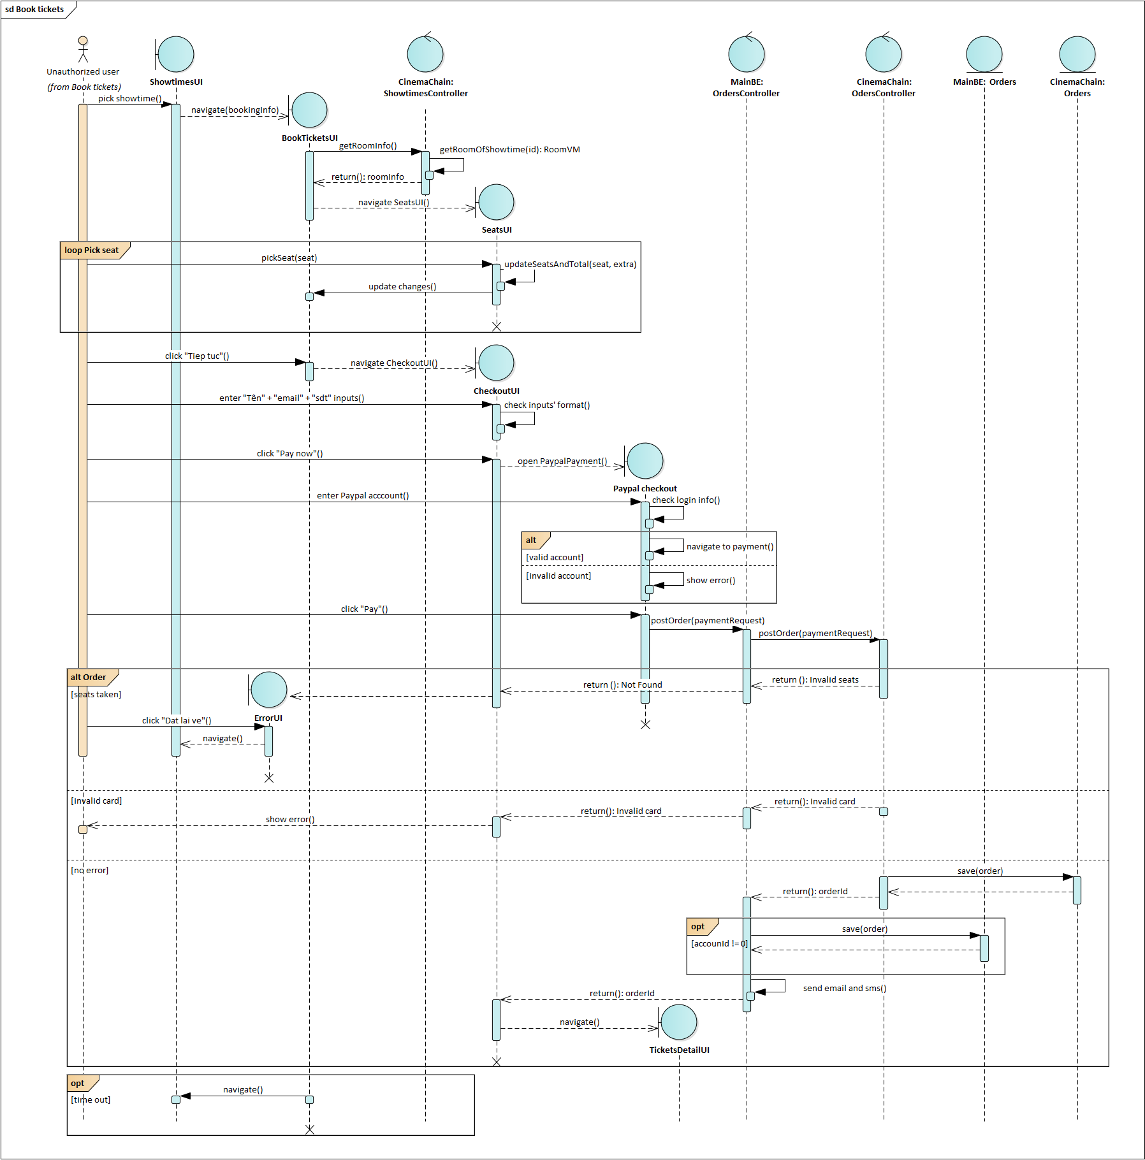

**Figure 4.6.** Sequence diagram Book tickets function

### Search Movies and Posts



**Figure 4.7.** Sequence diagram Search Movies and Posts fucntion

### Change Passwod



**Figure 4.8.** Sequence diagram Change Password function

### 

### Update Movie’s Details



**Figure 4.9.** Sequence diagram Update Movie’s Details function

### Share Post to Facebook



**Figure 4.10.** Sequence diagram Share Post to Facebook function

### Block Admin



**Figure 4.11.** Sequence diagram Block Admin function

### 

### Send Post

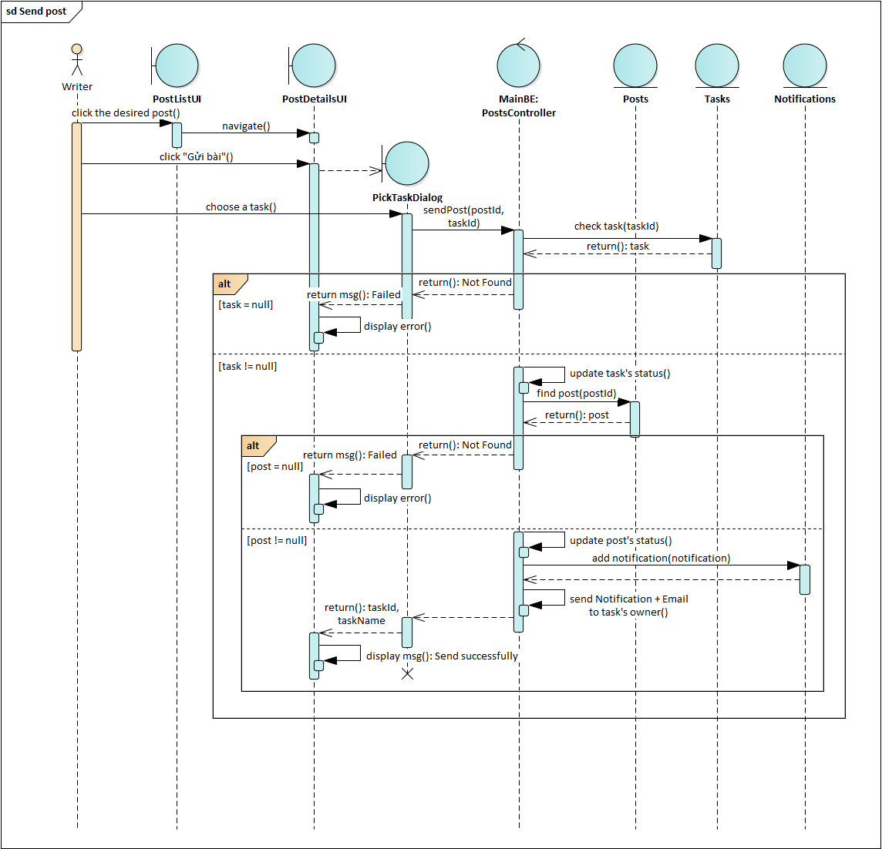

**Figure 4.12.** Sequence diagram Send Post function

### 

### Register

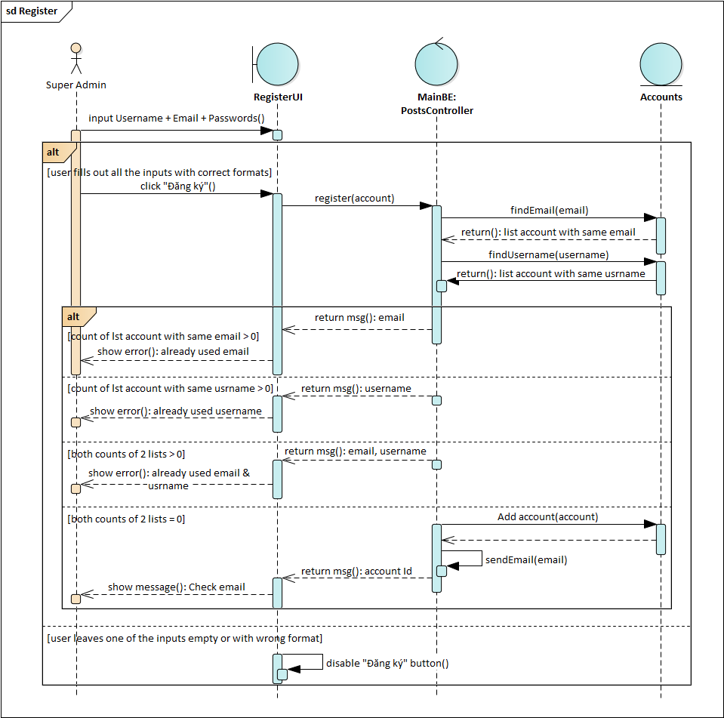

**Figure 4.13.** Sequence diagram Register function

### 

### Add Admin

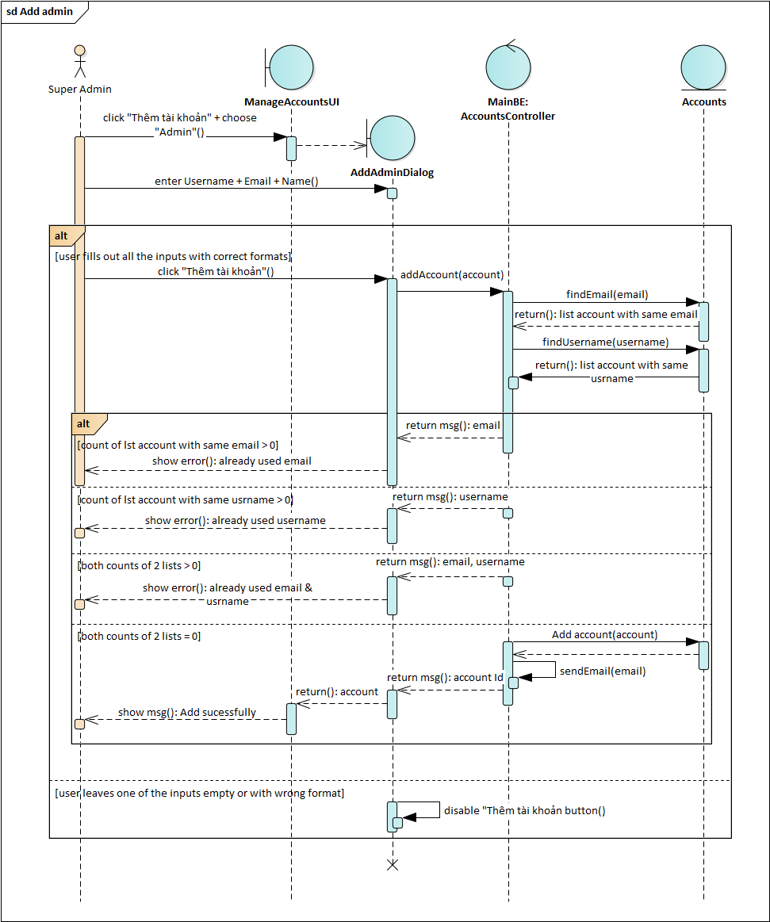

**Figure 4.14**. Sequence diagram Add Admin function

### Create Post

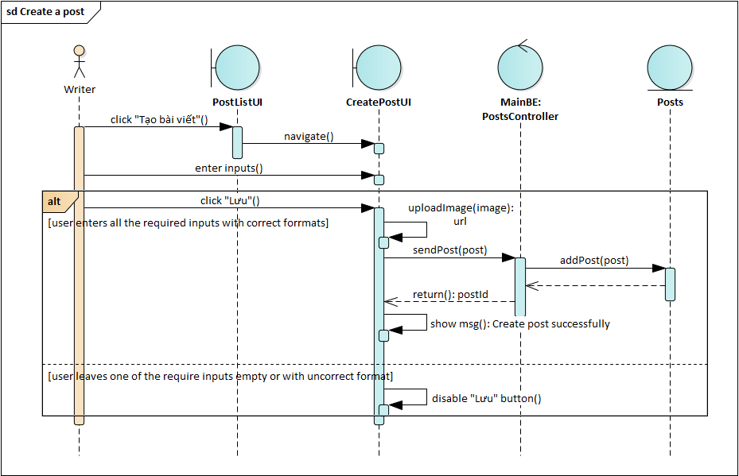

**Figure 4.15.** Sequence diagram Create Post fucntion

### Create Task

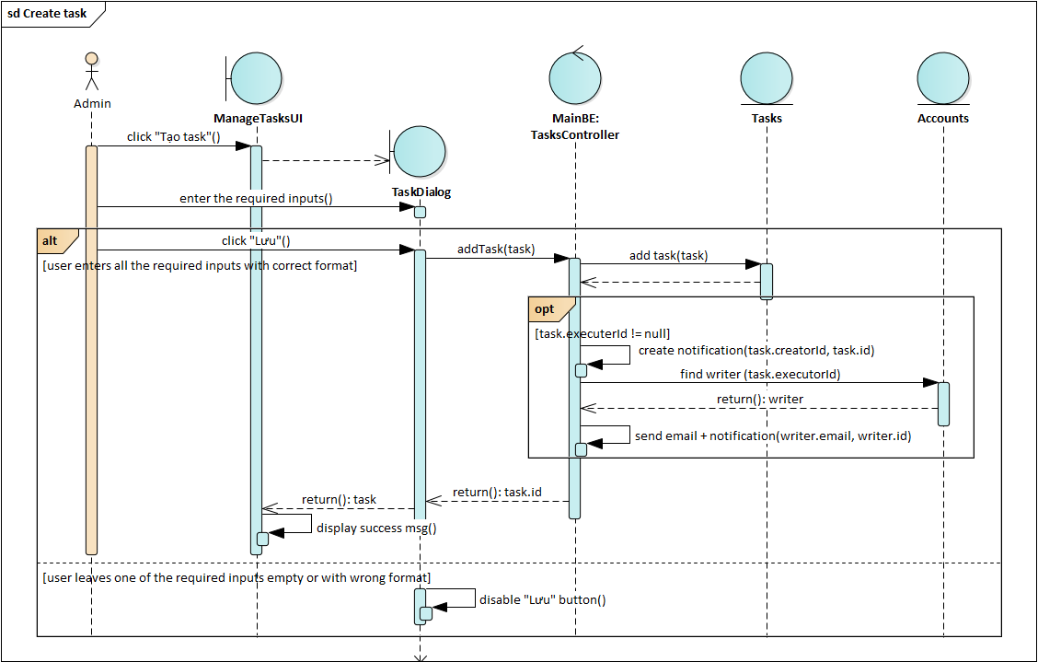

**Figure 4.16.** Sequence diagram Create Task function

### Accept Task

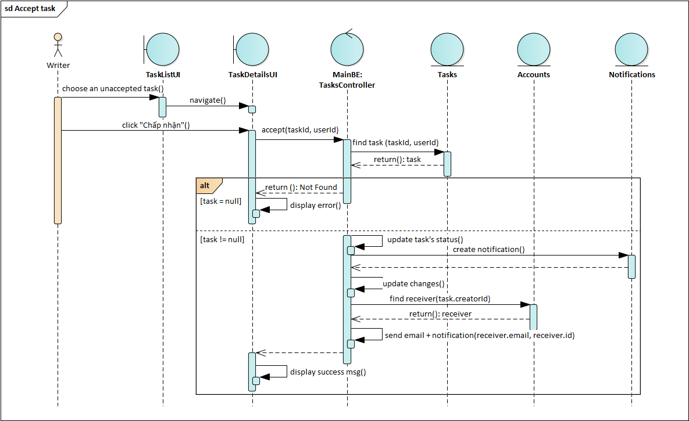

**Figure 4.17.** Sequence diagram Accept Task function

## 

## Database Design

### Database Diagram



**Figure 4.18.** Database diagram of CinemaChainAPI



**Figure 4.19.** Database diagram of MainBackend

### Intergrity Constraints

#### Constraint on User uniqueness

* Content: Account must have unique Email and UserName.
* Context: AspNetUser (Accounts), Users

**Table 4.35.** Influence of Constraint on User uniqueness

|  |  |  |  |
| --- | --- | --- | --- |
|  | Add | Update | Delete |
| AspNetUsers | + | - | - |
| Users | - (*) | - | - (*) |

#### Constraint on Posting a review

* Content: User who logged into the end-user website can write review for a movie.
* Context: Accounts, Movies, Reviews

**Table 4.36.** Influence of Constraint on Posting a review

|  |  |  |  |
| --- | --- | --- | --- |
|  | Add | Update | Delete |
| Accounts | - | - | - |
| Movies | - | - | - |
| Reviews | + | - | - |

#### Constraint on Creating Admin/ Writer account

* Content: Only user who logged into the admin website with role Super Admin can create Admin & Writer account
* Context: Accounts, AspNetRoles (Roles), AspNetUserRoles (UserRoles)

**Table 4.37.** Influence of Constraint on Creating Admin/ Writer account

|  |  |  |  |
| --- | --- | --- | --- |
|  | Add | Update | Delete |
| Accounts | + | - (*) | - |
| Roles | - (*) | - (*) | - (*) |
| UserRoles | - (*) | - (*) | - (*) |

#### Constraint on Managing accounts

* Content: Users who logged into the admin website with role Super Admin can block, unblock and delete user with role Admin, User & Writer. Users with role Admin can only do the same with User & Writer accounts.
* Context: Accounts

**Table 4.38**. Influence of Constraint on Managing accounts

|  |  |  |  |
| --- | --- | --- | --- |
|  | Add | Update | Delete |
| Accounts | - (*) | + (LockoutEnabled, IsDeleted) | + (IsDeleted) |

#### Constraint on Accepting task

* Content: User who logged into the end-user website with role Writer can accept task assign for him/her.
* Context: Accounts, Tasks

**Table 4.39.** Influence of Constraint on Accepting task

|  |  |  |  |
| --- | --- | --- | --- |
|  | Add | Update | Delete |
| Accounts | - | - | - |
| Tasks | - | + (ExecuterId, IsDeleted) | + (IsDeleted) |

#### Constraint on Sending post

* Content: User who logged into the end-user website with role Writer can attach his/her post to an accepted task so that admin creating the task can approve the post.
* Context: Accounts, Tasks, Posts

**Table 4.40.** Influence of Constraint on Accepting task

|  |  |  |  |
| --- | --- | --- | --- |
|  | Add | Update | Delete |
| Accounts | - | - | - |
| Tasks | - | + (Deadline, IsDeleted) | + (IsDeleted) |
| Posts | - | + (IsDeleted) | + (IsDeleted) |

#### Constraint on Editing task

* Content: User who logged into the admin website with role Admin or Super Admin can edit his/ her task if the task hasn’t been assigned to any writer at the moment. If the task is already assigned and writer hasn’t accepted it for 2 hours, user can edit the task to delegate it to another writer.
* Context: Accounts, Tasks

**Table 4.41.** Influence of Constraint on Editing task

|  |  |  |  |
| --- | --- | --- | --- |
|  | Add | Update | Delete |
| Accounts | - | - | + (IsDeleted) |
| Tasks | - | + (IsDeleted, Status) | + (IsDeleted) |

## 

## Activity Diagram

### Add Movie



**Figure 4.20.** Activity diagram Add movie function

### Write Review and Rate



**Figure 4.21.** Activity diagram Write review and rate function

## State Machine Diagram

### Login (End – user website)



**Figure 4.22.** State machine diagram Login function

### Book Tickets



**Figure 4.23.** State machine diagram Book tickets function

## Component Diagram

### CinemaChain API



**Figure 4.24.** Component diagram of CinemaChainAPI

**Table 4.42.** Component of CinemaChainAPI description

|  |  |
| --- | --- |
| Name | Description |
| Models | Contains Entity Framework Core entities (classes) to work with the database. |
| Controllers | Classes that handle the API requests from the Frontend. They retrieve model data and return to the Frontend. |
| ViewModels | Contains classes which are combinations of many models or a model with more attributes required for a particular view in Frontend. |
| EF Core | An open-source, lightweight, extensible and a cross-platform data access technology which is used to access data in the SQL Server. |
| Cinemachain database | The CinemaChains database in SQL Server. |

### Movie Reviews & Tickets API



**Figure 4.25.** Component diagram of MainbackendAPI

**Table 4.43.** Component of MainBackEndAPI description

|  |  |
| --- | --- |
| Name | Description |
| Models | Contains Entity Framework Core entities (classes) to work with the database. |
| Controllers | Classes that handle the API requests from the Frontend. They retrieve model data and return to the Frontend. |
| ViewModels | Contains classes which are combinations of many models or a model with more attributes required for a particular view in Frontend. |
| Services | Contains classes implementing services used for MainBackend API (SendGrid email service). |
| Helpers | Contains classes keeping the static strings to use accross the project. |
| EF Core | An open-source, lightweight, extensible and a cross-platform data access technology which is used to access data in the SQL Server. |
| MovieReviews database | The MovieReviews database stored in SQL Server. |
| MLModels | Learn from data, training data to make movie recommendations. |

## Interface Design

### End-user Website

The screen flow for Guest in End – user website consists of screens which can be accessed without an authorization.

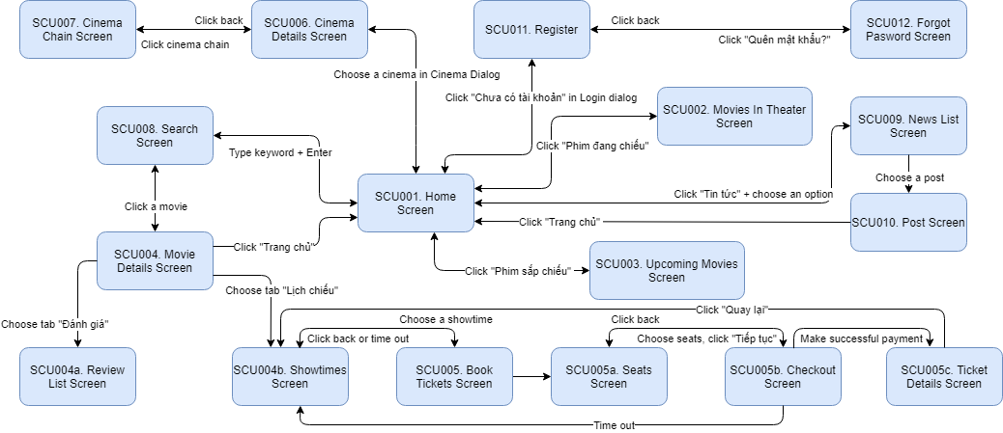

**Figure 4.26.** Screen flow for Guest in End user website

Users who registered account and confirmed the registration will be authorized users. They will have access to both Guest’s screens and the screens below

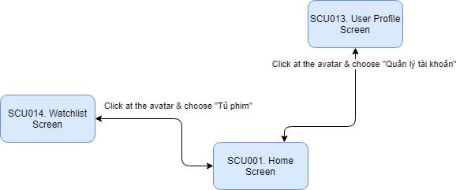

**Figure 4.27.** Screen flow for Authorized user in End user website

Finally, as for the writers, who are added to the website by adminstrators to write posts, will have the access to the writer screens and authorized users’ screens.

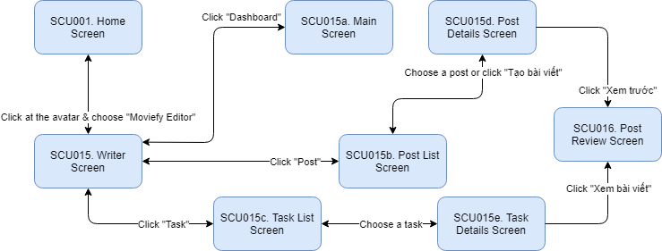

**Figure 4.28.** Screen flow for Writer in End user website

**Table 4.44.** List of screens in user website

|  |  |  |
| --- | --- | --- |
| No | Screen name | Description |
| SCU001 | Home Screen | Main screen of user side, display top rate, weekly popular movies, latest movies’ trailer, movies in theaters |
| SCU002 | Movies In Theater Screen | List of movies currently showed in theaters nationwide |
| SCU003 | Upcoming Movies Screen | List of movies scheduled to open in theaters nationwide |
| SCU004 | Movie Details Screen | Movie details such as content summaries, actors, rating scores |
| SCU004a | Review List Screen | List of movie’s reviews from the website’s users |
| SCU004b | Showtimes Screen | List of movie’s showtimes from across the national cinemas |
| SCU005 | Book Tickets Screen | Display of countdown and order summary when user choose seats |
| SCU005a | Seats Screen | Display of showtime’s available seats for user to choose |
| SCU005b | Checkout Screen | Summary of user’s order and methods for user to execute payment |
| SCU005c | Ticket Details Screen | Order’s information when user successfully reserves seats for the showtime |
| SCU006 | Cinema Details Screen | Cinema’s details such as address, showtime of movies in theater |
| SCU007 | Cinema Chain Screen | Cinemas in chain grouped by cities in Vietnam |
| SCU008 | Search Screen | Allows user to search movies, news that match the keyword |
| SCU009 | News List Screen | Displays list of posts group by a type, theme or tag. |
| SCU010 | Post Screen | Displays the movies the user has liked or rated |
| SCU011 | Register Screen | Register for an account for a guest |
| SCU012 | Forgot Password Screen | Make request to reset password for user losing password |
| SCU013 | User Profile Screen | Allow user to view his/her personal information such as name, email, avatar; modify information & change password |
| SCU014 | Watchlist Screen | Display the movies the user has liked or rated |
| SCU015 | Writer Screen | Allows user with role Writer to manage his/her tasks and posts |
| SCU015a | Main Screen | Main screen of writer’s section, displaying summaries of writer’s activities and user’s recent notifications |
| SCU015b | Post List Screen | Allows writer to manage his/her posts |
| SCU015c | Task List Screen | Allows writer to manage his/her tasks |
| SCU015d | Post Details Screen | Allows writer to create a new post or edit a created one |
| SCU015e | Task Details Screen | Allows writer to accept/deny a task assigned for them or view the attached post of the submited task |
| SCU016 | Post Review Screen | Displays content of a post in published format and admin’s feedbacks for the post |
| SCU017 | Confirm Registration Screen | For user to user to confirm registration in order to activate his/her newly created account |
| SCU018 | Change Password Screen | For user who sent the reset password request to create a new password for his/her account |

#### Navbar



**Figure 4.29.** Navbar of Guest



**Figure 4.30.** Navbar of Authorized user

**Table 4.45.** End user’s navbar objects

|  |  |  |  |  |  |
| --- | --- | --- | --- | --- | --- |
| No | Name | Required | Format | Reference | Action |
| 1 | Home |  | Link | Home Screen | When clicked, the page goes to Home page |
| 2 | Movie Dropdown |  | Dropdown | Movies In Theater Screen, Upcoming Movies Screen | When clicked, it shows 2 options: “Sắp chiếu” goes to Upcoming Movies Screen and “Đang chiếu” goes to Movies In Theater Screen |
| 3 | Cinemas |  | Link | Cinemas dialog | When clicked, it shows Cinemas dialog displaying cinemas in user’s city |
| 4 | News Dropdown |  | Dropdown | Data from MainBackend API, News List Screen | When clicked, it goes to News List Screen |
| 5 | Search | No | Input | Search Screen | Enter the keyword then hit “Enter” key, the page will go to Search Screen |
| 6 | Search button |  | Button | Search Screen | When clicked, the page goes to Search Screen |
| 7 | Location |  | Button | Location dialog | When clicked, it opens Location dialog displaying Vietnam’s cities for user to pick a city |
| 8 | Login button |  | Button | Login dialog | When clicked, it opens Login dialog for guest to login |
| 9 | Avatar |  | Dropdown | Writer, User Profile, Watchlist Screen | When clicked, it shows options: Moviefy Editor (if user has role Writer) – Writer Screen, “Quản lý tài khoản” – User Profile & “Tủ phim” - Watchlist |

#### SCU002. Movies In Theater Screen

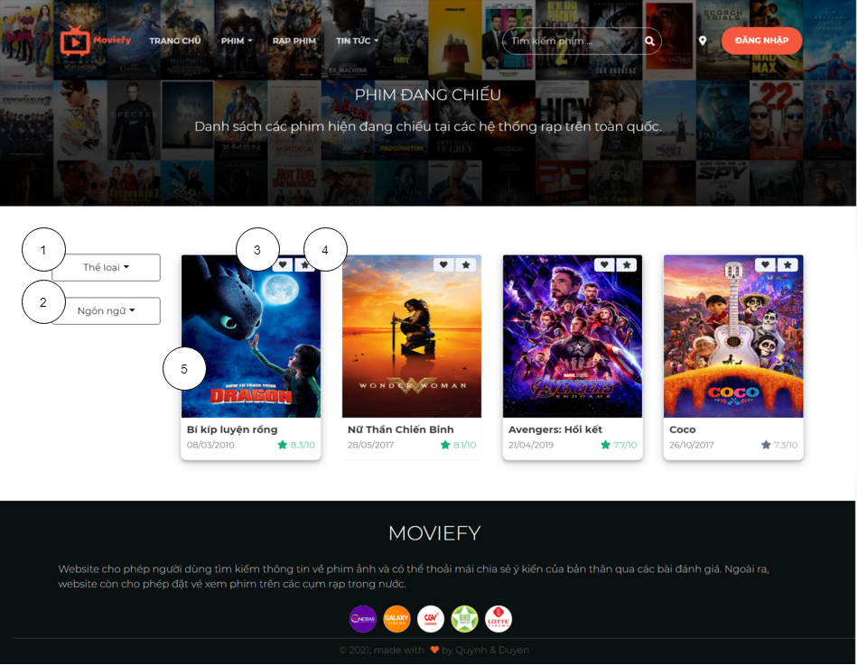

**Figure 4.31.** SCU002 - Movies In Theater Screen

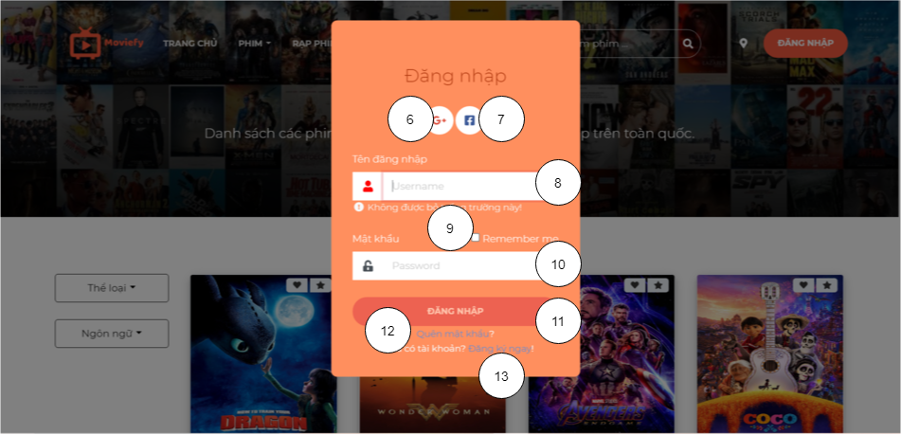

**Figure 4.32.** Login Dialog

**Table 4.46.** Movies In Theater Screen’s objects

|  |  |  |  |  |  |
| --- | --- | --- | --- | --- | --- |
| No | Name | Required | Format | Reference | Action |
| 1 | Genre filter |  | Dropdown | Data from MainBackend API | When clicked, it displays a list of genres. Choose a genre & the list will be filtered by the selected genre |
| 2 | Language filter |  | Dropdown | Data from MainBackend API | When clicked, it displays a list of languages. Choose a language & the list will be filtered by the selected genre |
| 3 | Like movie |  | Button | Data from MainBackend API, Login dialog | When clicked, it shows Login dialog if the user haven’t logged in or turns red/grey if the user’ve already logged in |
| 4 | Rate a movie |  | Button | Data from MainBackend API, Rate dialog | When clicked, it shows Login dialog if the user haven’t logged in or shows Rate dialog if the user’ve already logged in |
| 5 | Movie details |  | Link | Data from MainBackend API, Movie Details Screen | When clicked, the page goes to Movie Details Screen |
| 6 | Google login |  | Button |  | When clicked, user will be able to login with Google account |
| 7 | Facebook login |  | Button |  | When clicked, user will be able to login with Facebook account |
| 8 | Username | Yes | Input |  | For user to enter his/her username |
| 9 | Remember | No | Checkbox |  | For user to choose whether he/she would remain login when user close the website |
| 10 | Password | Yes | Input |  | For user to enter his/her username |
| 11 | Login |  | Button |  | When clicked, user’s account will be sent to backend for authorization |
| 12 | Forget password |  | Link |  | When clicked, the page goes to Forgot Password Screen |
| 13 | Register |  | Link |  | When clicked, the page goes to Register Screen |

#### SCU005a. Seats Screen

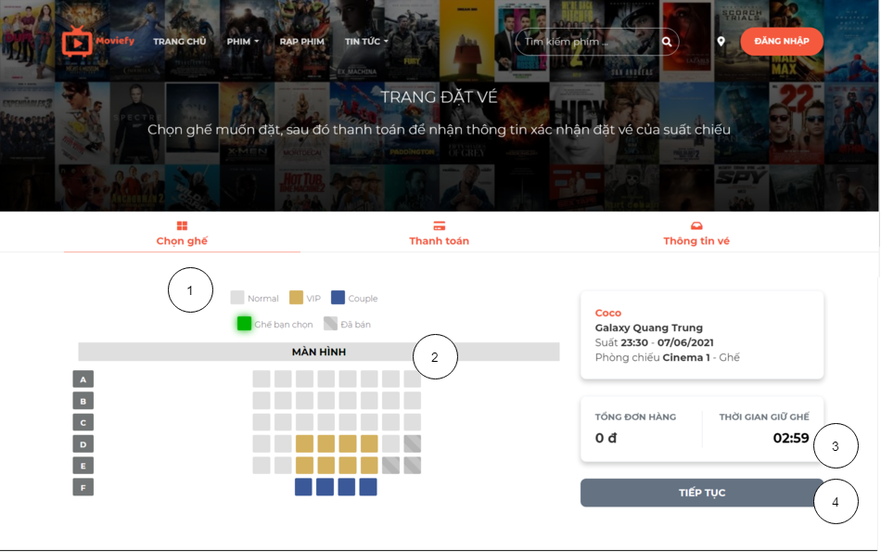

**Figure 4.33.** SCU005a - Seats Screen

**Table 4.47.** Seats Screen’s objects

|  |  |  |  |  |  |
| --- | --- | --- | --- | --- | --- |
| No | Name | Required | Format | Reference | Action |
| 1 | Seat types |  | Button | Data from CinemaChain API |  |
| 2 | Seat |  | Button | Data from CinemaChain API | When clicked, if the seat is still available, it will turn green, button “Tiếp tục” enables |
| 3 | Countdown |  | Span |  | When reaching “0:00”, a dialog appears asking user to restart the order. |
| 4 | Continue button |  | Button |  | When clicked, navigate to “Thanh toán page” |

### Admin Website

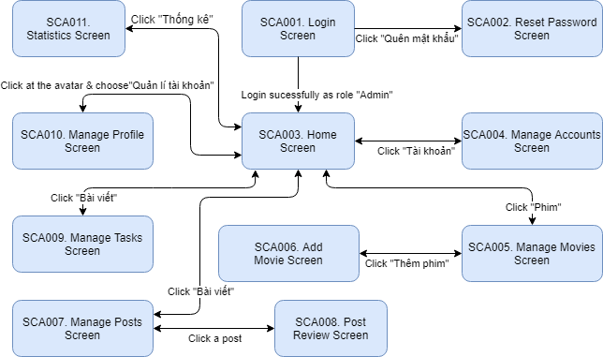

**Figure 4.34.** Screen flow for Admin in Admin website

The screen flow for Admin can also be applied for Super Admin. Super Admin will also have access to more screens than Admin.

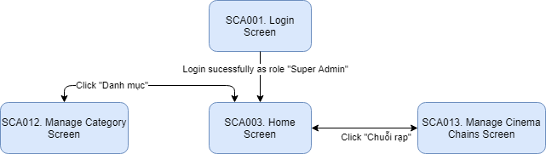

**Figure 4.35.** Screen flow for Super Admin in Admin website

**Table 4.48.** List of screens in admin website

|  |  |  |
| --- | --- | --- |
| No | Screen name | Description |
| SCA001 | Login Screen | For admin to log in to the website. |
| SCA002 | Reset Password Screen | For admin to reset his/her password incase he/she forgets it. |
| SCA003 | Home Screen | Main screen of admin side, display informations and statistics. |
| SCA004 | Manage Accounts Screen | For super admin and admin to manage user accounts. |
| SCA005 | Manage Movies Screen | For admin to add new movie, update movie’s information and delete movie. |
| SCA006 | Add Movie Screen | For admin to discover, search movie and save new movie to website store. |
| SCA007 | Manage Posts Screen | For admin to manage posts. |
| SCA008 | Post Review Screen | For admin to review a post in published format & write feedbacks for the post |
| SCA009 | Manage Tasks Screen | For admin to manage his/her tasks. |
| SCA010 | Manage Profile Screen | For admin to manage his/her profile and change password. |
| SCA011 | Statistics Screen | For admin to view statistics. |
| SCA012 | Manage Category Screen | For only super admin to manage categories such as languages, genres, post types and themes. |
| SCA013 | Manage Cinema Chains Screen | For only super admin to manage cinema chain. |

#### Navbar



**Figure 4.36.** Navbar of Admin



**Figure 4.37.** Navbar of Super Admin

**Table 4.49.** Admin’s navbar objects

|  |  |  |  |  |  |
| --- | --- | --- | --- | --- | --- |
| No | Name | Required | Format | Reference | Action |
| 1 | Home |  | Link | Home Screen | When clicked, the page goes to Home page |
| 2 | Movie |  | Link | Manage Movies Screen | When clicked, the page goes to Manage Movies Screen |
| 3 | Account |  | Link | Manage Accounts Screen | When clicked, the page goes to Manage Accounts Screen |
| 4 | Task |  | Link | Manage Accounts Screen | When clicked, the page goes to Manage Tasks Screen |
| 5 | Post |  | Link | Manage Posts Screen | When clicked, the page goes to Manage Posts Screen |
| 6 | Statistics |  | Link | Statistics Screen | When clicked, the page goes to Statistics Screen |
| 7 | Notification |  | Button | Notification list | When clicked, it opens Notification list displaying unread notifications of user |
| 8 | Avatar |  | Dropdown | Manage Profile, Login Screen | When clicked, it shows options: “Quản lý tài khoản” – Manage Profile & “Đăng xuất” – Login Screen |
| 9 | Cinema Chains |  | Link | Manage Cinema Chains Screen | When clicked, the page goes to Manage Cinema Chains Screen |
| 10 | Category |  | Link | Manage Category Screen | When clicked, the page goes to Manage Category Screen |

#### SCA004. Manage Accounts Screen

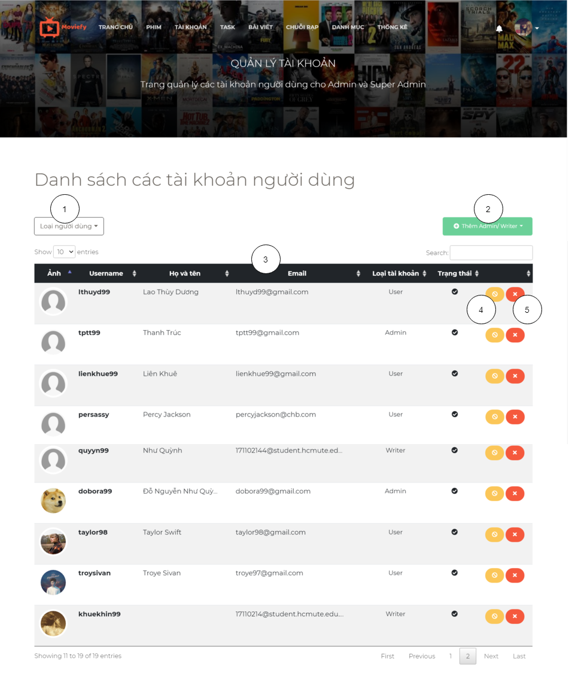

**Figure 4.38.** SCA004 - Manage Accounts Screen

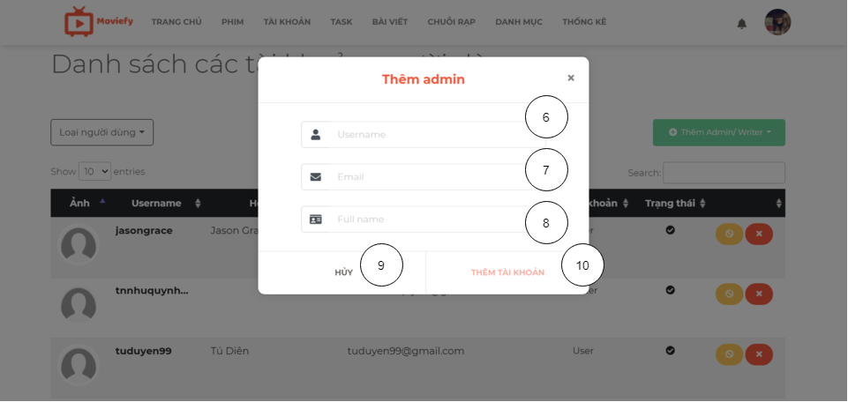

**Figure 4.39.** Dialog Add Admin/Writer of SCA004

**Table 4.50.** Manage Accounts Screen’s objects

|  |  |  |  |  |  |
| --- | --- | --- | --- | --- | --- |
| No | Name | Required | Format | Reference | Action |
| 1 | User role filter |  | Dropdown | Data from MainBackend API | When clicked, it displays a list of user roles. Choose a role & the table will be filtered by the selected role |
| 2 | Add admin or writer button |  | Dropdown | Add Admin/Writer dialog | When clicked, it displays 2 options: “Thêm Admin” & “Thêm Writer” |
| 3 | Account list |  | Datatable | Data from MainBackend API | User can sort the list by columns & find records matching the search key |
| 4 | Block/Active user |  | Button |  | If user has “active” status. When clicked, it changes to “block” and vice versa. |
| 5 | Delete user |  | Button |  | When clicked, a dialog appears asking admin to confirm delete user or not. |
| 6 | Username | Yes | Input |  | For admin to enter username of the new account |
| 7 | Email | Yes | Input |  | For admin to enter email of the new account |
| 8 | Full name | Yes | Input |  | For admin to enter full name of the new account |
| 9 | Cancel |  | Button |  | When clicked, the dialog is closed |
| 10 | Add account |  | Button |  | When clicked, the account is added to database |

#### SCA005. Manage Movies Screen

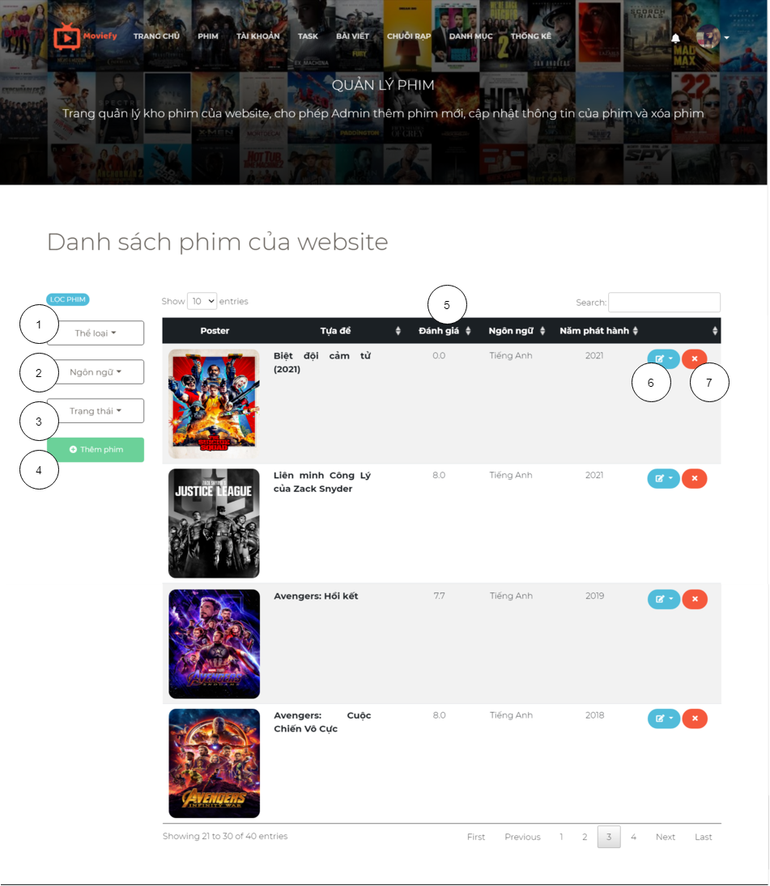

**Figure 4.40.** SCA005 - Manage Movies Screen’s objects

**Table 4.51.** Manage Movies Screen’s objects

|  |  |  |  |  |  |
| --- | --- | --- | --- | --- | --- |
| No | Name | Required | Format | Reference | Action |
| 1 | Genre filter |  | Dropdown | Data from MainBackend API | When clicked, it displays a list of genres. Choose a genre & the table will be filtered by the selected genre |
| 2 | Language filter |  | Dropdown | Data from MainBackend API | When clicked, it displays a list of languages. Choose a language & the table will be filtered by the selected genre |
| 3 | Status filter |  | Dropdown | Data from MainBackend API | When clicked, it displays a list of statuses. Choose a status & the table will be filtered by the selected status |
| 4 | Add movie |  | Link | Add Movie Screen | When clicked, the page goes to Add Movie Screen |
| 5 | Movie list |  | Datatable | Data from MainBackend API | User can sort the list by columns & find records matching the search key |
| 6 | Edit movie |  | Dropdown | Movie dialog, Actors dialog | When clicked, it displays 2 options: “Chi tiết phim” (open Movie dialog) & “Diễn viên” (open Actors dialog) |
| 7 | Delete movie |  | Button |  | When clicked, a confirrm box appears to verify the deletion of the movie |

# IMPLEMENTATION AND TESTING

## System Architecture

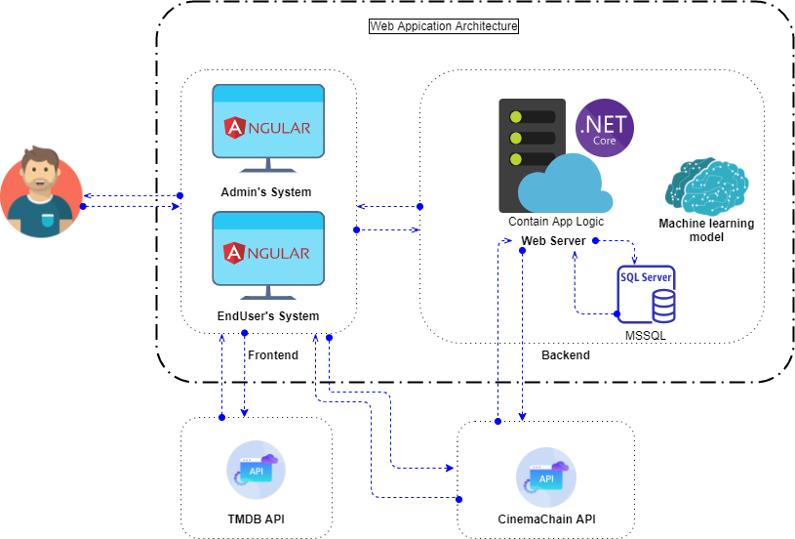

**Figure 5.1.** Overview of architectural design for system

A System Architecture is the fundamental organization of a system, embodied in its components, their relationships to each other and the environment, and the principles governing its design and evolution.

As you can see, the Movie Reviews & Tickets internal system consists of two subsystem which is:

- Frontend: is where user interacts with the website. The Frontend is developed by Angular 10 and Bootstrap 4.

- Backend (Main Backend or MovieReviewsAndTickets API): an ASP .Net Core 3.1 Web API connects with the SQL Server database and handles requests made from Frontend.

Externally, the system also communicates with the TMDb API and the CinemaChain API. The TMDb API is an API service is for those interested in using available data of movie, TV show or actor images to intergrate in their application. We need this API not only for its available movie data so that user won’t waste much time when adding a movie, but it’s also because we can use the movie’s ids of TMDb database to synchonize our movie data with the CinemaChain API and make request for showtimes data. The CinemaChain API is where our system request for showtimes data so user can book tickets. Since there’s no Showtimes API service available for non profit organization so the CinemaChain API is an ASP Net Core Web API emulating <https://tix.vn/sdk> and other tickets API services.

## Tools in Project

**Table 5.1.** Tools using for project

|  |  |
| --- | --- |
| Tool | Name |
| Environment | .Net Core |
| IDE | Visual Studio 2019 |
| Visual Studio Code |
| Dbms | SQL Server 2017 |
| Source control | Github, Git bash |
| Modelling tools | Draw.io, Enterprise Architect |

## Technologies in Project

In the project, the technologies will use which is listed in the table below:

**Table 5.2.** Technologies using for project

|  |  |
| --- | --- |
| Transmission Protocol | REST API |
| JSON Web Token |
| User Interface | Angular 10.1.3 |
| System Technologies | ASP.NET Core API 3.1 |
| Entity Framework Core |
| Databases | Microsoft SQL Server 2017 |
| Services | SendGrid (Email Sender) |
| Twilio (SMS message) |
| Paypal checkout (Payment gateway) |
| Firebase (Uploading user’s image) |
| Thirdly Party | TMDB ( The Movie Database API) |
| Ipinfo.io ( Get Location) |

After we finish developing the application, we use these hosting services to deploy our website:

- Database and Backend : using Somee to deploy.

- Frontend : using Firebase and Heroku to deploy.

## Test Plan

In this project, we use Black box Testing method to test main functions of the application. The biggest advantage of Black box Testing is that it is quite suitable for testing a large part of code or main functions of the system, which is very convenient for rapid software development. The functions will be tested are:

- Authorized user: Login.

- Guest: Book tickets.

- Admin: Add a movie.

### Test Scenarios

**Table 5.3.** Test scenarios

|  |  |  |  |
| --- | --- | --- | --- |
| # | Actor | Function | Description |
| 1 | Authorized user | Login | Test the End – user website’s response when user enters inputs in the “Đăng nhập” dialog and takes actions on it. |
| 2 | Guest | Book tickets | Test the End – user website’s response when user enters the “Đặt vé” screen and takes actions on it. |
| 3 | Admin | Add a movie | Test the Admin website’s response when user enters inputs in the “Thêm phim” dialog and takes actions on it. |

### Test Result

#### Authorized user – Login

**Table 5.4.** Test results of Login function

|  |  |  |  |  |  |  |
| --- | --- | --- | --- | --- | --- | --- |
| ID | Description | Test steps | Test data | Expected Result | Actual Result | Status |
| TC_LI_01 | Test response of the website when user enters correct authentication | 1. Click the “Đăng nhập” button on the navigation bar. 2. Enter username 3. Enter password 4. Click “Đăng nhập” button | Step 2: Username = “khuekhin99”  Step 3: Password = “121899” | User is logged in to the End – user website with Writer role, website navigates to Writer page | As expected | Pass |
| TC_LI_02 | Test response of the website when user enters incorrect authentication | 1. Click the “Đăng nhập” button on the navigation bar. 2. Enter username 3. Enter password 4. Click “Đăng nhập” button | Step 2: Username = “tnnhuquynh”  Step 3: Password = “121899” | Error appears above the Username input “Tài khoản không tồn tại” | As expected | Pass |
| TC_LI_03 | Test response of the website when user enters correct authentication but unconfirmed one | 1. Click the “Đăng nhập” button on the navigation bar. 2. Enter username 3. Enter password 4. Click “Đăng nhập” button | Step 2: Username = “tuduyen99”  Step 3: Password = “121899” | Error appears above the Username input “Chưa xác nhận email” | As expected | Pass |

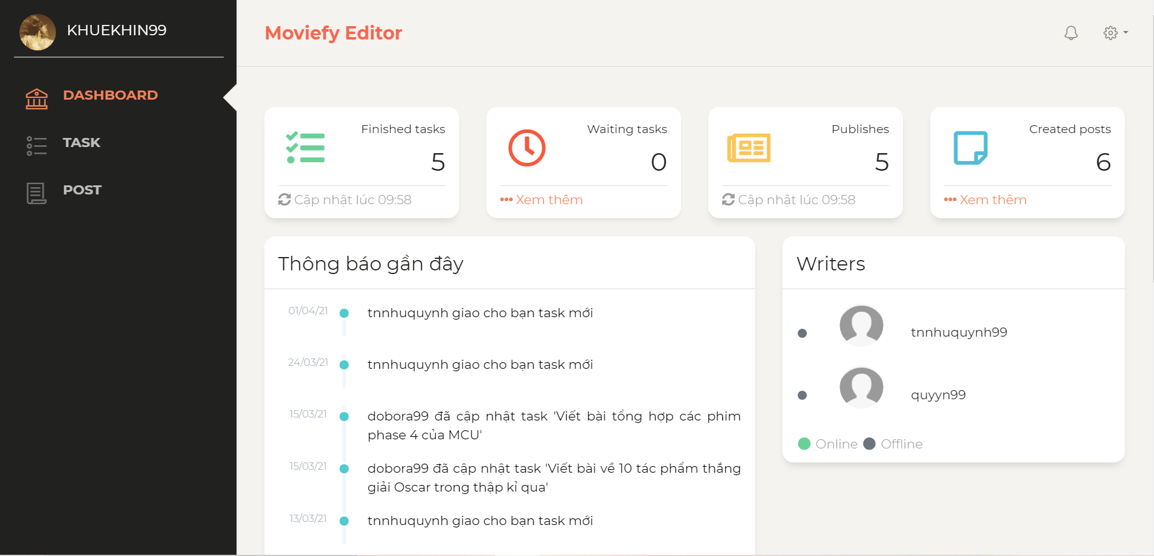

**Figure 5.2.** Expected & Actual result of TC_LI_01

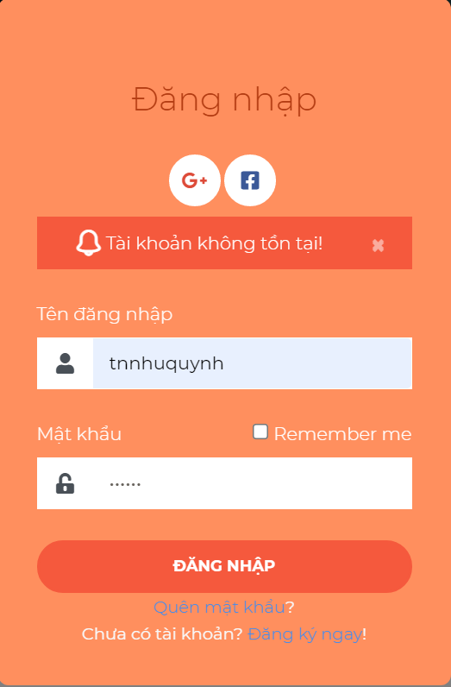

**Figure 5.3.** Expected & Actual result of TC_LI_02

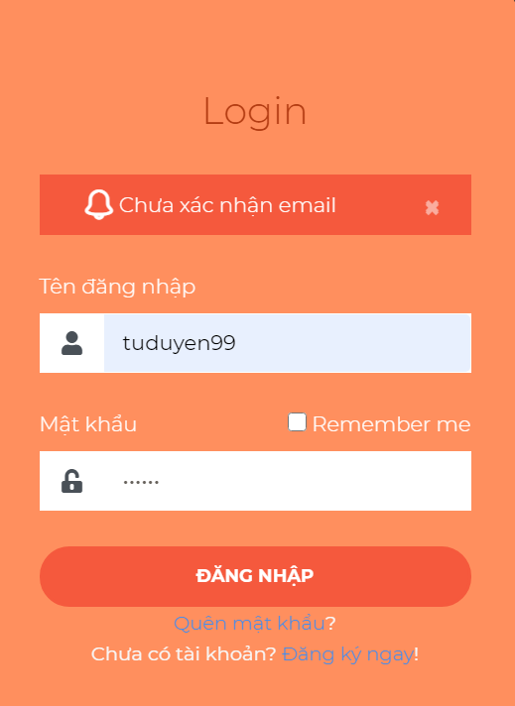

**Figure 5.4.** Expected & Actual result of TC_LI_03

#### Guest – Book tickets

**Table 5.5.** Test results of Book tickets function

|  |  |  |  |  |  |  |
| --- | --- | --- | --- | --- | --- | --- |
| ID | Description | Test steps | Test data | Expected Result | Actual Result | Status |
| TC_BT_01 | Test response of the website when user enters correct checkout information | 1. Go to “Lịch chiếu” page of movie “Coco” 2. Pick showtime “23:30” 3. Pick seat “E7” 4. Click “Tiếp tục” button 5. Enter “Họ và tên” input 6. Enter Email 7. Enter “Số điện thoại” input 8. Click “Paypal” 9. Login to Paypal 10. Click “Pay Now” of Paypal window | * Step 5: “Họ và tên” = “Quỳnh” * Step 6: Email = “tonnunhuquynh99@gmail.com” * Step 7: “Số điện thoại” = “0932228092” * Step 9: * Email = “17110214@student.hcmute.edu.vn” * Email = “sb-xl47jr5868467@personal.example.com” * Password = “12061999” | Website naviagates to “Thông tin vé” page | As expected | Pass |
| TC_BT_02 | Test response of the website when the reservation time is over | 1. Go to “Lịch chiếu” page of movie “Coco” 2. Pick showtime “23:30” 3. Wait for the countdown at the right side of the screen is up |  | Error dialog appears “Hết thời gian giữ ghế, hãy thực hiện lại đơn hàng của bạn” | As expected | Pass |

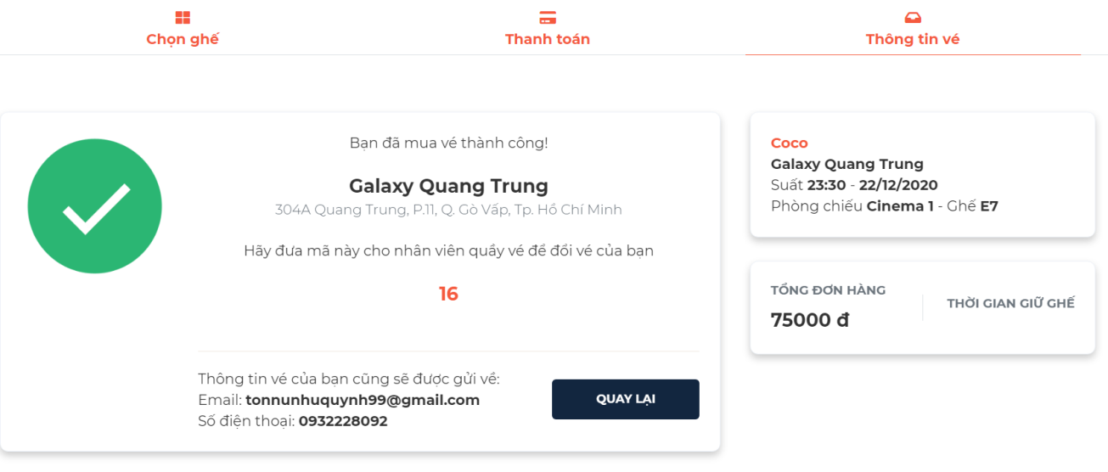

**Figure 5.5.** Expected & Actual result of TC_BT_01

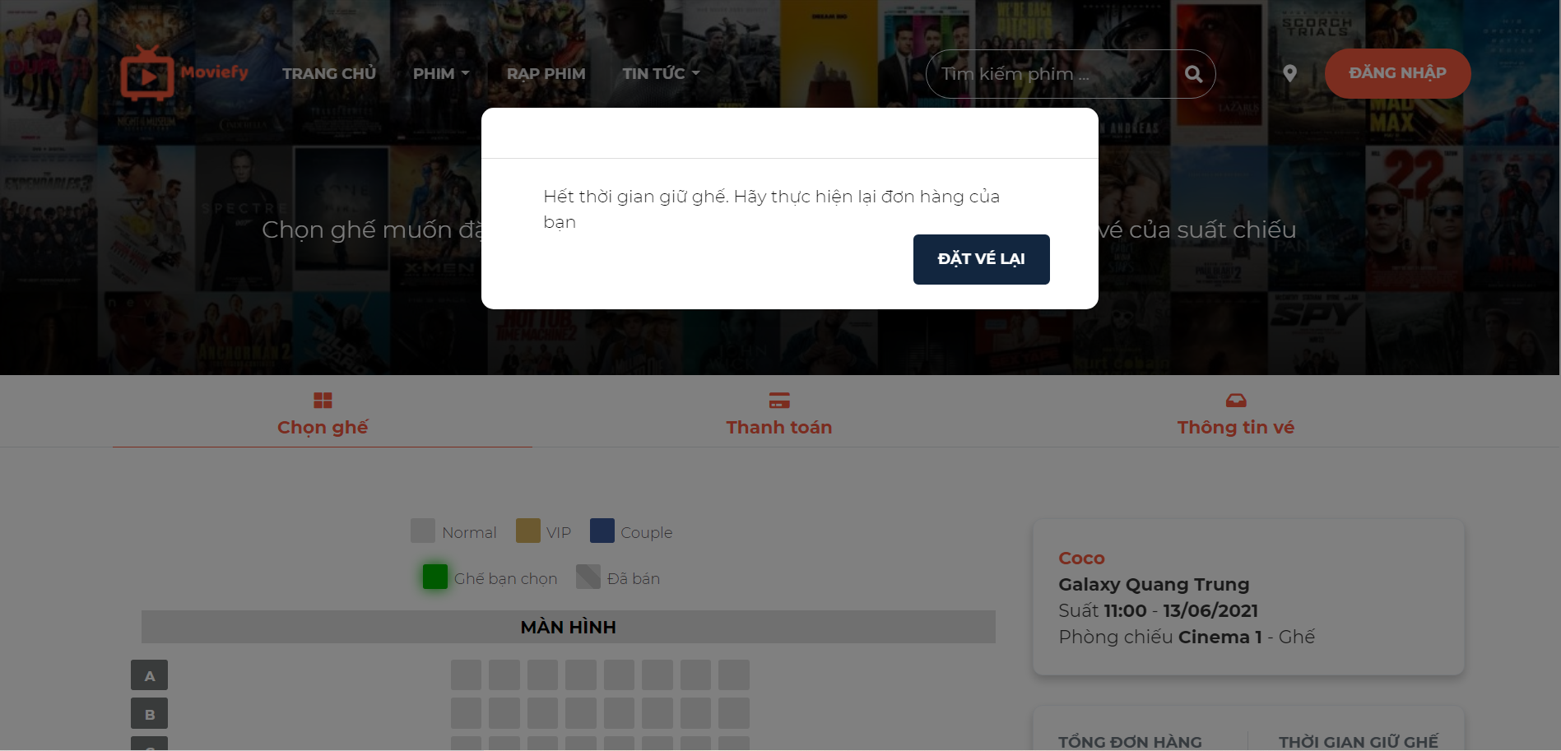

**Figure 5.6.** Expected & Actual result of TC_BT_02

#### Admin – Add a movie

**Table 5.6.** Test results of Add a movie function

|  |  |  |  |  |  |  |
| --- | --- | --- | --- | --- | --- | --- |
| ID | Description | Test steps | Test data | Expected Result | Actual Result | Status |
| TC_AM_01 | Test response of the website when user add a non existed movie | 1. Go to the “Quản lý phim” page 2. Click “Thêm phim” button 3. Pick movie “Ponyo” and click the plus icon button 4. Enter “Tựa Việt” input 5. Pick “Ngôn ngữ” 6. Pick “Trạng phái phim” 7. Pick “Thể loại” 8. Click “Lưu” button | Step 4: “Tựa Việt” = “Ponyo”  Step 5: “Ngôn ngữ” = “Tiếng Anh”  Step 6: “Trạng phái phim” = “Chưa có lịch chiếu”  Step 7: “Thể loại” = “Hoạt hình”, “Phiêu lưu” | A green message appears at top right corner of the screen “Thêm phim thành công” | As expected | Pass |
| TC_AM_02 | Test response of the website when user add an existed movie | 1. Go to the “Quản lý phim” page 2. Click “Thêm phim” button 3. Pick movie “Wonder woman 1984” and click the plus icon button 4. Enter “Tựa Việt” input 5. Pick “Ngôn ngữ” 6. Pick “Trạng phái phim” 7. Pick “Thể loại” 8. Click “Lưu” button | Step 4: “Tựa Việt” = “Wonder woman 1984”  Step 5: “Ngôn ngữ” = “Tiếng Anh”  Step 6: “Trạng phái phim” = “Đang chiếu”  Step 7: “Thể loại” = “Hành động”, “Phiêu lưu” | A red message appears at top right corner of the screen “Phim đã được thêm rồi” | As expected | Pass |

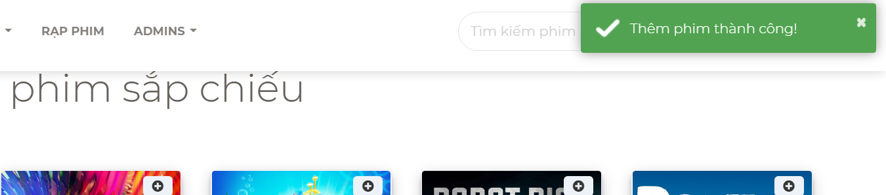

**Figure 5.7.** Expected & Actual result of TC_AM_01

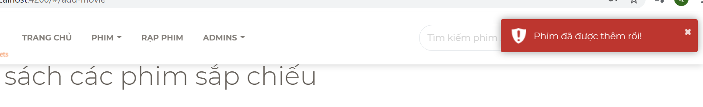

**Figure 5.8.** Expected & Actual result of TC_AM_02

# CONCLUSION

## Results

The project is 100% complete, providing an overview of the architecture and system design, complete all the functions of the application set out from the beginning. From there, we have an overview for the operation of the movie review and tickets booking system. We have applied our learned knowledge as well as new knowledge to build our website.

* End – user website URL: <https://movie-reviews-and-tickets.herokuapp.com>
* Admin website URL: <https://admin-moviefy.web.app>
* Source: https://github.com/TonNuNhuQuynh/KL_17110116_17110214

## Strengths

* User-friendly interface.
* Easy maintenance and development.
* Personalized system.

## Drawbacks

* Lack of practical experience in building system architecture.
* Processing performance is not good because of using a free implementation package.

## Future works

* Continue to complete the project and apply it to stores to keep updating system and fixing bugs.
* Build mobile apps for end users to easily access the system and update information.
* Add more payment method.
* Improve search engine optimization (SEO) for the website.

# REFERENCES

[1] Amazon company (1990). IMDb. <https://www.imdb.com/>. (Accessed on 17/03/2021).

[2] MONET company (2020). Moveek. <https://moveek.com/> . (Accessed on 17/03/2021).

[3] Wikipedia (12/2020). ASP.NET Core. <https://en.wikipedia.org/wiki/ASP.NET_Core>. (Accessed on 28/05/2021).

[4] Microsoft (2020). ASP.NET Web APIs. <https://dotnet.microsoft.com/apps/aspnet/apis>. (Accessed on 28/05/2021).

[5] Angular (2020). Introduction to the Angular Docs. <https://angular.io/docs>. (Accessed on 29/05/2021).

[6] Angular (2020). Introduction to Angular concepts. <https://angular.io/guide/architecture> . (Accessed on 29/05/2021).

[7] Sachin Prabhu Thandapani (2019). Matrix Factorization. <https://medium0.com/sfu-cspmp/recommendation-systems-collaborative-filtering-using-matrix-factorization-simplified-2118f4ef2cd3>. (Accessed on 30/05/2021).